Name

Mathematics Advanced Year 12
Curve Sketching

Book 1 | Turning points, inflections, and curve-sketching | Version: 261019  Feedback:  https://MrDingMaths.com
Contents
Syllabus Content 2
Continuous and Differentiable 3
Classifying Stationary Points using the Derivative 8
Sketching Cubic Curves using Calculus 14
The Second Derivative 23
Concavity and Points of Inflection 25
Classifying Stationary Points using the Second Derivative 34
Curve Sketching using Calculus 41
Exam Questions 59

Syllabus Content
MAV-12-06 applies calculus to graph functions and model and solve problems involving optimisation, rates of change and motion in a line
Turning points, inflections and curve-sketching
- Define a function $f\left(x\right)$ to be differentiable at $x=a$ if $\lim_{h→0}\frac{f\left(a+h\right)-f\left(a\right)}{h}$ exists, that is if there is a non-vertical tangent to the curve at the point $P\left(a,f\left(a\right)\right)$ and recognise that if $f\left(x\right)$ is differentiable at $x=a$ then it is continuous at $x=a$
- Identify any values of $x$ where a function is continuous, but not differentiable, given either the equation of the function or its graph
- Use repeated differentiation to find second derivatives of a function $y=f(x)$, denoting them by $f''(x)$ or $\frac{d^{2}y}{dx^{2}}$ or $y''$
- Analyse the stationary points of a function by testing values for $f'(x)$, then classify the stationary points as local minima or local maxima where gradients change around the point, or horizontal points of inflection where gradients have the same sign on both sides of the point
- Interpret the second derivative $y''$ as the gradient function of the first derivative $y'$, and deduce that if $y''>0$ the curve is concave up and if $y''<0$ the curve is concave down
- Define a point of inflection on a curve as a point where the concavity changes
- Analyse the value of $f''(x)$ either side of the roots of $f''\left(x\right)=0$, and use the resulting concavities to identify which zeroes of $f''\left(x\right)$ are points of inflection
- Use the second derivative to classify a stationary point as a local maximum, local minimum or a horizontal point of inflection
- Graph a function by determining local maxima and minima and points of inflection, horizontal and non-horizontal, considering any even or odd symmetry, the domain, any vertical asymptotes or other discontinuities, and where applicable, the behaviour of a function as $x→±∞$
- Graph $y=f'(x)$ and $y=f''(x)$ for a function $y=f(x)$, given only a graph of $y=f(x)$

Continuous and Differentiable

- Continuous at a Point
A function is continuous at a point $x=a$ if the graph of $y=f\left(x\right)$ can be drawn through the point in a single pen stroke without lifting the pen. In the graph below, the function is continuous everywhere except for the discontinuities at $x∈\left\{c, d, e, f\right\}$.
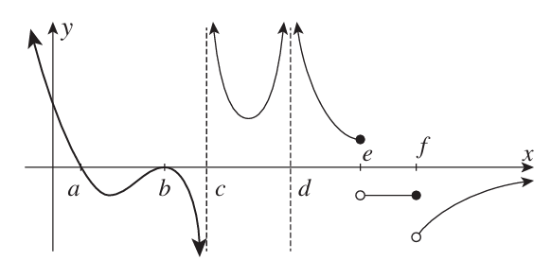

- Identify discontinuities in graphs.
Identify any discontinuities in these curves, if any.
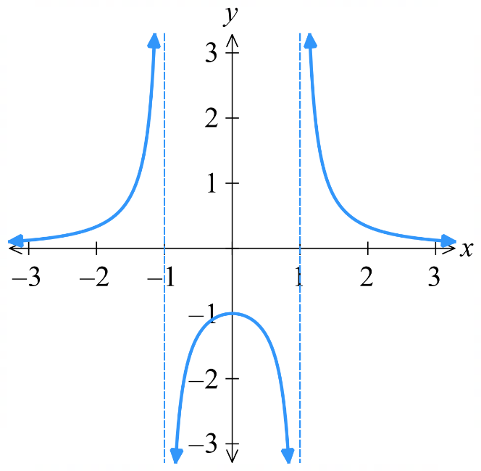
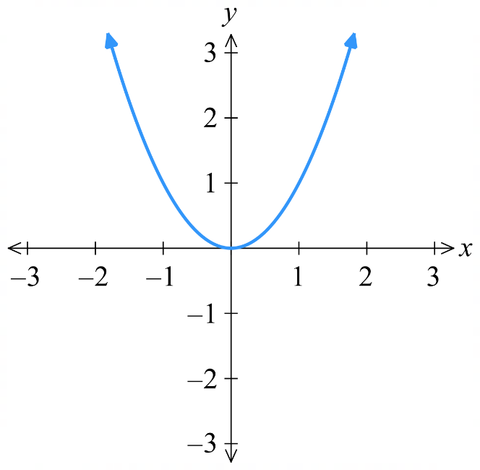
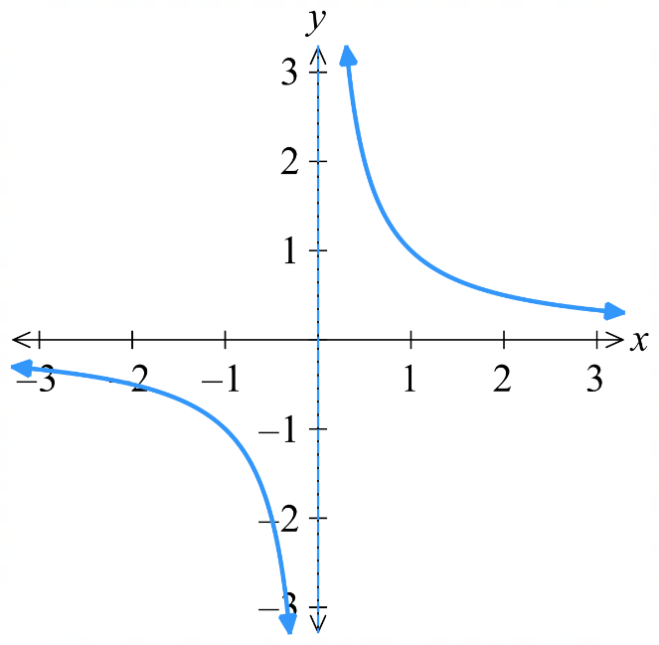

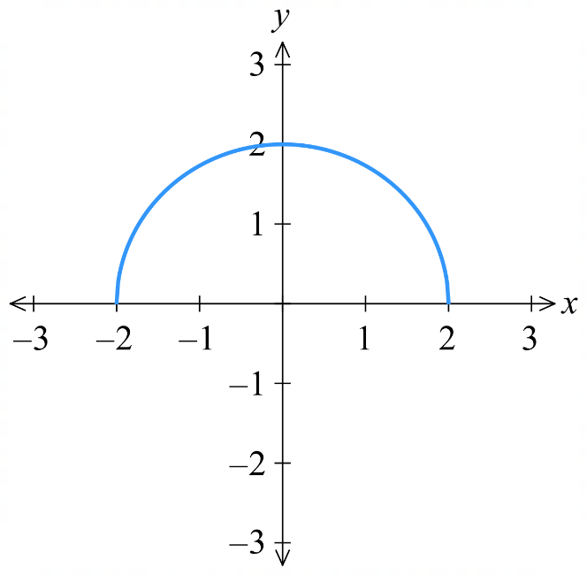 | 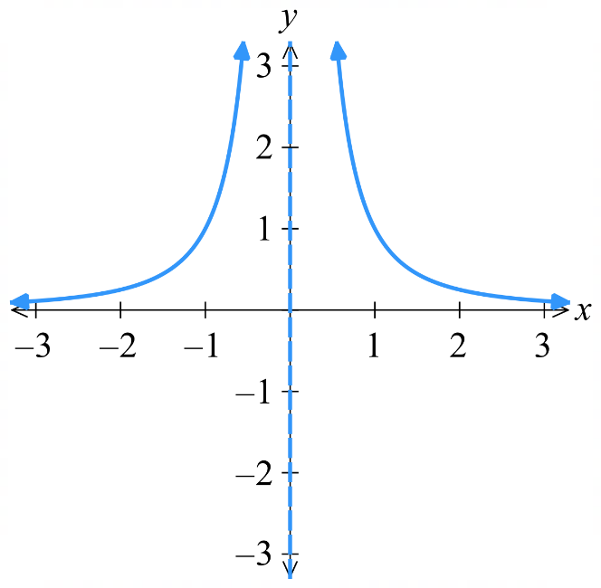 | 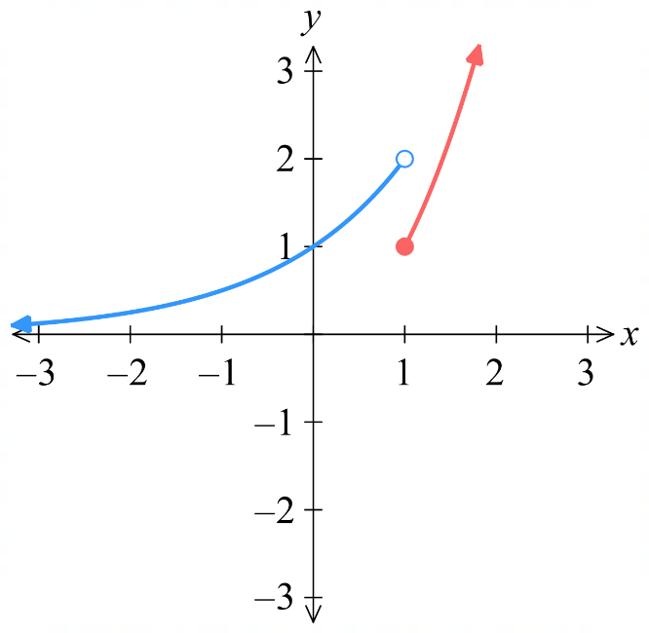

- Continuous from an Equation
A function is discontinuous at $x=a$ if:
- The function is undefined at that point (e.g. asymptote, denominator = 0).
- A piecewise function doesn’t join up at $x=a.$

We will assume the curve is continuous everywhere else.

- Example Determine continuous from an equation.
Decide whether these functions are continuous at $x=1$ using the equation. A sketch is given.
$$f\left(x\right)=\frac{3x-3}{4x-4}$$  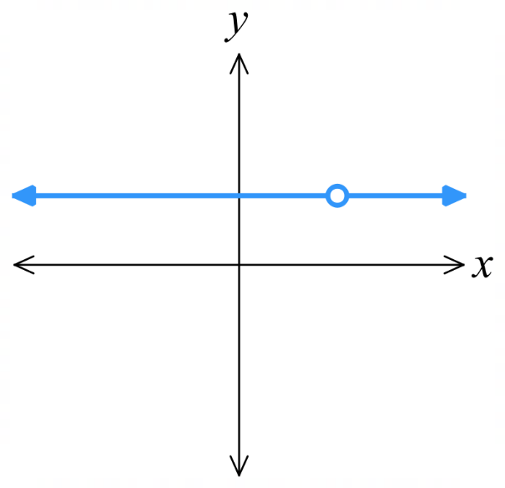  $f\left(x\right)$ is undefined when $4x-4=0$  $x=1$  Since $f\left(x\right)$ is undefined at $x=1$, it is not continuous at $x=1$. | $$f\left(x\right)=\left\{\begin{aligned}2-x, x<1 \\ x^{2}, x≥1\end{aligned}\right.$$  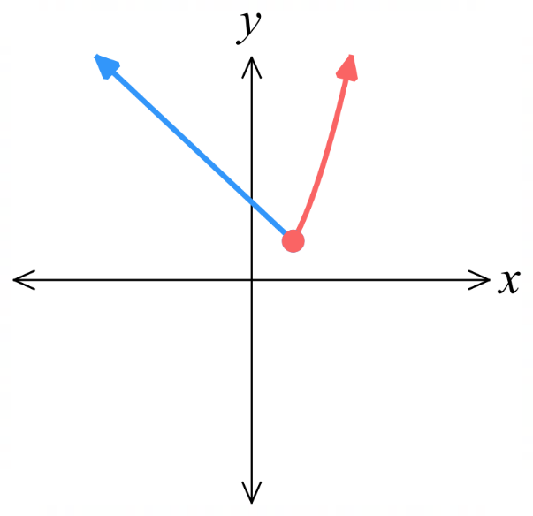  Let $g\left(x\right)=2-x$  $$g\left(1\right)=1$$  Let $h\left(x\right)=x^{2}$  $$h\left(1\right)=1$$  The graphs join up at $x=1$, $∴$ continuous.

- Practice
Decide whether these functions are continuous at $x=3$.
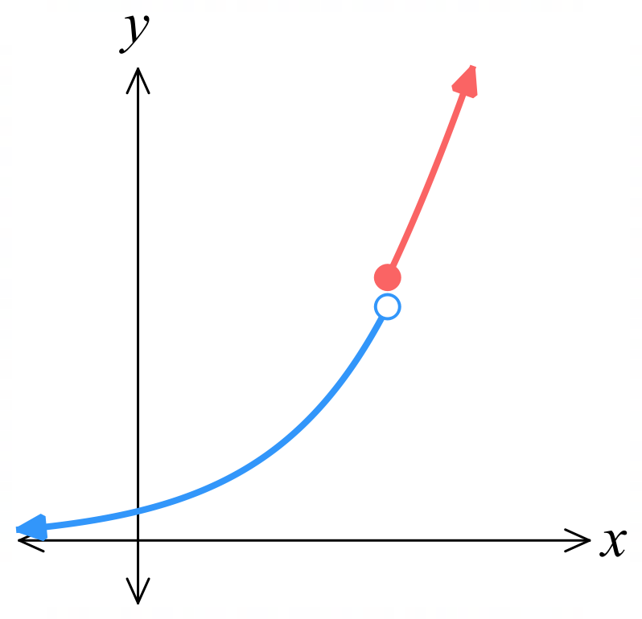  $f\left(x\right)=\left\{\begin{aligned}2^{x}, x<3 \\ x^{2}, x≥3\end{aligned}\right.$  Discontinuity at $x=3$ | $$f\left(x\right)=\frac{5}{x^{2}-4}$$  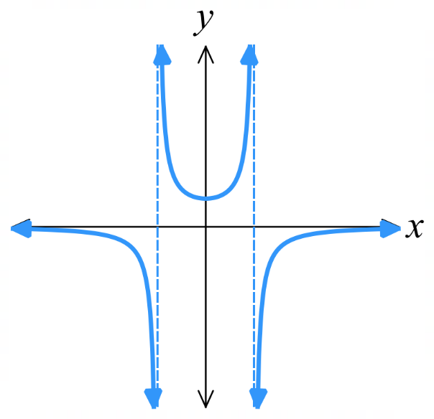  Continuous at $x=3$
- Differentiable at a Point
A function is differentiable (or smooth) at a point $x=a$ if $\lim_{h→0}\frac{f\left(a+h\right)-f\left(a\right)}{h}$ exists;
in other words: there is a non-vertical tangent at the point $P\left(a, f\left(a\right)\right)$ and there is no sharp change in direction.
in other words: if you zoom in enough, you get a non-vertical straight line through the point.
In the graphs below, $f\left(x\right)=x^{2}$ is differentiable for all $x$, while $y=\left|x\right|$ is differentiable everywhere except $x=0.$
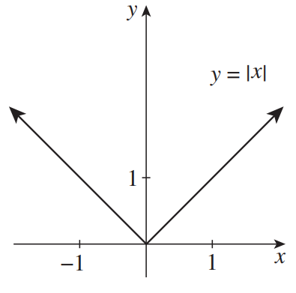
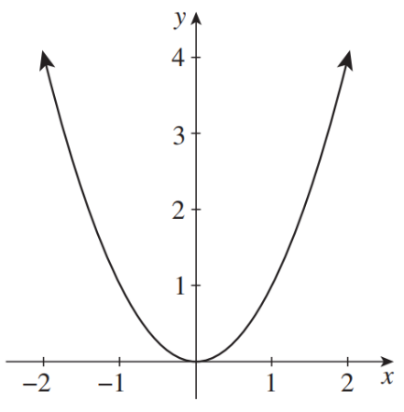

- Identify non-differentiable points in graphs.
Identify any non-differentiable points in these curves, if any.
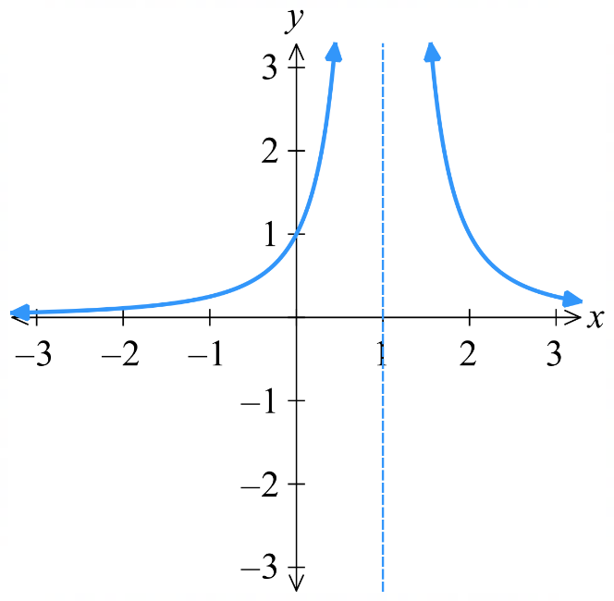 | 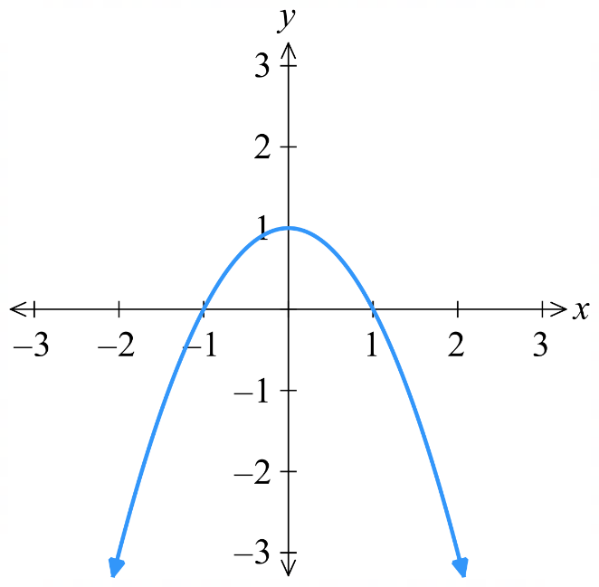 | 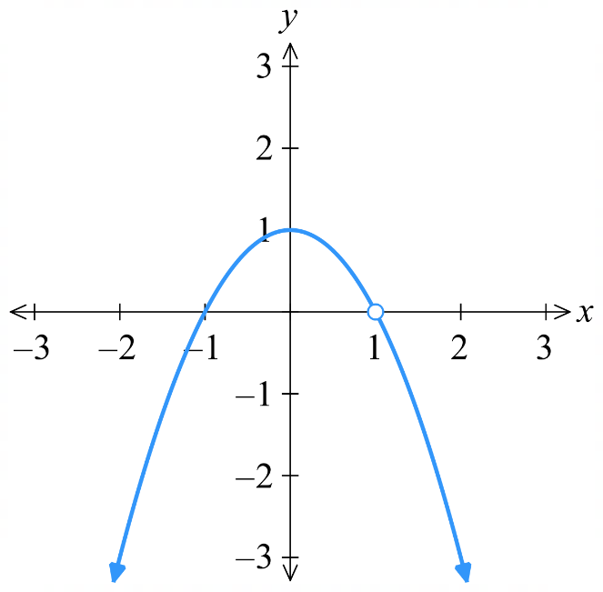
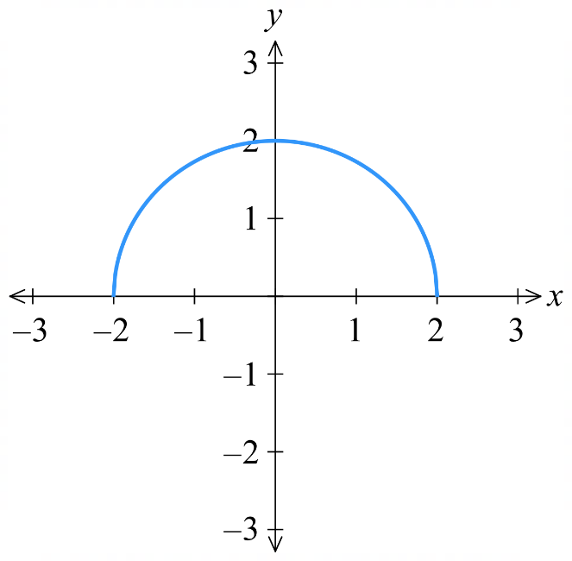 | 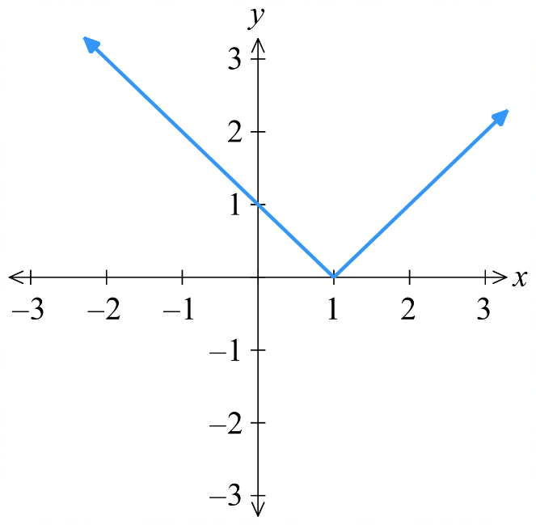 | 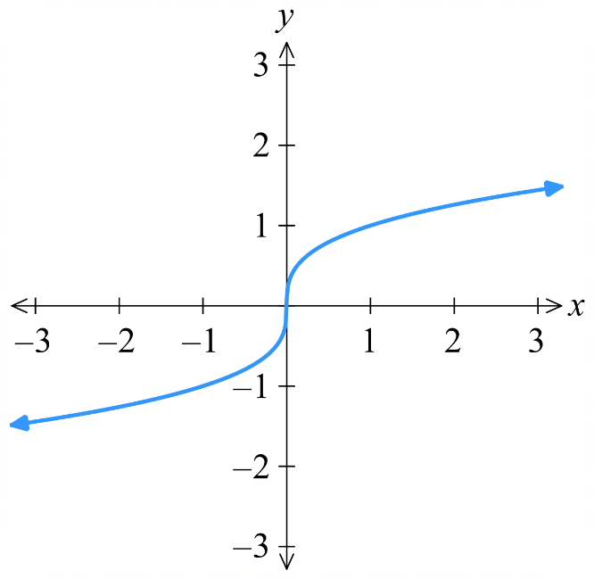

- Differentiable from an Equation
A function is not differentiable (not smooth) at $x=a$ if:
- It is discontinuous at $x=a$.
- If the tangent is vertical, $f^{'}\left(a\right)$ is undefined, e.g. ends of a semicircle, square root function.
- There is a sharp change in direction, e.g. where absolute value curves change direction.
- If a piecewise function has different $f^{'}\left(a\right)$ at $x=a$.

- Remember that an absolute value function is a piecewise-defined function.
$$f\left(x\right)=\left|x-a\right|=\left\{\begin{aligned}-(x-a), x<a \\ x-a, x≥a\end{aligned}\right.$$

- Example Determine continuous or differentiable from an equation.
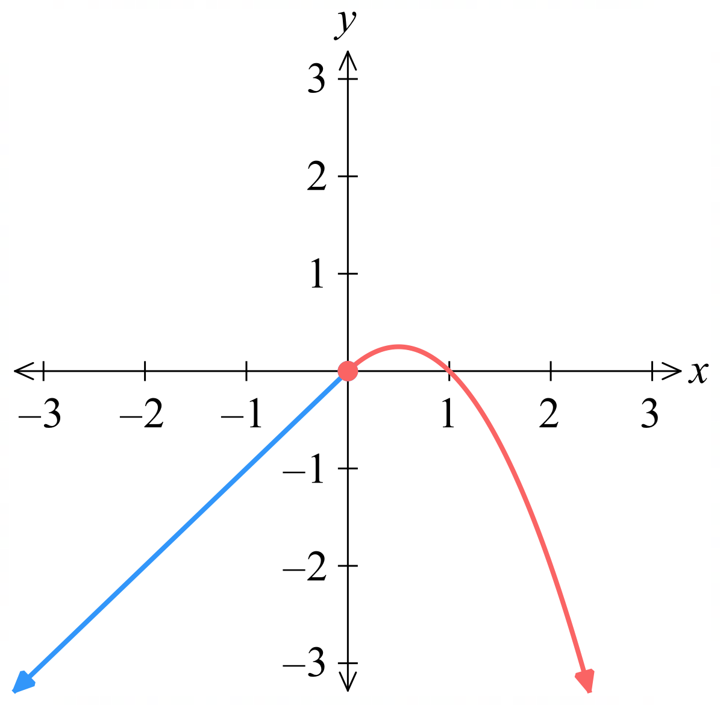
Decide whether $f\left(x\right)$ is differentiable at $x=0.$
$$f\left(x\right)=\left\{\begin{aligned}x, x<0 \\ x-x^{2}, x≥0\end{aligned}\right.$$
Let $g\left(x\right)=x$, $h\left(x\right)=x-x^{2}$

First, test continuity at $x=0$
$g\left(0\right)=0, h\left(0\right)=0$ ∴ continuous

Differentiate and test $f^{'}\left(x\right)$
$$f^{'}\left(x\right)=\left\{\begin{aligned}1, x<0 \\ 1-2x, x≥0\end{aligned}\right.$$
$g^{'}\left(0\right)=1, h^{'}\left(0\right)=1$ ∴ differentiable

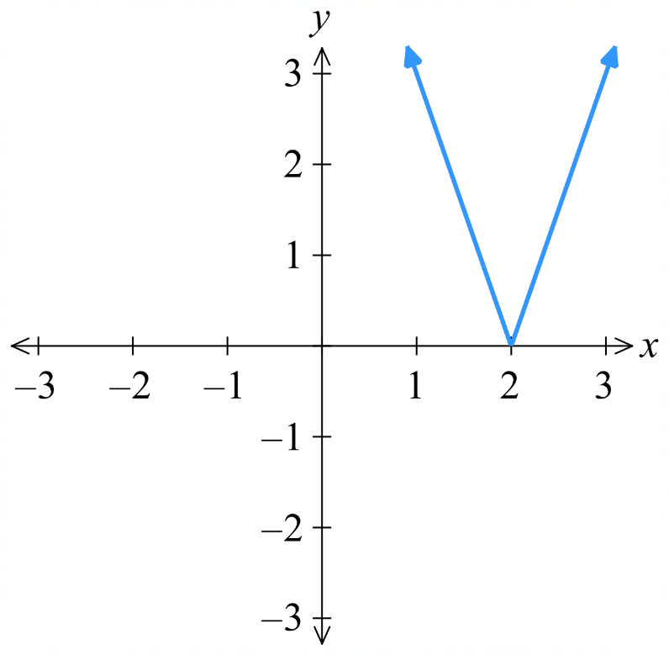
Decide whether $f\left(x\right)$ is differentiable at $x=2.$
$$f\left(x\right)=3\left|x-2\right|$$
$$f\left(x\right)=\left\{\begin{aligned}-3\left(x-2\right), x<2 \\ 3(x-2), x≥2\end{aligned}\right.$$
Let $g\left(x\right)=-3\left(x-2\right)$, $h\left(x\right)=3\left(x-2\right)$

First, test continuity at $x=2$
$g\left(2\right)=0, h\left(2\right)=0$ ∴ continuous

Differentiate and test $f^{'}\left(x\right)$
$$f^{'}\left(x\right)=\left\{\begin{aligned}-3, x<2 \\ 3, x≥2\end{aligned}\right.$$
$g^{'}\left(2\right)=-3, h^{'}\left(2\right)=3$ ∴ not differentiable

- Practice
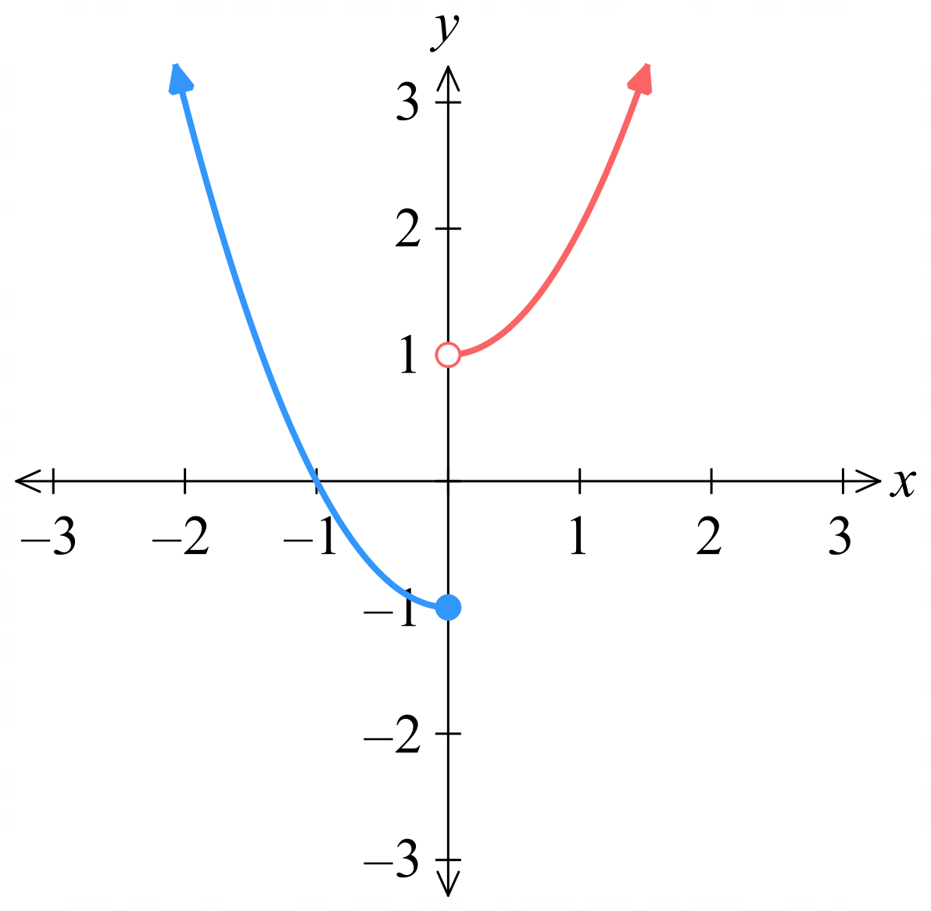
Decide whether $f\left(x\right)$ is differentiable at $x=0$.
$$f\left(x\right)=\left\{\begin{aligned}x^{2}-1, x≤0 \\ x^{2}+1, x>0\end{aligned}\right.$$

No, the function is not continuous at $x=0$
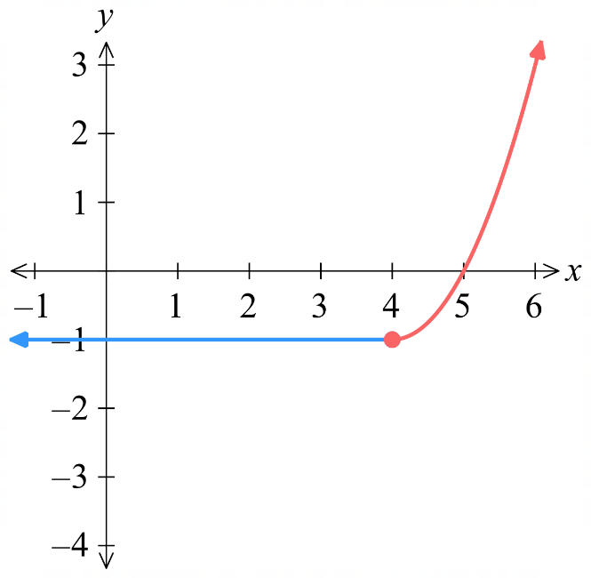
Decide whether $f\left(x\right)$ is differentiable at $x=4$.
$$f\left(x\right)=\left\{\begin{aligned}-1, x<4 \\ x^{2}-8x+15, x≥4\end{aligned}\right.$$

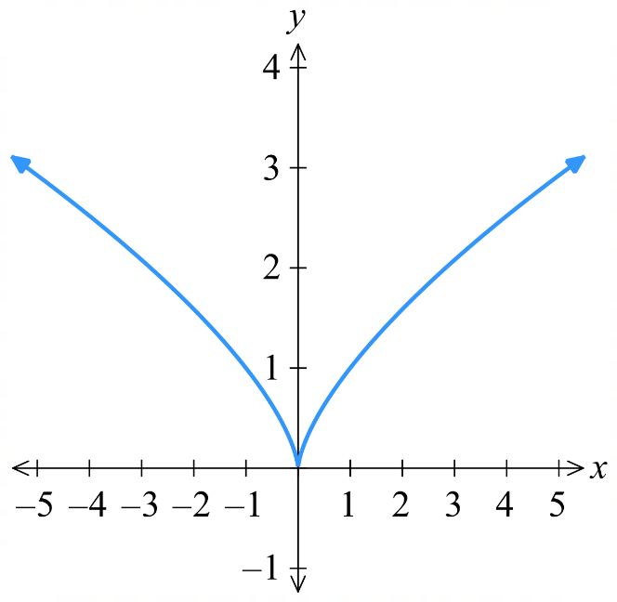
Decide whether $f\left(x\right)$ is differentiable at $x=0$.
$$f\left(x\right)=\sqrt[3]{x^{2}}$$

Classifying Stationary Points using the Derivative

- Review
- Identify whether a curve is increasing/decreasing/stationary at a point graphically.
On the given diagram, annotate the points to say whether $f^{'}\left(x\right)>0$, $f^{'}\left(x\right)<0$, or $f^{'}\left(x\right)=0$

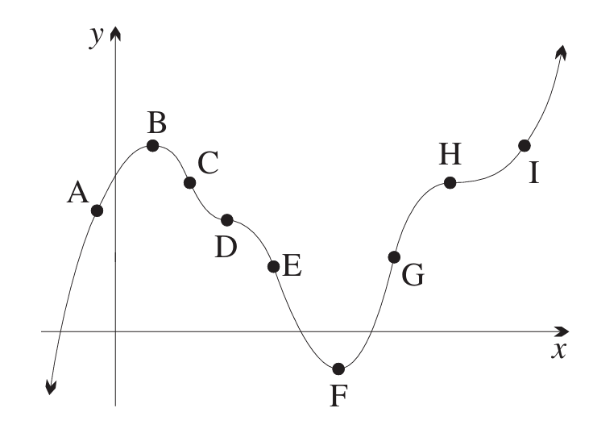

- Identify whether a curve is increasing/decreasing/stationary at a point algebraically.
  - Differentiate $y=x^{3}-4x$

  - Determine whether the curve is increasing, decreasing, or stationary at:
    - $x=-3$

    - $x=0$

    - $x=2$

- Find stationary points
  - $f\left(x\right)=x^{2}-2x-3$

  - $f\left(x\right)=2x^{3}+3x^{2}-36x+9$

- Types of stationary points
Maximum | Minimum | Stationary inflection
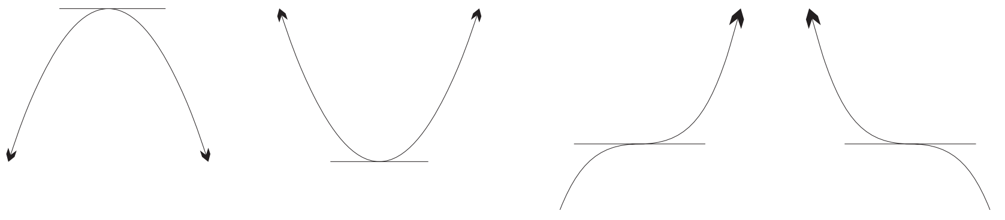 |  | \
$f^{'}\left(x\right)$ changes from positive to negative | $f^{'}\left(x\right)$ changes from negative to positive | $f'(x)$ doesn’t change sign

- Interpret a slope table.
A slope table finds the derivative immediately to the left and right of a stationary point.
This helps us classify the stationary point.
For each function, the stationary point and derivative is given.
Classify the stationary point and check using the provided sketch.
$$f\left(x\right)=x^{2}+2x$$  $$f^{'}\left(x\right)=2x+2$$  Classify point at $x=-1$:  - Max  - Min  - Inflection | $$f\left(x\right)=x^{3}-9x^{2}+27x-28$$  $f^{'}\left(x\right)=3x^{2}-18x+27$  Classify point at $x=3$:  - Max  - Min  - Inflection | $$f\left(x\right)=x^{3}+ 3x^{2}- 4$$  $$f^{'}\left(x\right)=3x^{2}+6x$$  Classify point at $x=-2$:  - Max  - Min  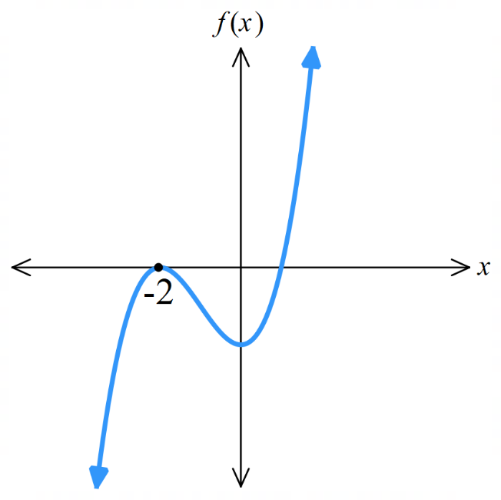  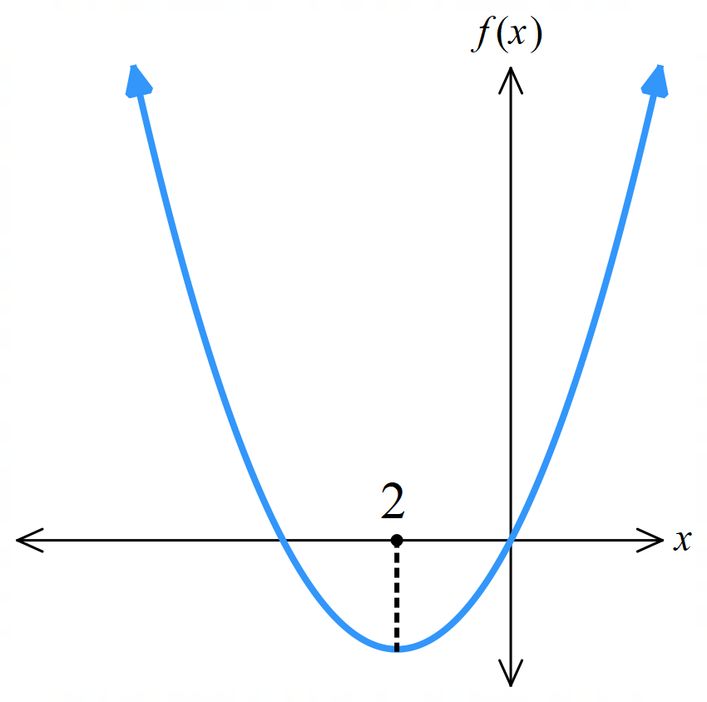  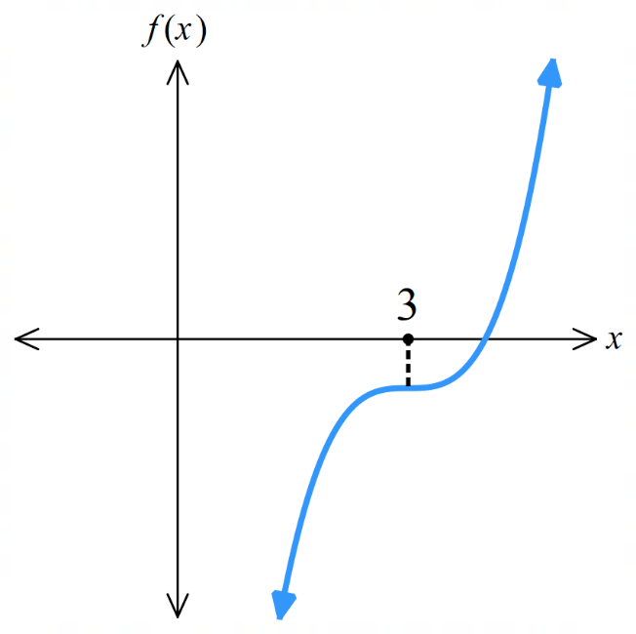  - Inflection
  $$x$$ |  | $$-1$$
  $$f'(x)$$ |  | 0
  Slope
  $$x$$ |  | 3
  $$f'(x)$$ |  | 0
  Slope
  $$x$$ |  | $$-2$$
  $$f'(x)$$ |  | 0
  Slope

- Classifying Stationary Points using a Slope Table
To find and classify stationary points of $f\left(x\right):$
- Find the derivative $f^{'}\left(x\right)$.
- Find the $x$-coordinate of stationary points using $f^{'}\left(x\right)=0$.
- Draw a slope table to classify the turning points.

- Example Find and classify stationary points using a slope table.
Find the stationary points of $f\left(x\right)=2x^{3}-15x^{2}+24x-7$ and determine their nature.
A sketch is provided for you to check your answer.
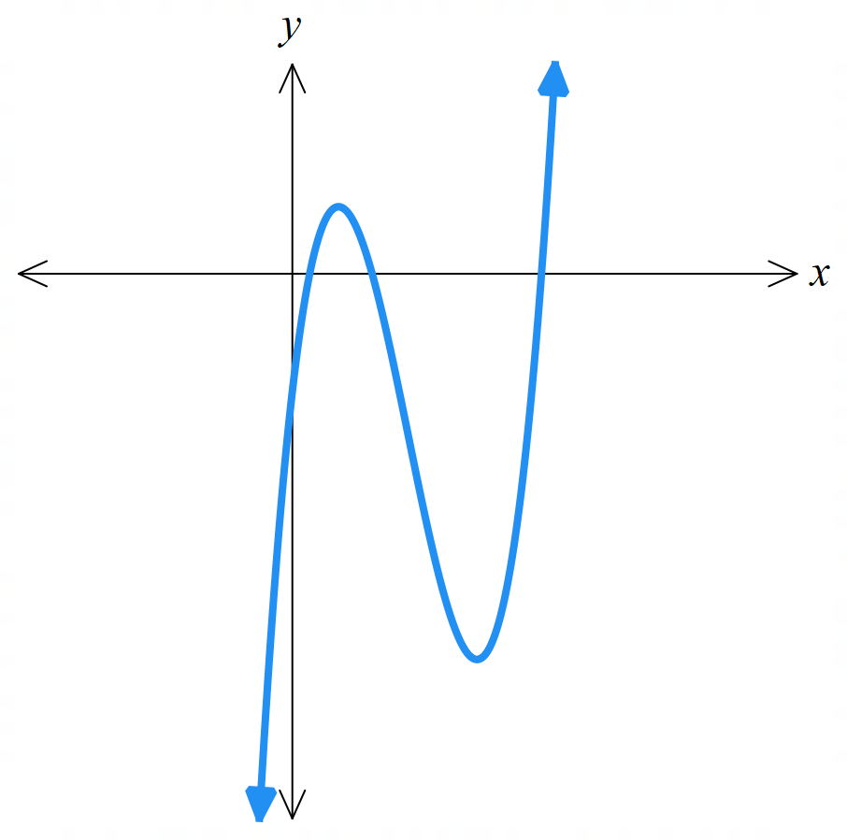
1. Differentiate
$f^{'}\left(x\right)=6x^{2}-30x+24$
2. Solve $f^{'}\left(x\right)=0$
$6x^{2}-30x+24=0$
$x^{2}-5x+4=0$
$\left(x-1\right)\left(x-4\right)=0$
$x=1, 4$
3. Slope table and classify
$$x$$ | 0 | 1 | 2 | 4 | 5
$$f'(x)$$ | 24 | 0 | $$-12$$ | 0 | 24
Slope | $$/$$ |  | $$\backslash$$ |  | $$/$$
Maximum at $\left(1,4\right)$
Minimum at $\left(4,-23\right)$

- Practice
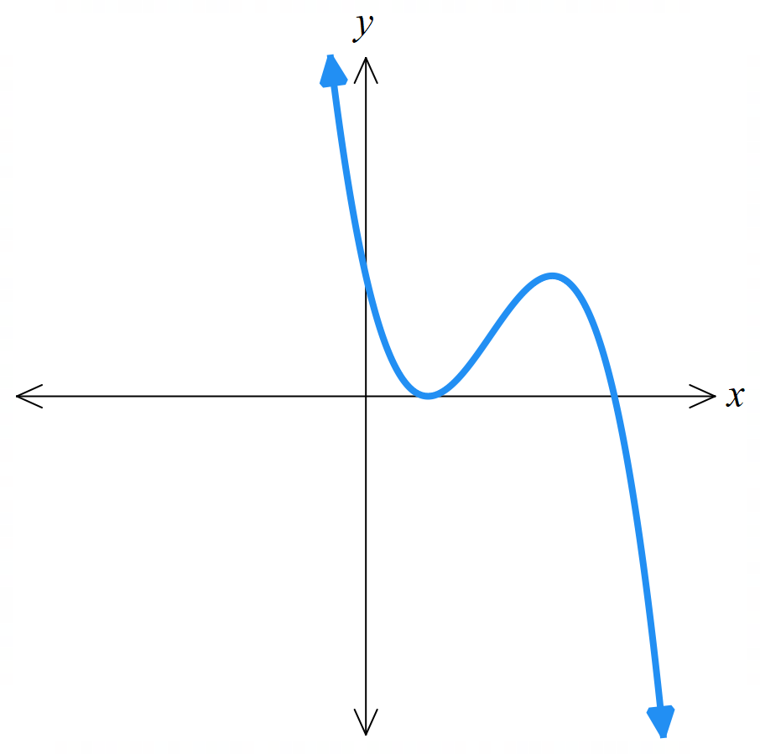
Find the stationary points of $y=-x^{3}+6x^{2}-9x+4$ and determine their nature.
A sketch is provided for you to check your answer.

Minimum at $\left(1,0\right)$, maximum (3,4)

Foundation
- For these quadratics, find the derivative of each function and complete the given table to determine the nature of the given stationary point.
- $f\left(x\right)=x^{2}-4x+3$  Min at $x=2$ | - $f\left(x\right)=12+4x-x^{2}$  Max at $x=2$
  $$x$$ | $$1$$ | $$2$$ | $$3$$
  $$f'(x)$$
  Slope
  $$x$$
  $$f'(x)$$
  Slope
- $f\left(x\right)=x^{2}+6x+8$  Min at $x=-3$ | - $f\left(x\right)=15-2x-x^{2}$  Max at $x=-1$
  $$x$$ | $$-4$$ | $$-3$$ | $$-2$$
  $$f'(x)$$
  Slope
  $$x$$
  $$f'(x)$$
  Slope

- Find the stationary points of each function then find the missing turning points on each graph.
- $y = 2x^{3}+ 3x^{2}- 36x + 15$  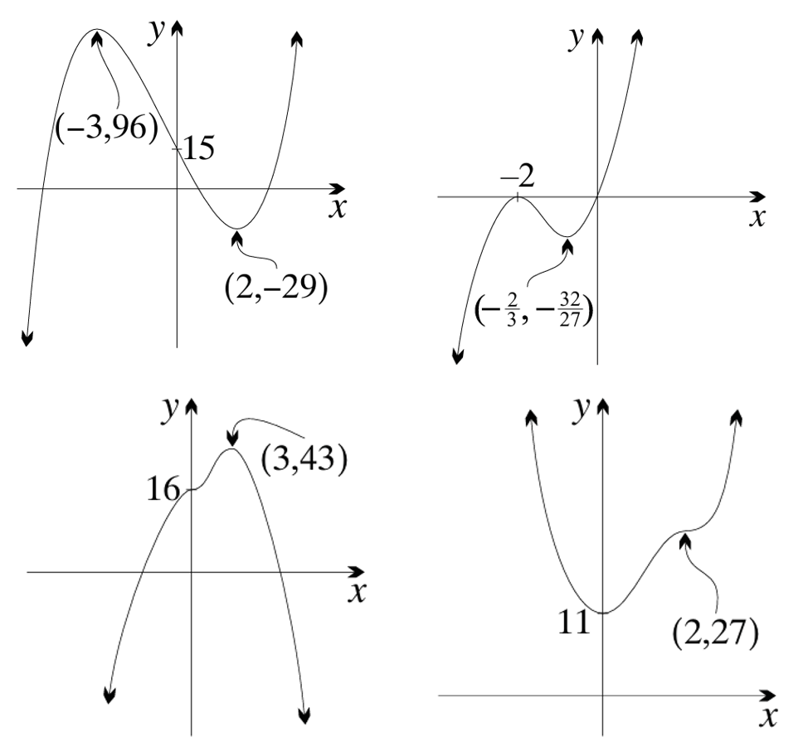 | - $y = x^{3}+ 4x^{2}+ 4x$  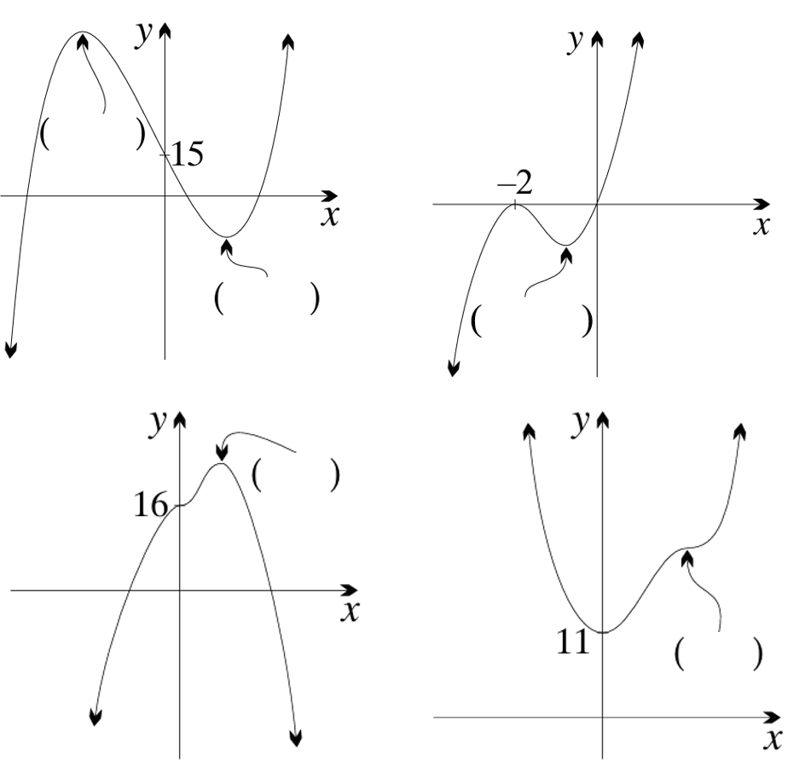
- $y = 16 + 4x^{3}- x^{4}$ | - $y = 3x^{4}- 16x^{3}+ 24x^{2}+ 11$

Development
- The curve $y = x³ - 6x² + 5$ has 2 turning points.
Find them and use the derivative to determine their nature.
$$\frac{dy}{dx}= 3x^{2}- 12x = 3x\left(x - 4\right)$$
$$3x\left(x - 4\right)= 0, so stationary points at x = 0 or x = 4$$
When $x = 0: y = 5$
When $x = 4: y = -27$
$$x$$ | $$-1$$ | $$0$$ | $$1$$ | $$3$$ | $$4$$ | $$5$$
$$\frac{dy}{dx}$$ | $$+15$$ | $$0$$ | $$-9$$ | $$-9$$ | $$0$$ | $$+15$$
(0, 5) maximum, (4, -27) minimum
- Find the turning points on the curve $y = x³ - 3x² + 5$ and determine their nature.
$$\frac{dy}{dx}= 3x^{2}- 6x = 3x\left(x - 2\right)$$
stationary points: $x = 0 or x = 2$
When $x = 0: y = 5$
When $x = 2: y = 1$
$$x$$ | $$-1$$ | $$0$$ | $$1$$ | $$2$$ | $$3$$
$$\frac{dy}{dx}$$ | $$+9$$ | $$0$$ | $$-3$$ | $$0$$ | $$+9$$
(0, 5) maximum, (2, 1) minimum
- Find any stationary points on the curve $f(x) = x⁴ - 2x² - 3$.
What type of stationary points are they?
$$f'(x) = 4x³ - 4x = 4x(x² - 1) = 4x\left(x - 1\right)\left(x + 1\right)$$
Stationary points: $x = 1, x=0, x = -1$
When $x = 0$: $f(0) = -3$ When $x = 1: f(1) = 1 - 2 - 3 = -4$
When $x = -1: f(-1) = 1 - 2 - 3 = -4$
$$x$$ | $$-2$$ | $$-1$$ | $$-0.5$$ | $$0$$ | $$0.5$$ | $$1$$ | $$2$$
$$f'(x)$$ | $$-24$$ | $$0$$ | $$+1.5$$ | $$0$$ | $$-1.5$$ | $$0$$ | $$+24$$
(0, -3) maximum, (1, -4) minimum, (-1, -4) minimum

- The curve $y = x³ - 3x + 2$ has 2 stationary points.
Find their coordinates and determine their type.
$$\frac{dy}{dx}= 3x^{2}- 3 = 3\left(x^{2}- 1\right)= 3\left(x - 1\right)\left(x + 1\right)$$
stationary points: $x = 1 or x = -1$
When x = 1: y = 0
When x = -1: y = 4
$$x$$ | $$-2$$ | $$-1$$ | $$0$$ | $$1$$ | $$2$$
$$\frac{dy}{dx}$$ | $$+9$$ | $$0$$ | $$-3$$ | $$0$$ | $$+9$$
(1, 0) minimum, (-1, 4) maximum

  - Differentiate $P = 2x +$ $\frac{50}{x}$ with respect to $x$.

$$\frac{dP}{dx}= 2 -\frac{50}{x^{2}}= 2 - 50x^{-2}$$
  - Find any stationary points on the curve and determine their nature.
$$2 -\frac{50}{x^{2}}= 0$$
$$2x^{2}= 50 x^{2}= 25 x = ±5$$
When $x = 5: P=20$
When $x = -5: P = -20$
$$x$$ | $$-6$$ | $$-5$$ | $$-4$$ | $4$ | $5$ | $6$
$$\frac{dP}{dx}$$ | $$/$$ | $$-$$ | $$\backslash$$ | $$\backslash$$ | $$-$$ | $$/$$
(-5, -20) maximum, (5, 20) minimum
Note that this curve has a discontinuity at $x=0$

  - Differentiate $A = x\sqrt{3600 - x^{2}}.$

$$A = x{\left(3600 - x^{2}\right)}^{\frac{1}{2}}$$
$$\frac{dA}{dx}= {\left(3600 - x^{2}\right)}^{\frac{1}{2}} + x\left(\frac{1}{2}\right){\left(3600 - x^{2}\right)}^{\left(-\frac{1}{2}\right)}\left(-2x\right)$$
$$=\frac{3600 - x^{2}- x^{2}}{\sqrt{3600 - x^{2}}}$$
$$=\frac{3600 - 2x^{2}}{\sqrt{3600 - x^{2}}}$$
  - Find any stationary points on $A = x\sqrt{3600 - x^{2}}$ (to 1 decimal place) and determine their nature.

$$3600 - 2x² = 0 x² = 1800 x = ±42.4 (1 d.p.)$$
When $x = 42.4: A = 42.4\sqrt{3600 - 1800} = 1800$
When $x = -42.4: A = -42.4\sqrt{3600 - 1800} = -1800$
$$x$$ | $$-50$$ | $$-42.4$$ | $$0$$ | $$42.4$$ | $$50$$
$$\frac{dA}{dx}$$ | $$-42.21$$ | $$0$$ | $$+60$$ | $$0$$ | $$-42.21$$
(42.4, 1800) maximum, (-42.4, -1800) minimum

Sketching Cubic Curves using Calculus

- Review
- Sketch cubics in factored form, showing intercepts.
- $y=(x+2)(x-1)(x-3)$ | - $y=x{\left(x+3\right)}^{2}$  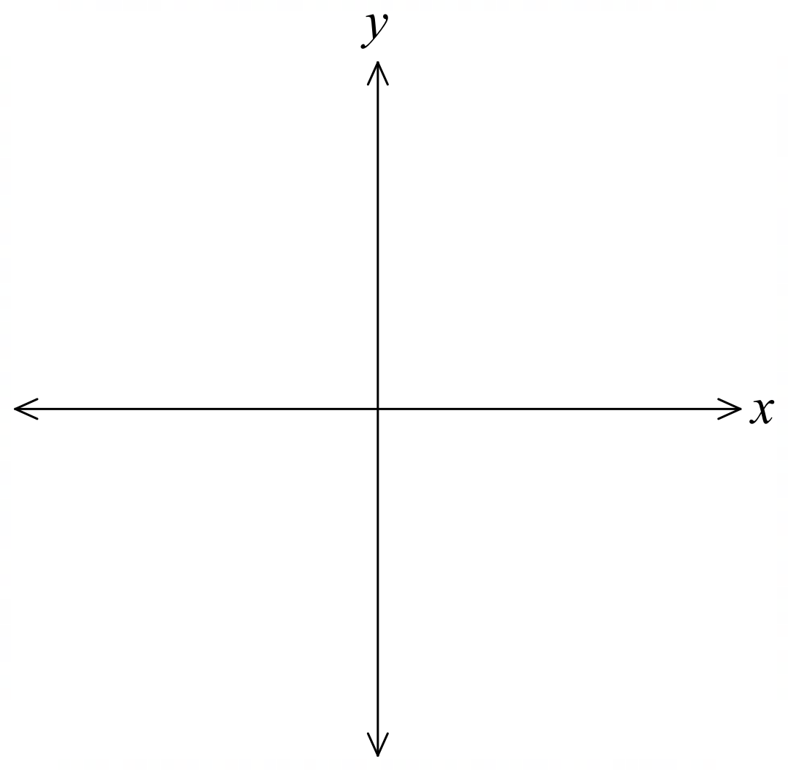

- Find stationary points of a function using calculus and classify them using a slope table.
- $y=3+6x-x^{2}$ | - $y=x^{3}-3x^{2}+5$ | - $y={\left(x-1\right)}^{2}\left(x+2\right)$

- Sketching cubic curves using calculus
- Sketch cubic from factored form.
  - Identify $x$-intercepts from factors.
  - Determine behaviour as $x→∞$ using leading term.
  - Determine $y$-intercept using constant term.
- Find the derivative $f^{'}\left(x\right)$.
- Find the $x$-coordinate of stationary points using $f^{'}\left(x\right)=0$.
- Draw a slope table to classify the turning points.
- Find $y$-coordinates of the turning points.
- Complete sketch by adding stationary points.

- Example Sketch cubics using calculus.
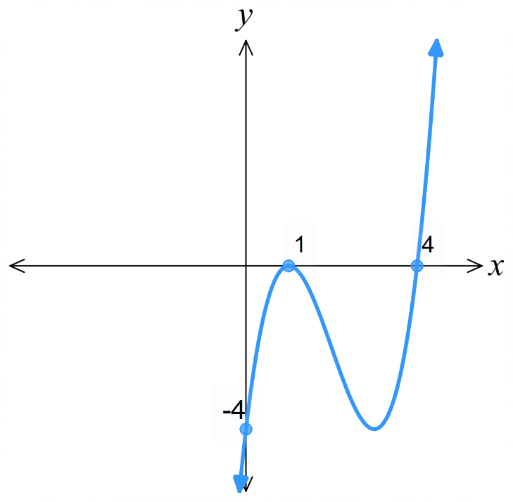
Sketch $f\left(x\right)=\left(x-4\right){\left(x-1\right)}^{2},$showing the turning points.
$1. f^{'}\left(x\right)={\left(x-1\right)}^{2}+\left(x-4\right)\left(2\right)\left(x-1\right)$ 0.
$=x^{2}-2x+1+2x^{2}-10x+8$
$=3x^{2}-12x+9$
2. Let $f^{'}\left(x\right)=0:$ $3x^{2}-12x+9=0$
$x^{2}-4x+3=0$
$$\left(x-3\right)\left(x-1\right)=0$$
$∴$ Stationary points at $x=1, x=3$
3.
$$x$$ | 0 | 1 | 2 | 3 | 4
$$f'(x)$$ | 9 | 0 | $$-3$$ | 0 | 9
Slope | $$/$$ |  | $$\backslash$$ |  | $$/$$

$∴$ max turning point at $x=1$
$∴$ min turning point at $x=3$
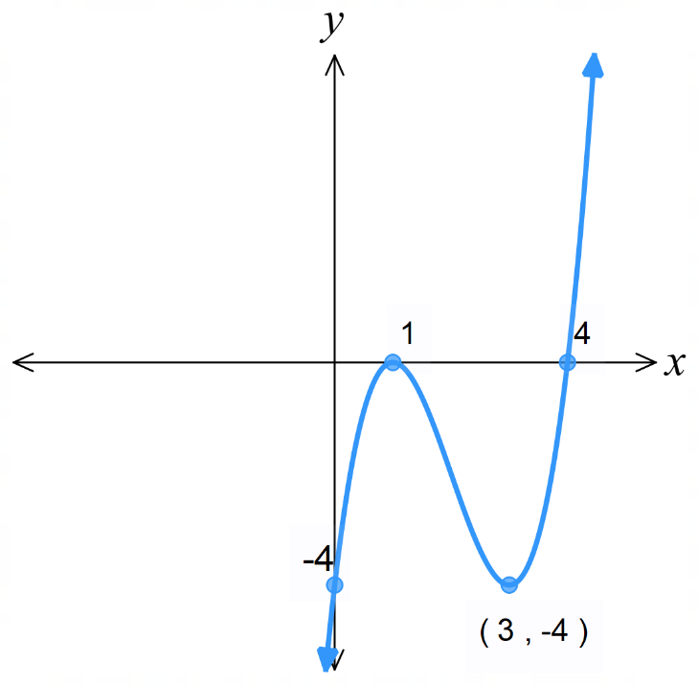
4. Max at $\left(1,0\right),$Min at $\left(3,-4\right)$ 5.

- Practice
Find the stationary points of these functions, determine their nature, then sketch the curve.
Check your answer using DESMOS.
- $y={\left(x-1\right)}^{2}\left(x+2\right)$  0. Sketch (below)  1. $f^{'}\left(x\right)$  2. $f^{'}\left(x\right)=0$  3.  4. Points  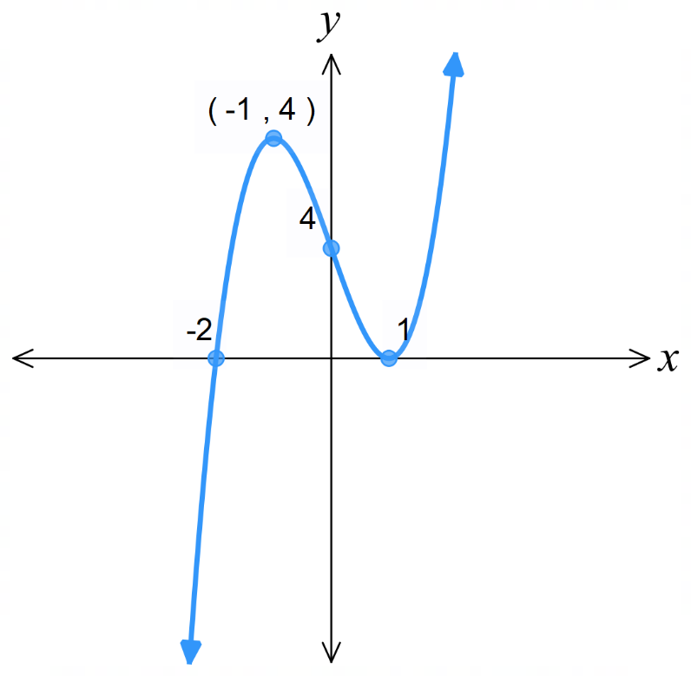  5. Complete sketch | - $y=\left(x-3\right)\left(x+2\right)\left(x-6\right)$  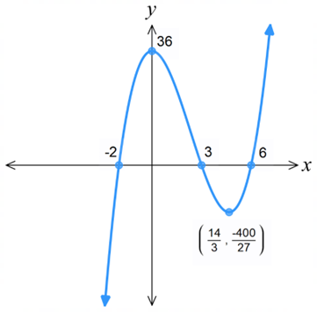
  $$x$$
  $$f'(x)$$
  Slope
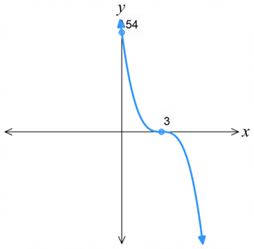
- $y=-2{\left(x-3\right)}^{3}$

Foundation
- $f\left(x\right)=x^{2}-4x+3$
  - Find the derivative of the function.
$$f^{'}\left(x\right)=2x-4$$
  - Find the coordinates of the stationary point.
$2x-4=0$; $x=2$
$$f\left(2\right)=4-4\left(2\right)+3=-1$$
$$∴\left(2,-1\right)$$
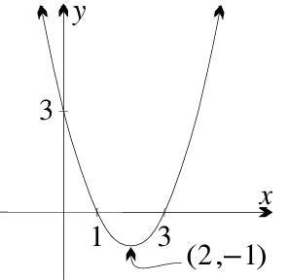
  - Use the given table to determine the nature of the stationary point.
$$x$$ | 1 | 2 | 3
$$f'(x)$$
Slope
$∴$ Min at $\left(2,-1\right)$
  - Sketch the graph.

  - Check your answer by completing the square for $f\left(x\right)=x^{2}-4x+3$.
By completing the square, this is
$$f\left(x\right)=x^{2}-4x+4-4+3$$
$$={\left(x-2\right)}^{2}-1$$
Which is a parabola with minimum at $\left(2,-1\right)$

  - Show that the derivative of $f\left(x\right)=x^{3}-3x^{2}$ is $f^{'}\left(x\right)=3x\left(x-2\right)$.

$$f^{'}\left(x\right)=3x^{2}-6x=3x\left(x-2\right)$$
  - Find the $x$-values of the turning points.
$$x=0 or 2$$
  - Using a slope table, determine the nature of the turning points.
$$x$$ |  | 0 |  | 2
$$f'(x)$$
Slope
Max at $x=0$, Min at $x=2$
  - Find the coordinates of the stationary points.
$$\left(0,0\right), \left(2,-4\right)$$
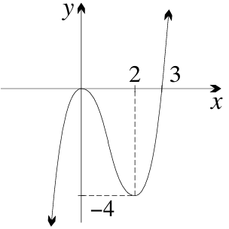
  - Sketch the graph of $y=f\left(x\right)$, by factorising it first.
Show all important features.

Development

  - Show that the derivative of $y=12x-x^{3}$ is $y^{'}=3\left(2-x\right)\left(2+x\right)$.

$$y^{'}=12-3x^{2}=3\left(4-x^{2}\right)$$
$$=3\left(2-x\right)\left(2+x\right)$$
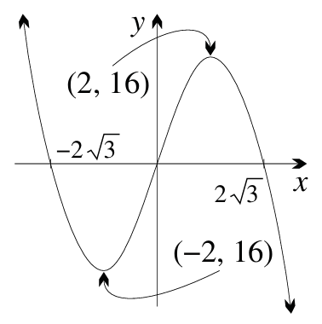
  - Use a table of values to find the nature of the turning points.
$$x$$
$$f'(x)$$
Slope
Max at $\left(2,16\right)$ Min at $\left(-2,-16\right)$
  - Sketch the graph of $y=12x-x^{3}$

- Sketch these cubic curves, showing all intercepts and turning points.
- $y=x^{2}\left(x-3\right)$  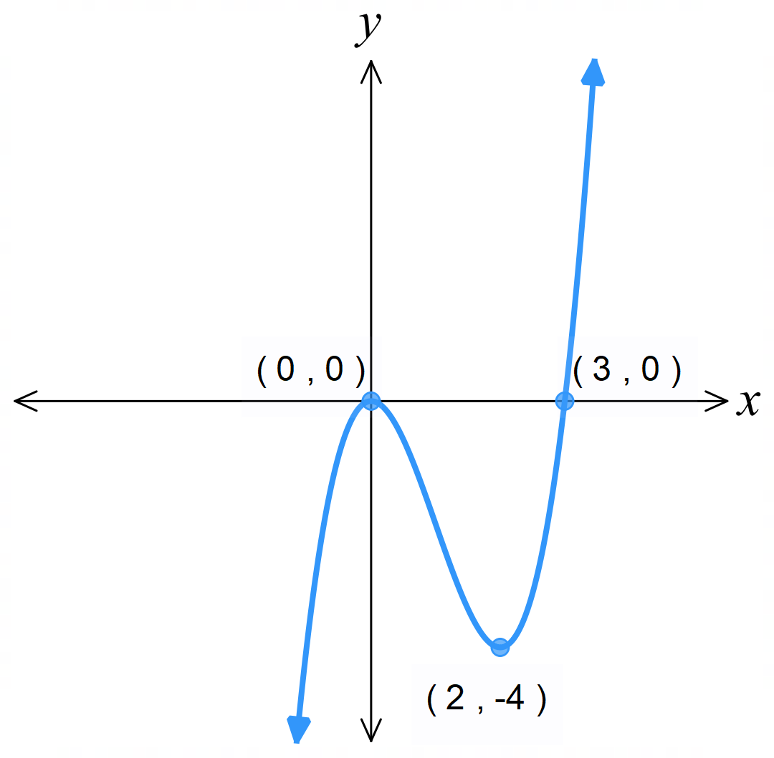 | - $y=x{\left(x+2\right)}^{2}$  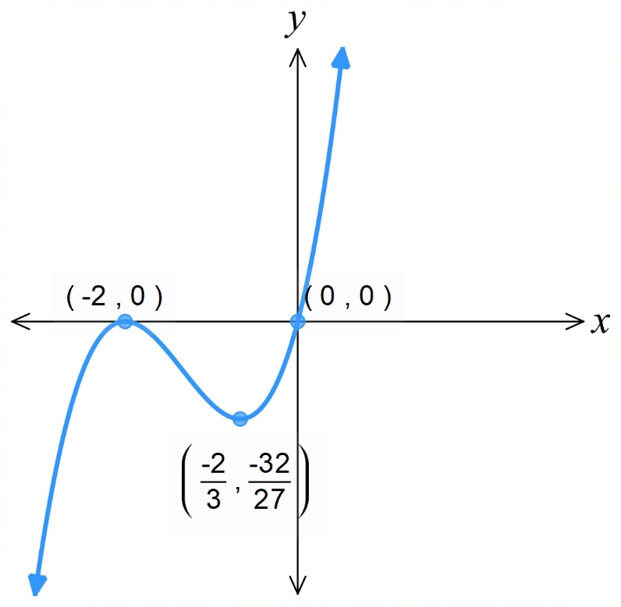
- $y={\left(x-1\right)}^{2}\left(x-4\right)$  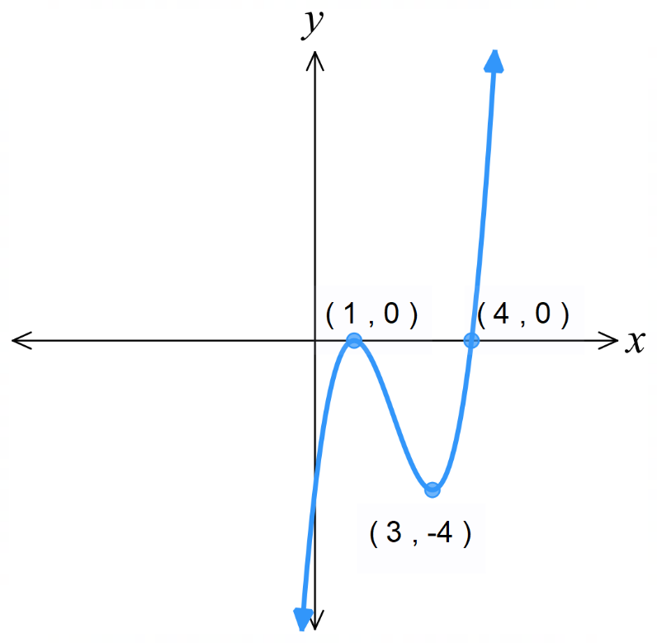 | - $y=\left(2x-1\right){\left(x-2\right)}^{2}$  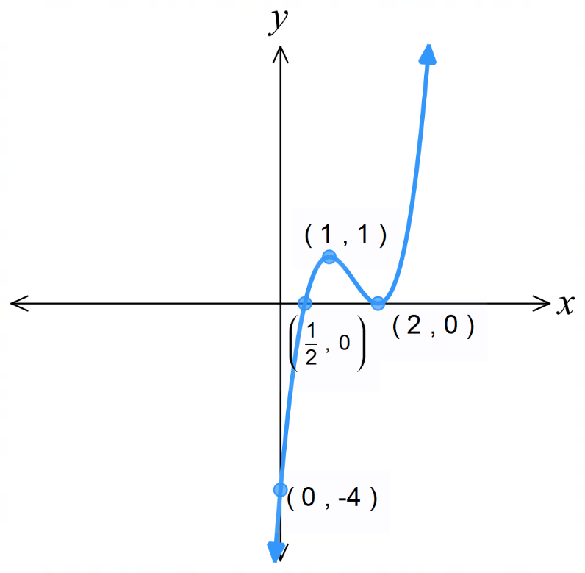
- $y=\left(x-4\right){\left(x-1\right)}^{2}$  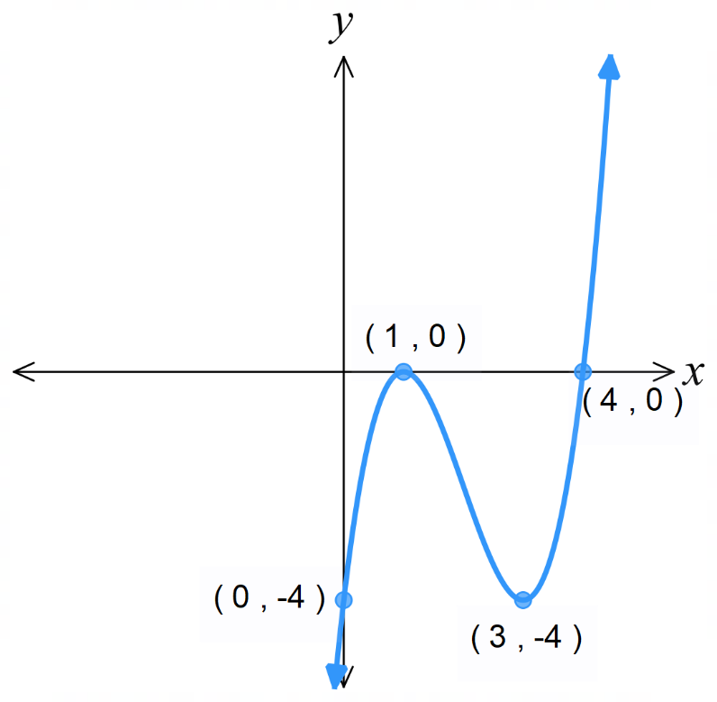 | - $y={\left(3x+1\right)}^{3}+1$  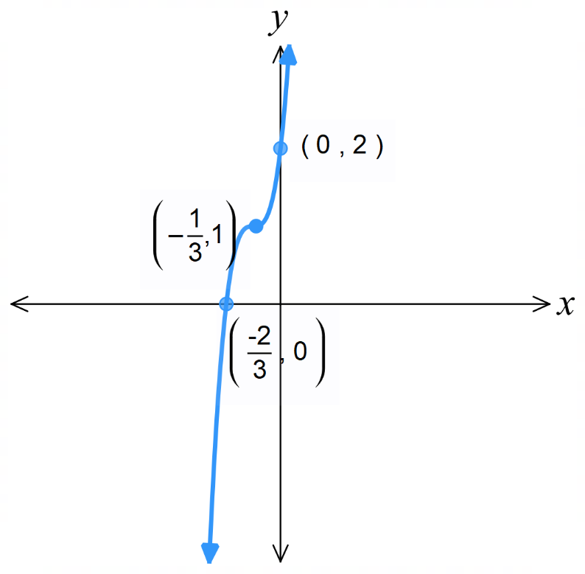
- $y={\left(x-5\right)}^{2}\left(2x+1\right)$  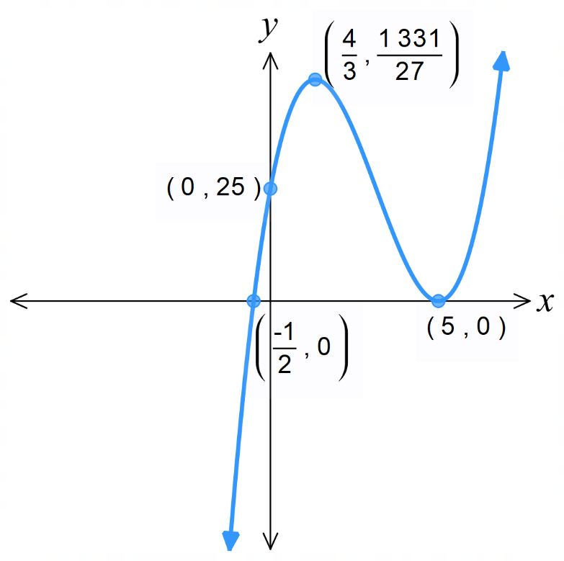 | - $y={\left(2x-1\right)}^{2}\left(x-2\right)$  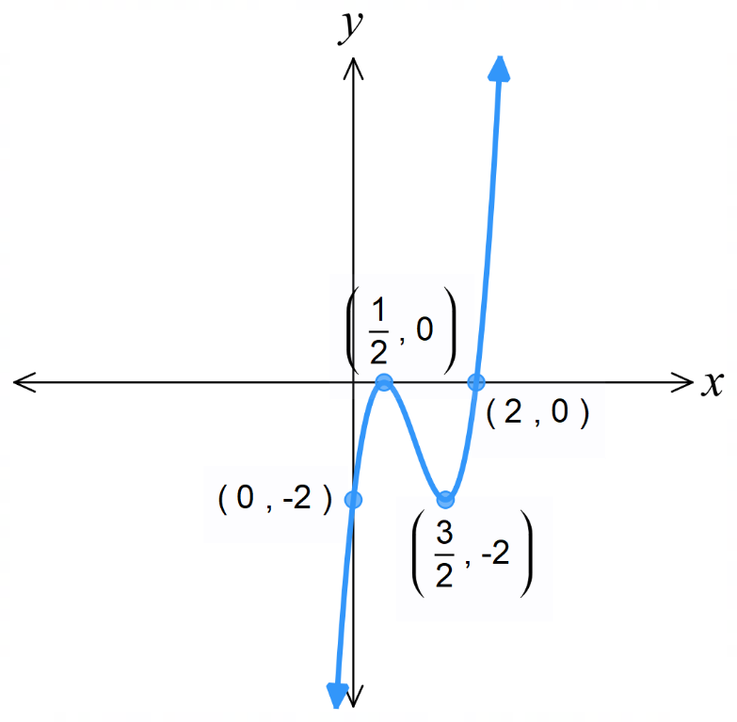
- $y=\left(x-1\right)\left(x+2\right)\left(x-3\right)$  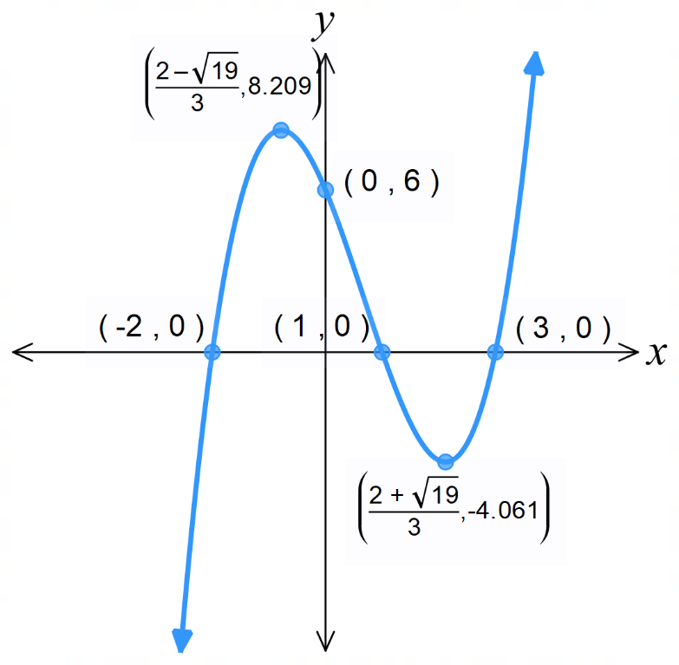 | - $y=-x\left(x+1\right)\left(x-2\right)$  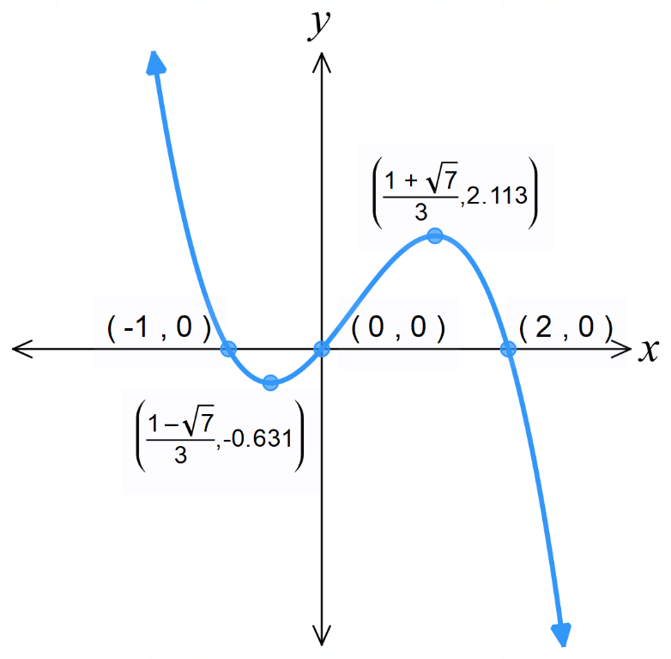

Mastery
- The tangent to $y=x^{2}+ax-15$is horizontal at the point $x=4$.
Find the value of $a$
$$y^{'}=2x+a$$
$$y^{'}\left(4\right)=8+a=0$$
$$a = -8$$
- The curve $y=x^{2}+ax+7$ has a turning point at $x=-1$.
Find the value of $a$.

$$y^{'}=2x+a$$
$$y^{'}\left(-1\right)=-2+a=0$$
$$a = 2$$
- The curve $f\left(x\right)=ax^{2}+4x+c$ has a turning point at $\left(-1,1\right)$. Find $a$ and $c$.

$$f^{'}\left(x\right)=2ax+4$$
$$f\left(-1\right)=a-4+c=1$$
$$f^{'}\left(-1\right)=-2a+4=0$$
$$a = 2, c = 3$$
- Find $b$ and $c$ if $y=x^{3}+bx^{2}+cx+5$ has stationary points at $x=-2$ and $x=4$.

$$f^{'}\left(x\right)=3x^{2}+2bx+c$$
$$f^{'}\left(-2\right)=12-4b+c=0$$
$$f^{'}\left(4\right)=48+8b+c=0$$
Solving simultaneously,
$$b = -3 c = -24$$

- The curve $y=ax^{2}+bx+c$ passes through the points $\left(1,4\right)$ and $\left(-1,6\right)$. There is a maximum turning point at $x=-0.5$.
  - Show that $a+b+c=4, a-b+c=6,$and $-a+b=0$

$$y\left(1\right)=a+b+c=4$$
$$y\left(-1\right)=a-b+c=6$$
$$y^{'}=2ax+b$$
$$y^{'}\left(-0.5\right)=-a+b=0$$
  - Find the values of $a, b, c$.

$$a = b = -1, c = 6$$

- The line $y=2x$ is tangent to the curve $y=ax^{2}+bx+c$ at the origin, and there is a maximum turning point at $x=1$.
  - Explain why $c=0.$
The curve passes through the origin, so y-intercept is 0.
  - Explain why $b=2$.
$$y^{'}=2ax+b$$
$$y^{'}\left(0\right)=b=2$$
  - Show that $2a+b=0$ and hence find the value of $a$.

$$y^{'}\left(1\right)=2a+b=0$$
$$a=-1$$

- The function $y=2x^{3}+bx^{2}+cx+d$ has $y$-intercept at $(0,7)$, a maximum turning point at
$x=-2$ and a minimum turning point at $x=1$. Find the values of $b,c,d.$

$$d=7$$
$$y^{'}=6x^{2}+2bx+c$$
$$y^{'}\left(-2\right)=24-4b+c=0$$
$$∴-4b+c=-24$$
$$y^{'}\left(1\right)=6+2b+c=0$$
$$∴2b+c=-6$$
Solving simultaneously,
$$b=3, c=-12$$

- Sketch $y=6x^{3}+x^{2}-35x$, showing all intercepts and turning points.
Give turning points as decimals to 3 d.p.

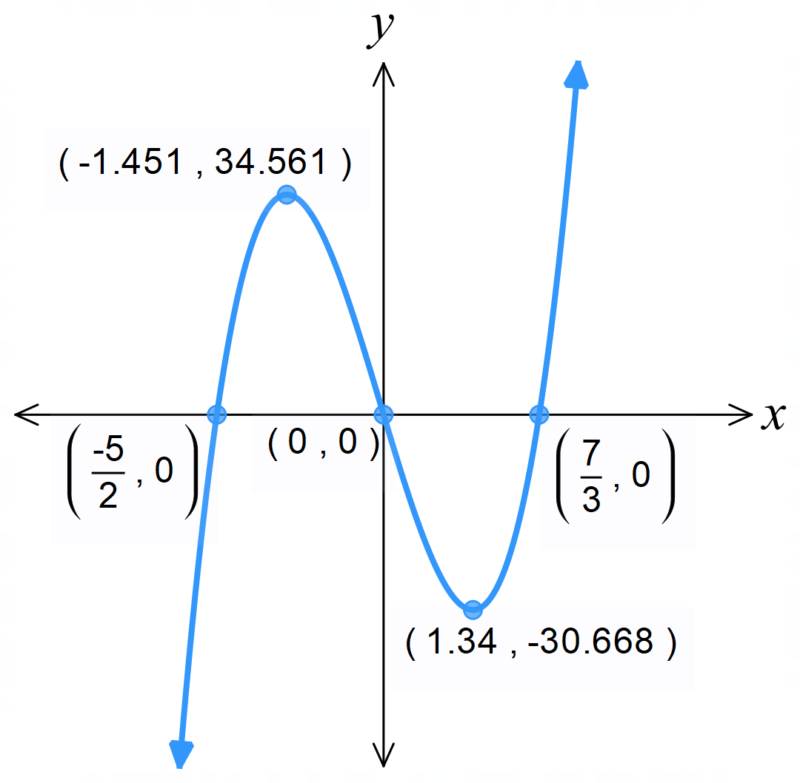

  - Use the product rule to show that if $y = x{\left(x - 2\right)}^{3},$ then $y' = 2\left(2x - 1\right){\left(x - 2\right)}^{2}.$
  - Find any stationary points and use a table of gradients to classify them.
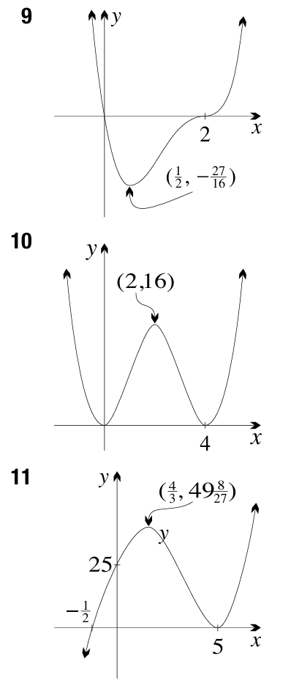
  - Sketch the graph of the function, indicating all important features.

  - Use the product rule to show that if $y = x^{2}{\left(x - 4\right)}^{2}$, then $\frac{dy}{dx}$ $= 4x\left(x - 4\right)\left(x - 2\right).$
  - Find any stationary points and use a table of gradients to classify them.
  - Sketch the graph of the function, indicating all important features.

  - Use the product rule to show that if $y = {\left(x - 5\right)}^{2}\left(2x + 1\right),$then $y' = 2\left(x - 5\right)\left(3x - 4\right).$
  - Find any stationary points and use a table of gradients to classify them.
  - Sketch the graph of the function, indicating all important features.

The Second Derivative

- The Second Derivative
The second derivative is the derivative of the derivative. There are many notations:

$$f^{''}\left(x\right)=f^{\left(2\right)}\left(x\right)=y^{''}=y^{\left(2\right)}=\frac{d^{2}y}{dx^{2}}$$

Foundation
- Find the first and second derivative.
- $y = 4 - 3x$  $$-3$$  $$0$$ | - $y = 4x³ - x²$  $$12x² - 2x$$  $$24x - 2$$ | - $y = x(x + 3)$  $$2x + 3$$  $$2$$
- $y = (x - 2)(x + 1)$  $$2x - 1$$  $$2$$ | - $y = 3x²(2x³ - 3x²)$  $$30x^{4}- 36x^{3}$$  $$120x³ - 108x²$$ | - $y =$ $\frac{1}{x^{3}}$  $$-\frac{3}{x^{4}}$$  $$\frac{12}{x^{5}}$$
- $y =$ $\frac{3}{x^{2}}$  $$-\frac{6}{x^{3}}$$  $$\frac{18}{x^{4}}$$ | - $y = (x + 1)²$  $$2\left(x + 1\right)$$  $$2$$ | - $y = (1 - 4x)²$  $$8\left(4x - 1\right)$$  $$32$$
- $y =$ $\frac{1}{x + 2}$  $$-\frac{1}{{\left(x + 2\right)}^{2}}$$  $$\frac{2}{{\left(x + 2\right)}^{3}}$$ | - $y =$ $\frac{1}{{\left(5x + 4\right)}^{3}}$  $$-\frac{15}{{\left(5x + 4\right)}^{4}}$$  $$\frac{300}{{\left(5x+4\right)}^{4}}$$ | - $y = \sqrt{x}$  $$\frac{1}{2\sqrt{x}},$$  $$-\frac{1}{4x\sqrt{x}}$$
- $y = x\sqrt{x}$  $$\frac{3\sqrt{x}}{2},$$  $$\frac{3}{4\sqrt{x}}$$ | - $y = \sqrt{x + 2}$  $$\frac{1}{2\sqrt{x + 2}},$$  $$-\frac{1}{4{\left(x + 2\right)}^{\frac{3}{2}}}$$ | - $y = \sqrt{1-4x}$  $$-\frac{2}{\sqrt{1 - 4x}},$$  $$-\frac{4}{{\left(1 - 4x\right)}^{\frac{3}{2}}}$$

  - Find $f^{'}\left(x\right)$ and $f^{''}\left(x\right)$ for $f\left(x\right)=x^{3}+3x^{2}+5x-6$.
$$f'(x) = 3x² + 6x + 5,$$
$$f''(x) = 6x + 6$$
  - Hence evaluate:
- $f^{'}\left(0\right)$  5 | - $f^{'}\left(1\right)$  14 | - $f^{''}\left(0\right)$  6 | - $f^{''}\left(1\right)$  12

  - Find $f^{'}\left(x\right)$ and $f^{''}\left(x\right)$ for $f\left(x\right)={\left(2x-3\right)}^{4}$
$$f'(x) = 8(2x - 3)³,$$
$$f''(x) = 48{\left(2x - 3\right)}^{2}$$

  - Hence evaluate:
- $f^{'}\left(1\right)$  -8 | - $f^{''}\left(1\right)$  48

- Use the quotient rule to find the first derivative of each function.
Then use the chain rule to find the second derivative.
- $y =$ $\frac{x}{x + 1}$  $$\frac{dy}{dx}=\frac{1}{{\left(x+1\right)}^{2}};$$  $$\frac{d^{2}y}{dx^{2}}= -\frac{2}{{\left(x+1\right)}^{3}}$$ | - $y =$ $\frac{x - 1}{2x + 5}$  $$\frac{dy}{dx}=\frac{7}{{\left(2x + 5\right)}^{2}};$$  $$\frac{d^{2}y}{dx^{2}}= -\frac{28}{{\left(2x + 5\right)}^{3}}$$

- If $f(x) = x(x - 1)⁴$, use the product rule to find $f'(x)$ and $f^{''}\left(x\right)$ in fully factored form.

$$f^{'}\left(x\right)= {\left(x - 1\right)}^{3}\left(5x - 1\right)$$
$$f''(x) = 4(x - 1)²(5x - 2)$$
- Find the values of $x$ for which $y'' = 0$ if:
- $y = x⁴ - 6x² + 11$  $$y'' = 12x² - 12 = 0;$$  $$x = 1, -1$$ | - $y = x³ + x² - 5x + 7$  $$y'' = 6x + 2 = 0;$$  $$x = -\frac{1}{3}$$

Concavity and Points of Inflection

- Concavity
Concave Up $∪$  The curve bends upwards.  The slope increases as you move left to right. | Concave Down $∩$  The curve bends downwards.  The slope decreases as you move left to right.  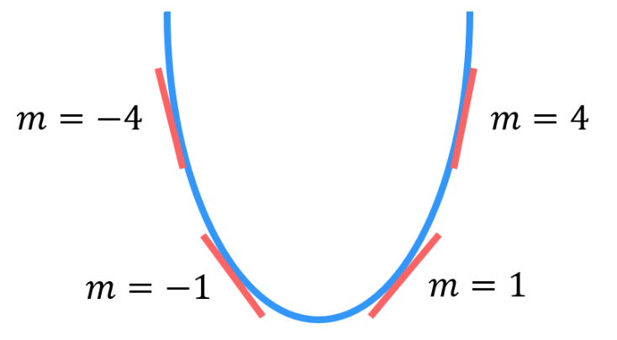  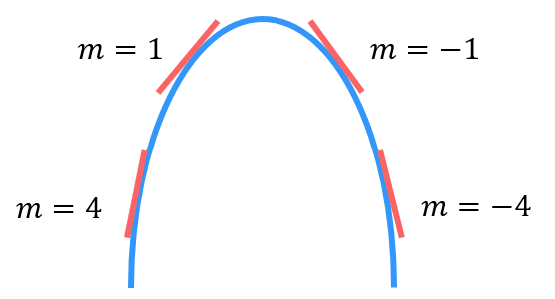

- Identify Concavity at a point from a graph.
Identify whether the graph is concave up or down at $x=a.$
Concave down  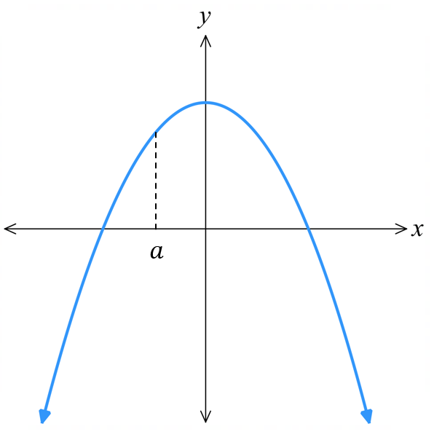 | Concave down  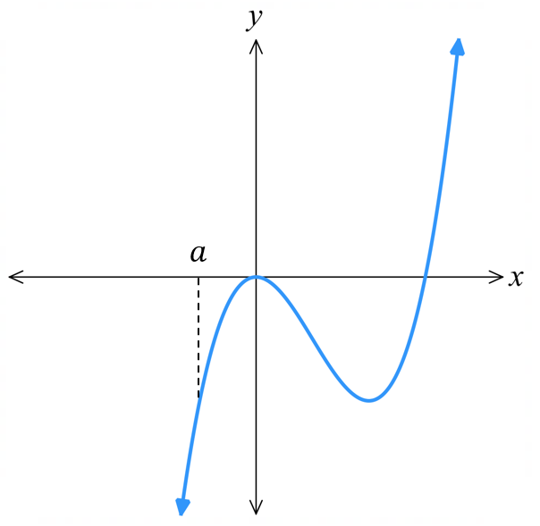 | Concave up  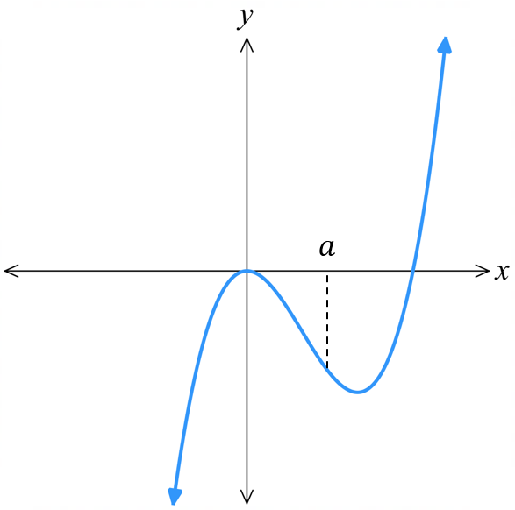
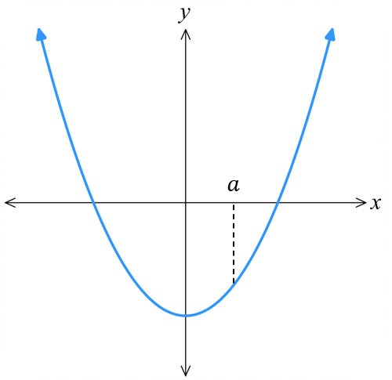 | 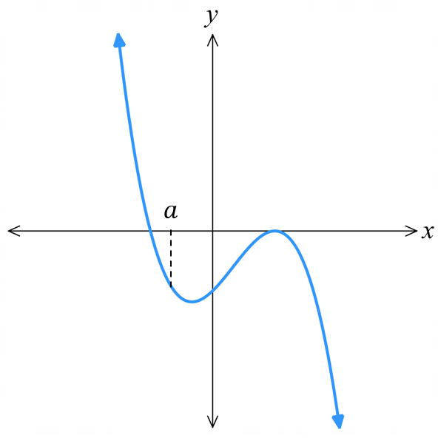 | 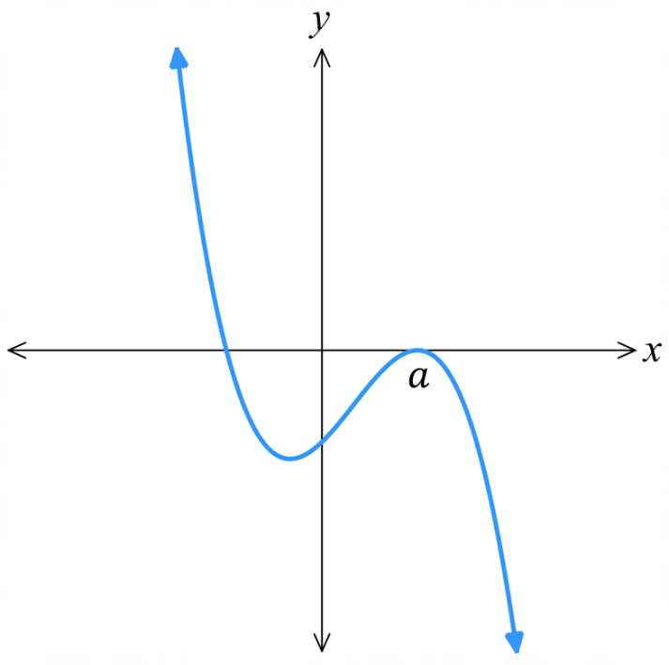

- Concavity and the Second Derivative
The second derivative tells us the rate of change of the gradient, and therefore the concavity.
Concave Up $∪$  $$f^{''}\left(x\right)>0$$ | Concave Down $∩$  $$f^{''}\left(x\right)<0$$
To find domain over which a curve has a certain concavity:
1. Find the second derivative $f^{''}\left(x\right)$.
2. Find where $f^{''}\left(x\right)>0$ for concave up, $f^{''}\left(x\right)<0$ for concave down.

- Example Find domain over which a curve has a certain concavity.
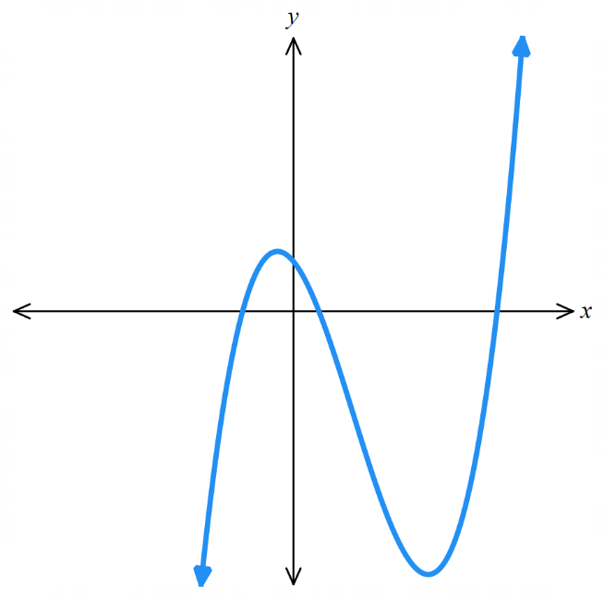
Find the domain over which the curve $f\left(x\right)=2x^{3}-7x^{2}-5x+4$ is concave downwards.
$$f^{'}\left(x\right)=6x^{2}-14x-5$$
$$f^{''}\left(x\right)=12x-14$$
For concave downwards:
$$f^{''}\left(x\right)<0$$
$$12x-14<0$$
$$x<\frac{7}{6}$$
$∴$ concave down for $\left(-∞,\frac{7}{6}\right)$

- Practice
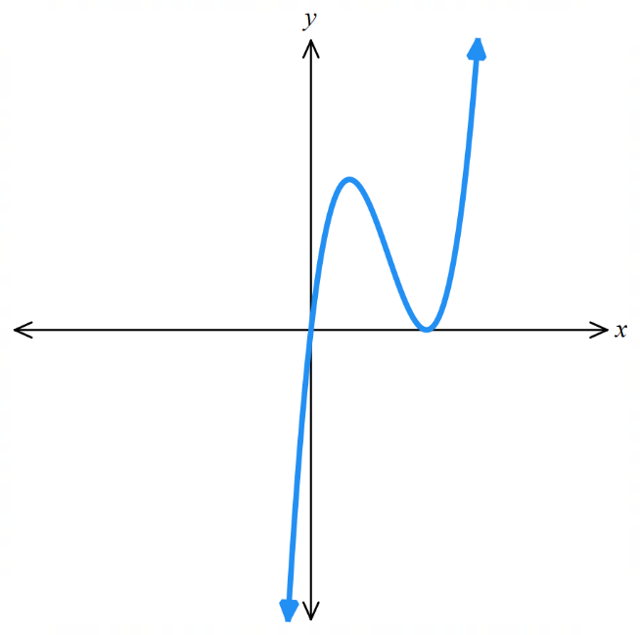
Find the domain over which the curve $f\left(x\right)=x^{3}-6x^{2}+9x$ is concave upwards.

$$\left(2.∞\right)$$
- Points of Inflection
When $f^{''}\left(x\right)=0$, it may be a point of inflection, where a curve changes between concave up and down. There are three possibilities:
Inflection point  (Fastest rate of change in a neighbourhood)  $f^{''}\left(x\right)$changes sign &  $f^{'}\left(x\right)≠0$.  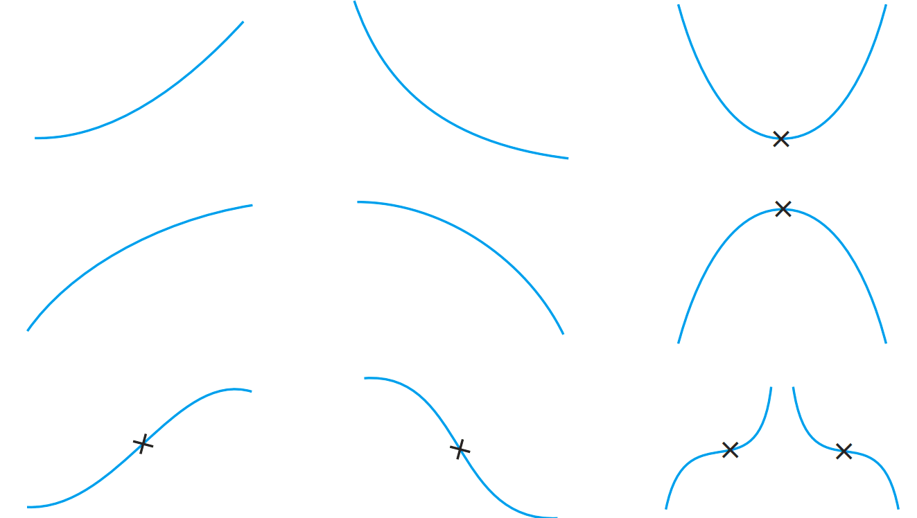 | Horizontal inflection point  $f^{''}\left(x\right)$ changes sign &  $f^{'}\left(x\right)=0$. | Very flat turning point  (not an inflection point,  called an undulation point)  $f^{''}\left(x\right)$ doesn’t change sign.
To find and classify inflection points:
1. Find the second derivative $f^{''}\left(x\right)$ and find possible inflection points.
2. Draw up a table of concavities to see if they are inflection points; sign must change.
Substitute inflection points into $f^{'}\left(x\right)$ to check if it is a horizontal inflection point.
Remember to find the $y$ value at the inflection point.

- Example Find and classify points of inflection.
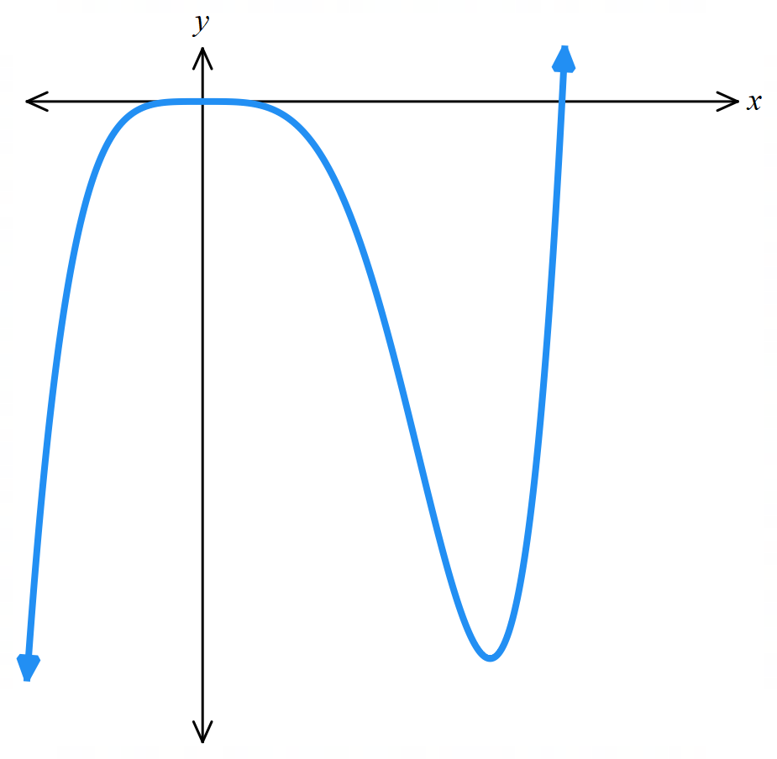
Find and classify point(s) of inflection on $f\left(x\right)=x^{5}-5x^{4}$.
1. $f^{'}\left(x\right)=5x^{4}-20x^{3}$
$f^{''}\left(x\right)=20x^{3}-60x^{2}$
$20x^{3}-60x^{2}=0$
$20x^{2}\left(x-3\right)=0$
$x=0, 3$ are possible inflection points
2.
$$x$$ | $$-1$$ | 0 | 1 | 3 | $$4$$
$$f''(x)$$ | $$-80$$ | 0 | $$-40$$ | $$0$$ | $$320$$
concavity | $$∩$$ | $$⋅$$ | $$∩$$ | $$⋅$$ | $$∪$$

At $x=0$, no point of inflection
At $x=3$, inflection point, $f\left(3\right)=-162$ $∴$ point is $\left(3,-162\right)$
$$f^{'}\left(3\right)=-135$$
$∴$ at $\left(3,-165\right)$ there is an inflection point; fastest decrease in that neighbourhood.

- Practice
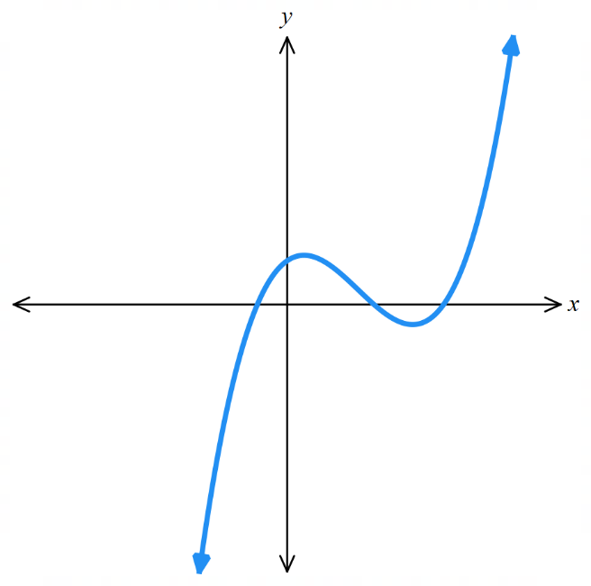
Find the point(s) of inflection on the curve $y=x^{3}-6x^{2}+5x+9$.
1. Find $y''$ and possible inflection points

2. Test whether point(s) are inflection points and whether they are
horizontal inflection point(s)
$$x$$
$$f''(x)$$
concavity

Inflection point at $\left(2,3\right)$
Find any points of inflection on the curve $y=x^{4}-5x^{3}+6x^{2}+4x-7$.
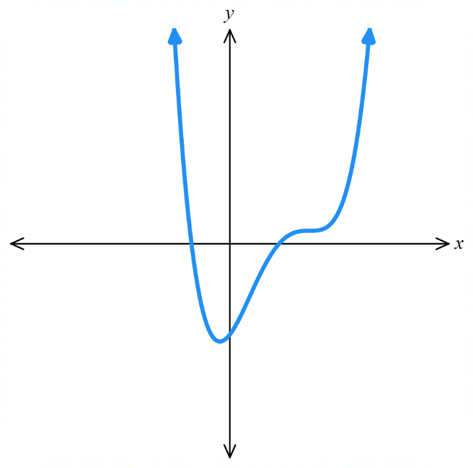

$$\left(\frac{1}{2}, -\frac{65}{16}\right):Inflection point$$
$$\left(2, 1\right):Horizontal inflection point$$

Foundation
- Complete the table below for the function shown.
At each point, state whether the first and second derivatives are positive, negative or zero.
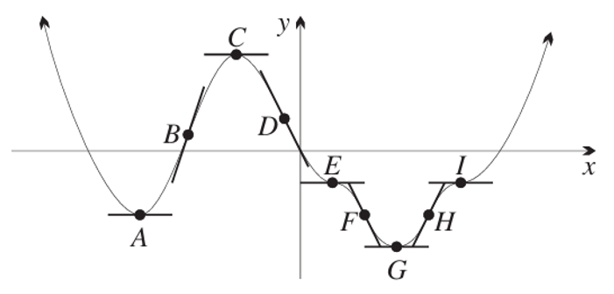
Point | A | B | C | D | E | F | G | H | I
$$y'$$ | 0 | + | 0 | − | 0 | − | 0 | + | 0
$$y″$$ | + | 0 | − | 0 | 0 | 0 | + | 0 | 0

- Find $f″(x)$ for each function. By evaluating$f″(0)$, state whether the curve is concave up $(f″(x) > 0)$ or concave down $(f″(x) < 0)$ at $x = 0$.
- $f\left(x\right)= x^{3}- 3x^{2}$  $$f'(x) = 3x² - 6x$$  $$f″(x) = 6x - 6$$  $$f″(0) = -6$$  $$Concave down at x = 0$$ | - $f\left(x\right)= x^{3}+ 4x^{2}- 5x + 7$  $$f'(x) = 3x² + 8x - 5$$  $$f″(x) = 6x + 8$$  $$f″(0) = 8$$  $$Concave up at x = 0$$
- $f\left(x\right)= x^{4}+ 2x^{2}- 3$  $$f'(x) = 4x³ + 4x$$  $$f″(x) = 12x² + 4$$  $$f″(0) = 4$$  $$Concave up at x = 0$$ | - $f\left(x\right)= 6x - 7x^{2}- 8x^{4}$  $$f'(x) = 6 - 14x - 32x³$$  $$f″(x) = -14 - 96x²$$  $$f″(0) = -14$$  $$Concave down at x = 0$$

- A curve is concave up when $\frac{d^{2}y}{dx^{2}}> 0$ and concave down when $\frac{d^{2}y}{dx^{2}}< 0$.
  - Explain why $y = x^{2}- 3x + 7$ is concave up for all values of $x$.

$$\frac{dy}{dx}= 2x - 3$$
$$\frac{d^{2}y}{dx^{2}}= 2$$
Since $\frac{d^{2}y}{dx^{2}}= 2 > 0$ for all $x$, the curve is concave up for all values of $x$.
  - Explain why $y = -3x^{2}+ 2x - 4$ is concave down for all values of $x$.
$$\frac{dy}{dx}= -6x + 2$$
$$\frac{d^{2}y}{dx^{2}}= -6$$
Since $\frac{d^{2}y}{dx^{2}}= -6 < 0$ for all $x$, the curve is concave down for all values of $x$.

Development

  - Find the second derivative $\frac{d^{2}y}{dx^{2}}$ of $y = x^{3}- 3x^{2}- 5x + 2$.
$$\frac{dy}{dx}= 3x^{2}- 6x - 5$$
$$\frac{d^{2}y}{dx^{2}}= 6x - 6$$
  - Hence find the values of $x$ for which the curve is:
- concave up,  $$6x - 6 > 0$$  $$6x > 6$$  $$x > 1$$ | - concave down.  $$6x - 6 < 0$$  $$6x < 6$$  $$x < 1$$

  - Find the second derivative $\frac{d^{2}y}{dx^{2}}$ of $y = x^{3}- x^{2}- 5x + 1$.
  - Hence find the values of $x$ for which the curve is:
- concave up,  $$6x - 2 > 0$$  $$6x > 2$$  $$x >\frac{1}{3}$$ | - concave down.  $$6x - 2 < 0$$  $$6x < 2$$  $$x <\frac{1}{3}$$

- A function has second derivative $y’’= 3x³(x + 3)²(x - 2).$
Determine the $x$-coordinates of the points of inflection on the graph of the function using a table of concavities.
$$y^{''}= 3x^{3}{\left(x + 3\right)}^{2}\left(x - 2\right)= 0$$
$$x=0, -3, or 2$$
At $x = 0$:
$$x$$ | −1 | 0 | 1
$$y″$$ | 36 | 0 | $$-48$$
Sign changes, so $x = 0$ is a point of inflection.
At $x = 2$:
$$x$$ | 1 | 2 | 3
$$y″$$ | $$-48$$ | 0 | 2916
Sign changes, so $x = 2$is a point of inflection.
At $x = -3$:
$$x$$ | −4 | −3 | −2
$$y″$$ | 1152 | 0 | 96
No sign change, so $x = -3$is not a point of inflection.

- Find the range of values of x for which the curve $y = 2x^{3}- 3x^{2}- 12x + 8$ is:
$$y^{'}= 6x^{2}- 6x - 12 = 6\left(x - 2\right)\left(x + 1\right)$$
$$y^{″}= 12x - 6 = 6\left(2x - 1\right)$$
- increasing  $$x > 2 or x < -1$$ | - decreasing  $$-1 < x < 2$$
- concave up  $$x >\frac{1}{2}$$ | - concave down  $$x <\frac{1}{2}$$

  - If $y = x^{3}+ 3x^{2}- 72x + 14$, find $y'$ and $y''$.

$$y^{'}= 3x^{2}+ 6x - 72$$
$$y^{″}= 6x + 6$$
  - Show that the curve has a point of inflection at $(-1, 88).$
$$At x = -1:$$
$$y^{″}= 6\left(-1\right)+ 6 = 0$$
At x = −1:
$$x$$ | $$-2$$ | $$-1$$ | $$0$$
$$y″$$ | $$-6$$ | $$0$$ | $$6$$
Sign changes from negative to positive, confirming point of inflection at $x = -1$.
$$y={\left(-1\right)}^{3}+ 3{\left(-1\right)}^{2}- 72\left(-1\right)+ 14=88$$
$$Point of inflection at \left(-1, 88\right)$$
  - Show that the gradient of the tangent at the point of inflection is $-75$.

$$At x = -1:$$
$$y^{'}= 3{\left(-1\right)}^{2}+ 6\left(-1\right)- 72 =-75$$
$$Gradient is -75$$
  - Hence find the equation of the tangent at the point of inflection.

$$Using y - y₁ = m(x - x₁):$$
$$y - 88 = -75(x - (-1))$$
$$y - 88 = -75x - 75$$
$$y = -75x + 13$$
- Find $a$ if the curve $y = x^{3}- ax^{2}+ 3x - 4$ has an inflection at the point where $x = 2$.

$$y^{'}= 3x^{2}- 2ax + 3$$
$$y^{″}= 6x - 2a$$
$$Inflection at x = 2: y^{″}\left(2\right)= 0$$
$$6(2) - 2a = 0$$
$$12 - 2a = 0$$
$$a = 6$$

Mastery
- For what values of $a$ is $y = x^{3}+ 2ax^{2}+ 3x - 4$ concave up at the point where $x = -1$?
$$y^{'}= 3x^{2}+ 4ax + 3$$
$$y^{″}= 6x + 4a$$
$$Concave up at x = -1: y^{″}> 0$$
$$6\left(-1\right)+ 4a > 0$$
$$-6 + 4a > 0$$
$$4a > 6$$
$$a >\frac{3}{2}$$

- Find $a$ and $b$ if the curve $y = x⁴ + ax³ + bx²$ has an inflection at $(2, 0).$
$$y^{'}= 4x^{3}+ 3ax^{2}+ 2bx$$
$$y^{″}= 12x^{2}+ 6ax + 2b$$
$$Inflection at \left(2, 0\right):$$
$$y^{″}\left(2\right) = 0: 12(2)² + 6a(2) + 2b = 0$$
$$48 + 12a + 2b = 0$$
$$24 + 6a + b = 0 ... \left(1\right)$$
$$y\left(2\right) = 0: {\left(2\right)}^{4}+ a{\left(2\right)}^{3}+ b{\left(2\right)}^{2}= 0$$
$$16 + 8a + 4b = 0$$
$$4 + 2a + b = 0 ... \left(2\right)$$
$$Subtract (2) from (1):$$
$$20 + 4a = 0$$
$$a = -5$$
$$Substitute into (2):$$
$$4 + 2(-5) + b = 0$$
$$b = 6$$

- For what values of $a$ is $y = x⁴ + ax³ - x^{2}$ concave up and increasing when $x = 1$?
$$y^{'}= 4x^{3}+ 3ax^{2}- 2x$$
$$y^{″}= 12x^{2}+ 6ax - 2$$
$$At x = 1, concave up: y^{″}> 0$$
$$12(1)² + 6a(1) - 2 > 0$$
$$10 + 6a > 0$$
$$a > -\frac{5}{3}$$
$$At x = 1, increasing: y^{'}\left(1\right)> 0$$
$$4(1)³ + 3a(1)² - 2(1) > 0$$
$$4 + 3a - 2 > 0$$
$$3a > -2$$
$$a > -\frac{2}{3}$$
$$Both conditions satisfied when: a > -\frac{2}{3}$$

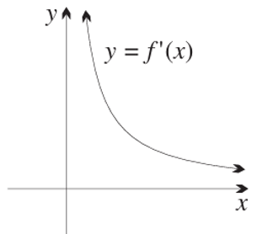
- The diagram shows the graph of the derivative $y = f^{'}\left(x\right)$
of the function $y = f(x),$ with domain $x>0$.
  - State whether the graph of $y = f\left(x\right)$ is
increasing or decreasing throughout its domain.

Since $f'(x) > 0$ for all x > 0, $f(x)$ is increasing throughout its domain.
  - State whether the graph of $y = f\left(x\right)$ is
concave up or concave down throughout its domain.

Since $f'(x)$ is decreasing (gradient is negative), $f″(x) < 0$, so $f(x)$ is concave down throughout its domain.

- A function has equation $y =\frac{x^{3}}{3}- 3x^{2}+ 11x - 9$.
  - Show that the function has no stationary points.
$$y^{'}= x^{2}- 6x + 11$$
For stationary points: $y^{'}= 0$
$$x^{2}- 6x + 11 = 0$$
Discriminant: $Δ = {\left(-6\right)}^{2}- 4\left(1\right)\left(11\right)=-8 < 0$
No real solutions, so no stationary points.
  - Show that there is a point of inflection.
$$y^{″}= 2x - 6$$
Setting $y^{″}= 0:$
$$2x - 6 = 0$$
$$x = 3$$
At x = 3:
$$x$$ | 2 | 3 | 4
$$y″$$ | −2 | 0 | 2
Sign changes from negative to positive, confirming a point of inflection at x = 3.

  - How many $x$-intercepts does the graph of the function have? Justify your answer.

From part a, since $f^{'}\left(x\right)$ is a positive parabola that never crosses the axis, $f^{'}\left(x\right)>0$.
Therefore, the graph is always increasing.
A graph that tends to $∞$ that is always increasing without a domain restriction will cross the $x$-axis once and only once.

Classifying Stationary Points using the Second Derivative

- The Second Derivative and Stationary Points
Minimum Turning Point  $$f^{'}\left(x\right)=0$$  $$f^{''}\left(x\right)>0$$ | Maximum Turning Point  $$f^{'}\left(x\right)=0$$  $$f^{''}\left(x\right)<0$$ | Horizontal Inflection  $$f^{'}\left(x\right)=0$$  $$f^{''}\left(x\right)=0$$  If $f^{''}\left(x\right)$ doesn’t change sign, undulation point
Instead of the table of slopes method, we can use the second derivative to classify the stationary points.
1. Find $f^{'}\left(x\right)$
2. Find stationary points $f^{'}\left(x\right)=0,$ remember to find $y$ values.
3. Find $f^{''}\left(x\right)$
4. Test stationary points by substituting $x$ values into $f^{''}\left(x\right)$.
If $f^{''}\left(x\right)=0$, use a table of slopes to find whether it is an inflection or undulation point.
- The second derivative method can be faster than the slope table method if the second derivative is easy to find, and if there are no inflection points.

- Example Classify stationary points using the second derivative.
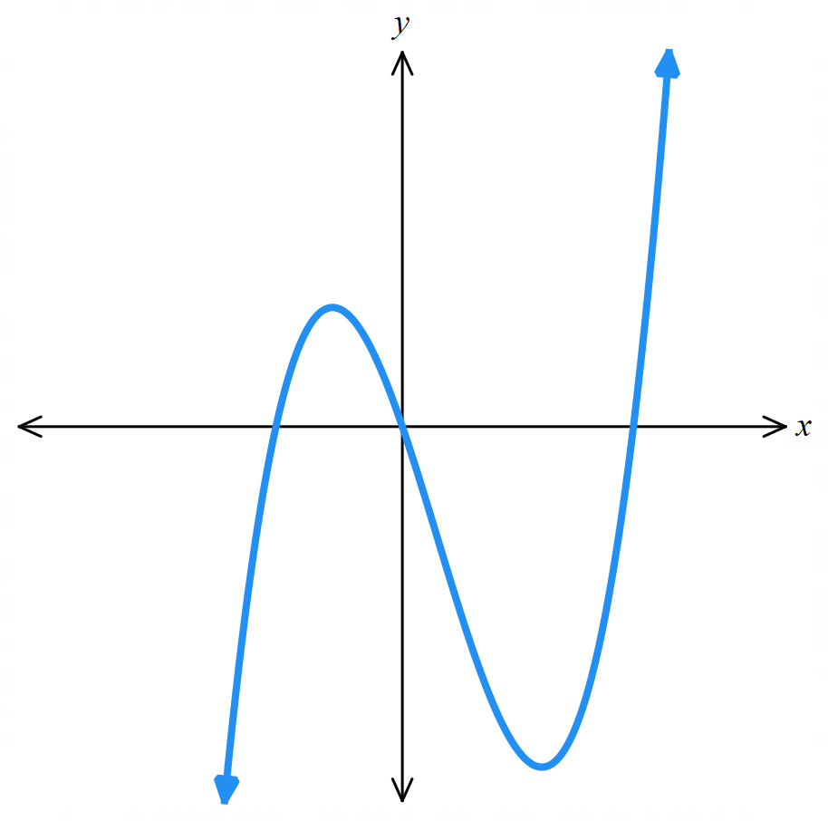
Find and classify the stationary points on $f\left(x\right)=2x^{3}-3x^{2}-12x$.
1. $f^{'}\left(x\right)=6x^{2}-6x-12$
2. $6x^{2}-6x-12=0$
$x^{2}-x-2=0$
$$\left(x-2\right)\left(x+1\right)=0$$
Stationary points at $x=2, -1$
$$∴\left(2,-20\right), \left(-1,7\right)$$
3. $f^{''}\left(x\right)=12x-6$
4. $f^{''}\left(2\right)=18>0$, so minimum at $\left(2,-20\right)$
$f^{''}\left(-1\right)=-18<0$, so maximum at $\left(-1,7\right)$

- Practice
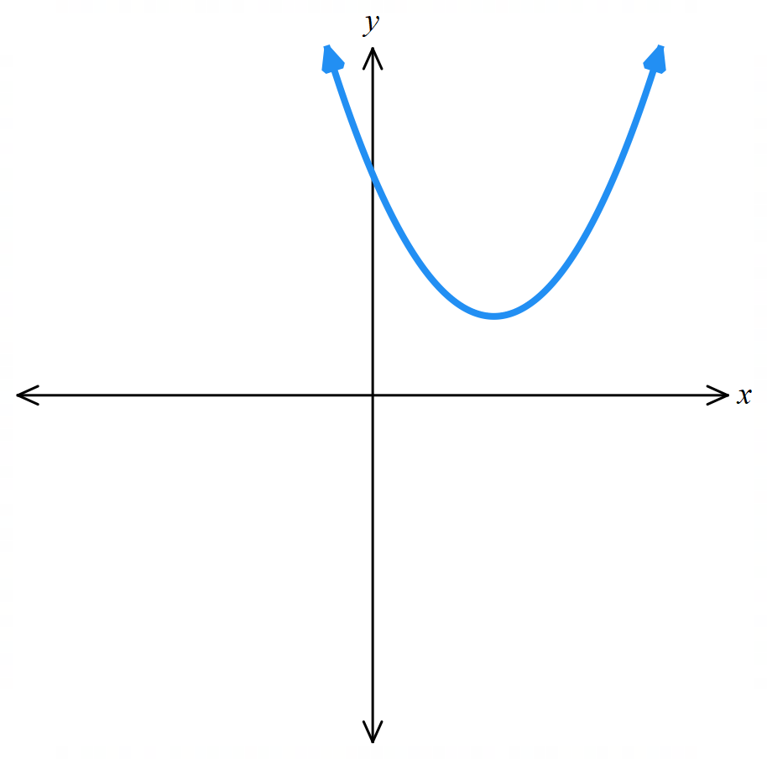
Find and classify the stationary point on $f\left(x\right)={\left(x-3\right)}^{2}+5$.

Min at $\left(3, 5\right)$
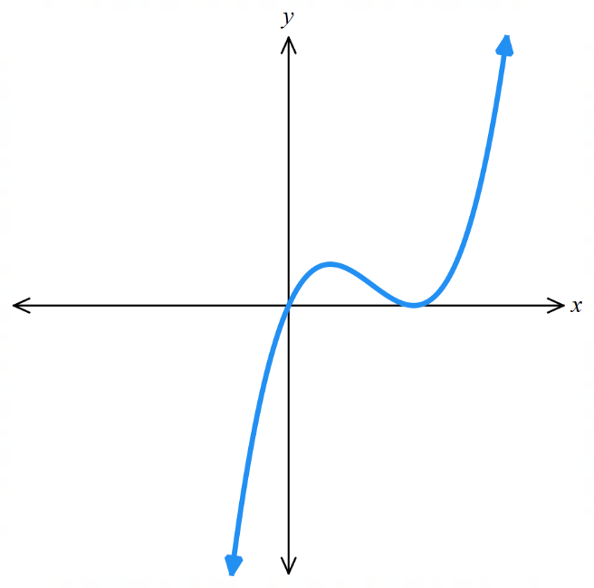
Find and classify the stationary points on $f\left(x\right)=x^{3}-4x^{2}+4x$.

$$Max at \left(\frac{2}{3},\frac{32}{27}\right), Min at \left(2,0\right)$$
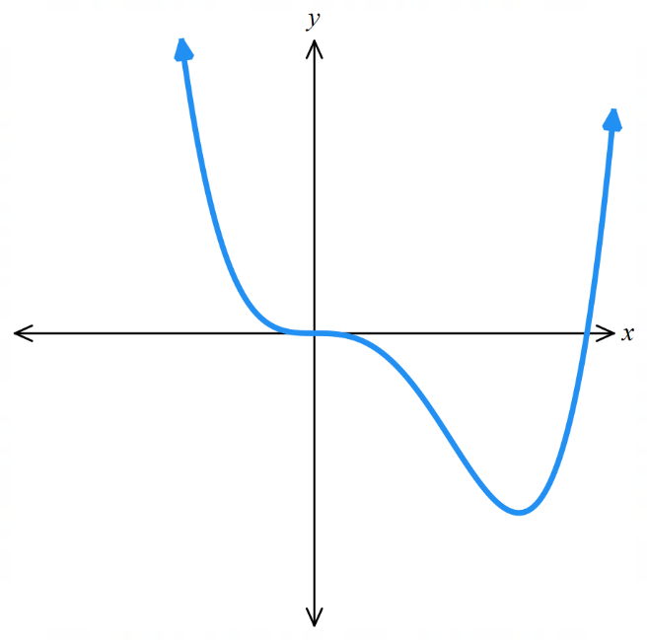
Find and classify the stationary points on $f\left(x\right)=x^{4}-4x^{3}$.

Horizontal inflection point at $\left(0,0\right)$, Min at $\left(3,-27\right)$

- Summary of First and Second Derivatives
 | $$f^{'}\left(x\right)>0$$  Increasing | $$f^{'}\left(x\right)<0$$  Decreasing | $$f^{'}\left(x\right)=0$$  Stationary point
$$f^{''}\left(x\right)>0$$  Concave up | Increasing at an increasing rate | Decreasing at a decreasing rate | Minimum turning point
$$f^{''}\left(x\right)<0$$  Concave down | Increasing at a decreasing rate | Decreasing at an increasing rate | Maximum turning point
$$f^{''}\left(x\right)=0$$  Possible point of inflection,  only if $f^{''}\left(x\right)$ changes sign around the point. | Fastest rate of increase  Concavity changes from positive to negative. | Fastest rate of decrease  Concavity changes from negative to positive. | Stationary inflection point  If $f^{''}\left(x\right)$ doesn’t change sign:  very flat turning point

Foundation
- Find the stationary point on the curve $y = x^{2}- 2x + 1$ and determine its nature.
$$\frac{dy}{dx}= 2x - 2 = 0$$
$$x = 1, y = 0$$
$$\frac{d^{2}y}{dx^{2}}= 2 > 0$$
(1, 0), minimum

- Find the stationary point on the curve $y = 3x^{2}- 12x + 7$ and show that it is a minimum turning point.
$$\frac{dy}{dx}= 6x - 12 = 0$$
$$x = 2, y = -5$$
$$\frac{d^{2}y}{dx^{2}}= 6 > 0$$
(2, −5), minimum

- Determine the stationary point on $y = x - x^{2}$ and show that it is a maximum point.
$$\frac{dy}{dx}= 1 - 2x = 0$$
$$x =\frac{1}{2}, y =\frac{1}{4}$$
$$\frac{d^{2}y}{dx^{2}}= -2 < 0$$
$$\left(\frac{1}{2},\frac{1}{4}\right), maximum$$
- Show that $f\left(x\right)= 2x^{3}- 5$ has a horizontal point of inflection and find its coordinates.
$$f^{'}\left(x\right)= 6x^{2}= 0$$
$$x = 0, y = -5$$
$$f^{''}\left(x\right)= 12x$$
$$f^{''}\left(0\right)=0$$
$$f^{''}\left(-1\right)=-12, f^{''}\left(1\right)=12$$
$(0, -5),$ horizontal point of inflection as $f^{''}\left(0\right)=0$ and concavity changes sign.
- Does the function $f\left(x\right)= 2x^{5}+ 3$ have a stationary point? If it does, determine its nature.
$$f^{'}\left(x\right)= 10x^{4}= 0$$
$$x = 0, y = 3$$
$$f^{''}\left(x\right)= 40x^{3}= 0$$
$$f''(0)=0$$
$$f^{''}\left(-1\right)=-40, f^{''}\left(1\right)=40$$
Horizontal point of inflection at $(0, 3)$ as $f^{''}\left(0\right)=0$ and concavity changes sign.
- Find any stationary points on $f\left(x\right)= 2x^{3}+ 15x^{2}+ 36x - 50$ and determine their nature.
f'(x) = 6x² + 30x + 36 = 6(x² + 5x + 6) = 6(x + 2)(x + 3) = 0
x = −2: y = −78; x = −3: y = −77
f''(x) = 12x + 30
At x = −2: f''(−2) = 6 > 0, minimum
At x = −3: f''(−3) = −6 < 0, maximum
(−2, −78) minimum, (−3, −77) maximum
- For each curve, identify the sign of $\frac{dy}{dx}$ and $\frac{d^{2}y}{dx^{2}}$.
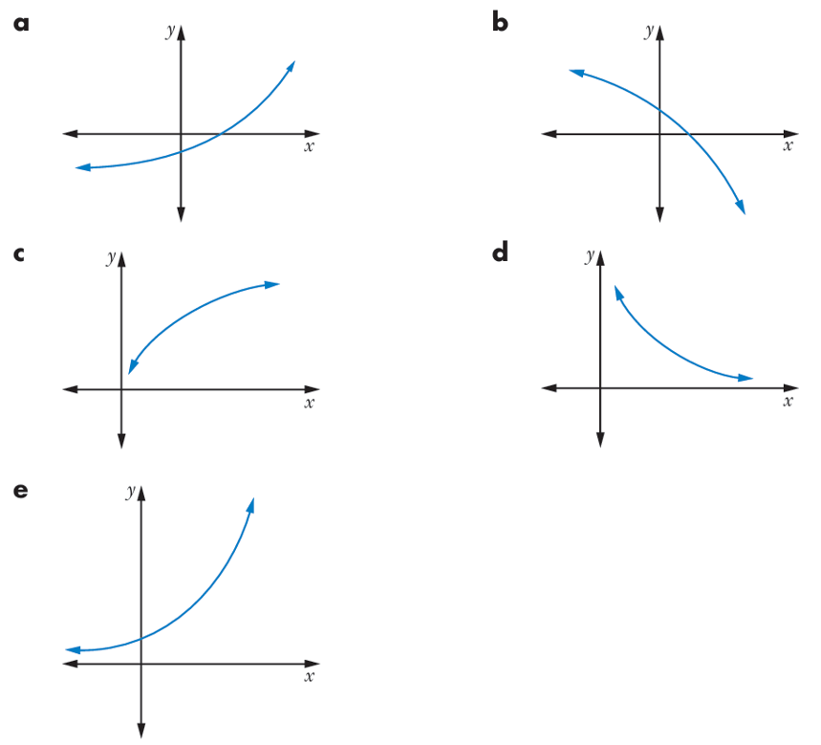  $$\frac{dy}{dx}>0$$  $$\frac{d^{2}y}{dx^{2}}>0$$ | $$\frac{dy}{dx}<0$$  $$\frac{d^{2}y}{dx^{2}}<0$$ | $$\frac{dy}{dx}>0$$  $$\frac{d^{2}y}{dx^{2}}<0$$
$$\frac{dy}{dx}<0$$  $$\frac{d^{2}y}{dx^{2}}>0$$ | $$\frac{dy}{dx}>0$$  $$\frac{d^{2}y}{dx^{2}}>0$$

- The population P of fish in a certain lake was studied over time. At the start of the study the number of fish was 2500.
  - During the study, $\frac{dP}{dt}< 0$. What does this say about the number of fish during the study?

Number of fish is decreasing
  - If at the same time, $\frac{d^{2}P}{dt^{2}}> 0$, what can you say about the population rate of change?

the rate of change is increasing (becoming less negative), so the decline is slowing
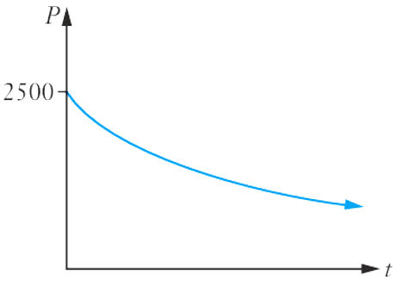
  - Sketch a possible graph of the population $P$ against $t$.

Development

  - If $f(x) = x³$and $g(x) = x⁴$, find $f'(x), f''(x), g'(x)$ and $g''(x).$
$$f'(x) = 3x^{2}$$
$$f^{''}\left(x\right)= 6x$$
$$g'(x) = 4x^{3}$$
$$g''(x) = 12x^{2}$$
  - Both$f(x)$ and $g(x)$ have a stationary point at $(0, 0)$. Evaluate $f''(x)$ and $g''(x)$ when $x=0$. Can you determine the nature of the stationary points from this calculation?
$$f^{''}\left(0\right)= 0, g^{''}\left(0\right)= 0$$
No, cannot determine nature when second derivative equals zero
  - Use tables of values of $f'(x)$ and $g'(x)$ to determine the nature of the stationary points.
For $f(x) = x³:$
$$x$$ | −0.1 | 0 | 0.1
$$f'(x)$$ | 0.03 | 0 | 0.03
f'(x) does not change sign, so (0, 0) is a horizontal (or stationary) point of inflection
For $g(x) = x⁴:$
$$x$$ | −0.1 | 0 | 0.1
$$g'(x)$$ | −0.004 | 0 | 0.004
g'(x) changes from − to +, so (0, 0) is a minimum turning point

- Find any stationary points on the curve $y = {\left(4x^{2}- 1\right)}^{4}$ and determine their nature.
$$\frac{dy}{dx}= 4{\left(4x^{2}- 1\right)}^{3}\left(8x\right)$$
$$= 32x{\left(2x-1\right)}^{3}{\left(2x+1\right)}^{3}$$
Stationary points at $\left(0, 1\right) \left(\frac{1}{2}, 0\right) \left(-\frac{1}{2}, 0\right)$
$$\frac{d^{2}y}{dx^{2}}= 32{\left(4x^{2}- 1\right)}^{3}+ 32x·3{\left(4x^{2}- 1\right)}^{2}\left(8x\right)$$
$$= 32{\left(4x^{2}- 1\right)}^{2}\left(4x^{2}- 1 + 24x^{2}\right)$$
$$= 32{\left(4x^{2}- 1\right)}^{2}\left(28x^{2}- 1\right)$$
At $x = 0:\frac{d^{2}y}{dx^{2}}= -32 < 0$, maximum
At $x =\frac{1}{2}:\frac{d^{2}y}{dx^{2}}= 0$, need further analysis
At $x = -\frac{1}{2}:\frac{d^{2}y}{dx^{2}}= 0,$ need further analysis
Using first derivative test: $\frac{dy}{dx}$ changes from − to + at $x = ±\frac{1}{2}$
(0, 1) maximum, $\left(\frac{1}{2}, 0\right)$ minimum, $\left(-\frac{1}{2}, 0\right)$ minimum

  - Find any stationary points on the curve $y = 2x^{3}- 27x^{2}+ 120x$ and distinguish between them.
$$\frac{dy}{dx}= 6x^{2}- 54x + 120$$
$$= 6\left(x^{2}- 9x + 20\right)$$
$$= 6\left(x - 4\right)\left(x - 5\right)$$
Stationary points at $\left(4,176\right) \left(5, 175\right)$
$$\frac{d^{2}y}{dx^{2}}= 12x - 54$$
At $x = 4:\frac{d^{2}y}{dx^{2}}= -6 < 0$, maximum
At $x = 5:\frac{d^{2}y}{dx^{2}}= 6 > 0$, minimum
(4, 176) maximum, (5, 175) minimum
  - Find any points of inflection on the curve.
$$\frac{d^{2}y}{dx^{2}}= 12x - 54 = 0$$
$$x = 4.5, y = 175.5$$
Using table of concavities, concavity changes from negative to positive across $x=4.5$
Point of inflection at $(4.5, 175.5)$

- Find any stationary points on the curve $f\left(x\right)= x^{4}+ 8x^{3}+ 16x^{2}- 1$ and their nature.
$$f^{'}\left(x\right)= 4x^{3}+ 24x^{2}+ 32x$$
$$= 4x\left(x^{2}+ 6x + 8\right)$$
$$= 4x\left(x + 2\right)\left(x + 4\right)= 0$$
$$x = 0: y = -1; x = -2: y = 15; x = -4: y = -1$$
$$f^{''}\left(x\right)= 12x^{2}+ 48x + 32$$
At $x = 0: f''(0) = 32 > 0$, minimum
At $x = -2: f''(-2) = -16 < 0$, maximum
At $x = -4: f''(-4) = 32 > 0$, minimum
(0, −1) minimum, (−2, 15) maximum, (−4, −1) minimum
- The curve $y = ax^{2}- 4x + 1$ has a stationary point where $x =\frac{1}{2}$.
  - Find the value of $a$.
$$\frac{dy}{dx}= 2ax - 4 = 0 at x =\frac{1}{2}$$
$$2a\left(\frac{1}{2}\right)- 4 = 0$$
$$a = 4$$
  - Hence, or otherwise, find the stationary point and determine its nature.
$$y = 4x^{2}- 4x + 1$$
$$At x =\frac{1}{2}: y = 0$$
$$\frac{d^{2}y}{dx^{2}}= 8 > 0$$
$\left(\frac{1}{2}, 0\right),$ minimum

Curve Sketching using Calculus

- Systematic Curve Sketching Method
Non-Calculus Methods
- Domain of the function, and any vertical asymptotes.
- Symmetry of the function: odd, even, neither.
- Intercepts: $x$ and $y$-intercepts.
- Behaviour as $x→$ asymptotes:
If there is an asymptote at $x=a$, find $y$ value when $x→a^{-}$ and $x→a^{+}$
- Behaviour as $x→±∞$:
If the $y$ approaches a particular value, this is the horizontal asymptote.

Calculus Methods
Used to find stationary points and points of inflection. Not all curves have stationary points, so use non-calculus sketching methods to find the general shape of the curve first.

- First derivative
$f^{'}\left(x\right)=0$ finds stationary points, then determine their nature by using a table of slopes.

- Second derivative
$f^{''}\left(x\right)=0$ finds possible inflection points, then determine their nature using a table of concavities.

Other considerations
If the curve is a known function, e.g., parabola, exponential, hyperbola, logarithm, we can sketch by identifying the transformations.
Trigonometric graphs are periodic; they repeat.
You can always draw up a table of values and hope for the best.

- Investigation Sketch curves using a systematic method.
Sketch $y=xe^{x}$

Sketch $y=x^{4}-8x^{2}$

- Investigation Sketch curves using a systematic method.
Sketch $y=$ $\frac{1}{x\left(x-4\right)}$, given that the second derivative is $y^{''}=\frac{2}{x^{3}(x-4)}+\frac{2}{x^{2}{\left(x-4\right)}^{2}}+\frac{2}{x{\left(x-4\right)}^{3} }$

Sketch $y=e^{x}\sin{x}$ in the domain $\left[0, 2π\right]$.

Foundation
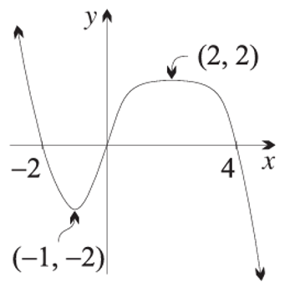
- The diagram to the right shows a curve $y = f(x).$
From the sketch, find the values of $x$ for which:
  - $f^{'}\left(x\right)=0$,
a) $x=-1, 2$
  - $f''(x) = 0$,
b) $x=0$
  - $f(x)$is increasing,
c) $-1<x<2$
  - $f''(x) > 0.$
d) $x<0$

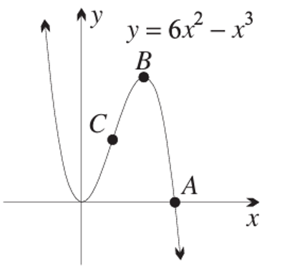
- The diagram to the right shows a sketch of $y=6x²-x^{3}.$
The curve cuts the $x$-axis at $A$, has a maximum turning point at $B$
and a point of inflection at $C$.
  - Find the coordinates of $A$.
  - Find the coordinates of $B$.
  - Find the coordinates of $C$.

a) (6,0)
b) (4,32)
c) (2,16)

  - Show that $y = 27x - x³$ is an odd function. What symmetry does its graph display?
  - Show that $y' = 3(9 - x²)$ and $y'' = -6x$.
  - Find the coordinates of the stationary points. Then determine their nature, either by examining the sign of $f''(3)$ and $f''(-3),$ or by means of a table of test values of $y'$.
  - Show, using a table of test values of $y''$, that $x = 0$ is a point of inflection.
  - By substituting into the gradient function $y'$, find the gradient at the inflection.
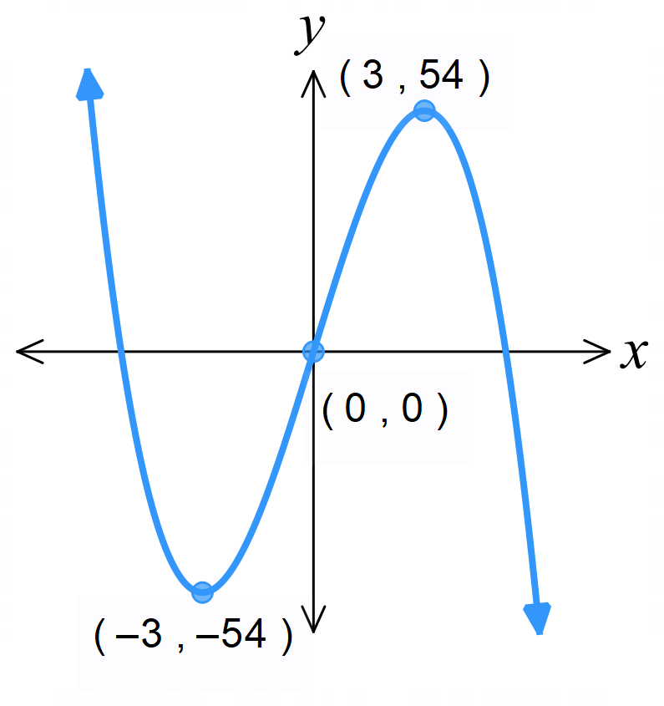
  - Sketch the graph of the function, indicating all important features.
a) Show that $f\left(-x\right)=-f\left(x\right)$ 180 degree rotational symmetry about origin.
c) maximum at (3, 54), minimum at (-3, -54)
d) concavity changes sign at $x=0$
e) Gradient at inflection is 27

  - If $f(x) = 2x³ - 3x² + 5,$ show that $f'(x) = 6x(x - 1)$and $f''(x) = 6(2x - 1)$.
  - Find the coordinates of the stationary points. Then determine their nature, either by examining the sign of $f''(0)$ and $f''(1),$ or by means of a table of test values of $y'$.
  - Explain why there is a point of inflection at $x =\frac{1}{2}$, and find the gradient there.
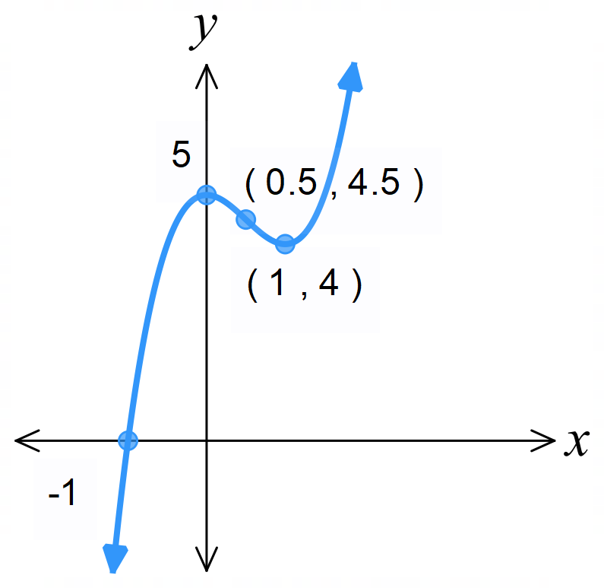
  - Sketch the graph of $f(x)$, indicating all important features.

b) maximum at (0, 5) minimum at (1, 4)

c) $f^{''}\left(\frac{1}{2}\right)= 0$
$$f^{''}\left(0\right)=-6, f^{''}\left(1\right)=6$$
Since $f^{''}\left(\frac{1}{2}\right)=0$ and concavity changes sign, it is an inflection point.

$$d) 6\left(2x - 1\right)= 0; x =\frac{1}{2}$$
Gradient is $-\frac{3}{2}$

  - If $y = 12x³ - 3x⁴ + 11$, show that $y' = 12x²(3 - x)$ and $y'' = 36x(2 - x).$
  - By solving $y' = 0,$ find the coordinates of any stationary points.
  - By examining the sign of $y'',$ establish the nature of the stationary point at $x = 3$.
Why does this method fail for the stationary point at $x = 0$?
  - Use a table of test values of $y'$ to show that there is a stationary inflection at $x = 0$.
  - Show that there is a change in concavity at $x = 2$.
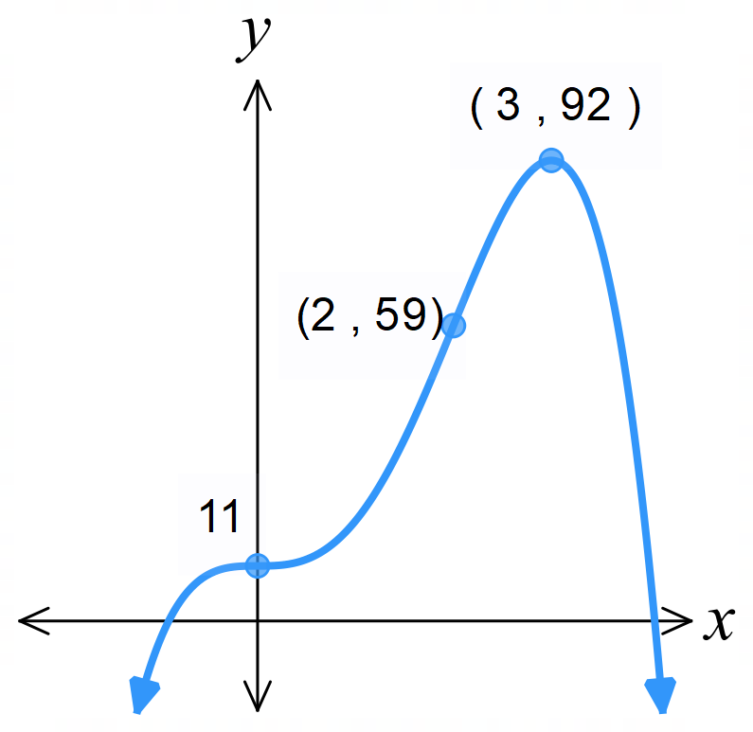
  - Sketch the graph of the function, showing all important features.
You do not need to find the $x$ intercepts.

b) (0, 11) (3, 92)
c) maximum at (3,92) $f^{''}\left(0\right)=0$ so can’t determine nature using second derivative at $x=0$.

Development
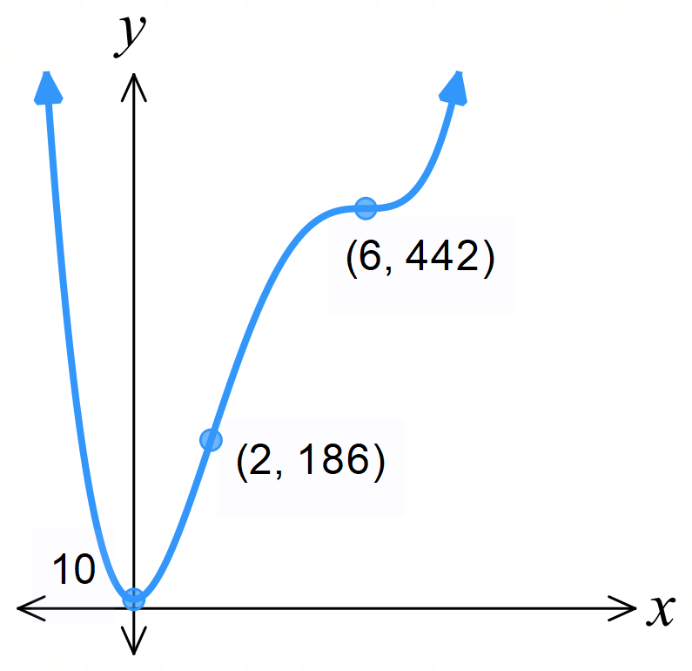
- Using the method outlined in the previous question, sketch $y = x^{4}- 16x^{3}+ 72x^{2}+ 10$.

  - If $f(x) = x³ - 3x$, show that $f'(x) = 3(x - 1)(x + 1)$ and $f''(x) = 6x$.
  - By solving $f'(x) = 0$, find the coordinates of any stationary points.
  - Examine the sign of $f''(1)$ and $f''(-1)$ to determine their nature.
  - Find the coordinates of the point of inflection. Remember that you must show that the sign of $f''(x)$changes about this point.
  - Sketch the graph of $f(x),$ indicating all important features.
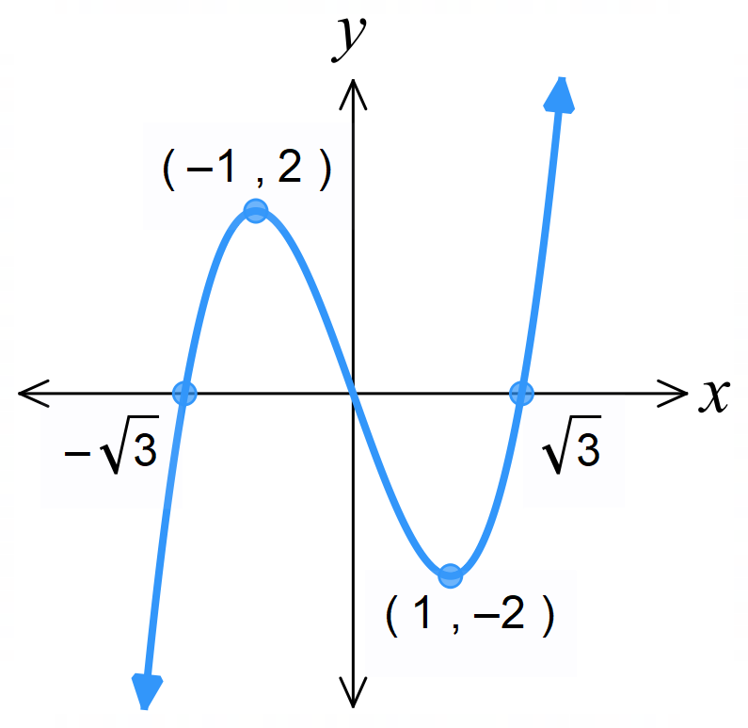
b) (-1, 2), (1, -2)
c) maximum at (-1, 2) minimum at (1, -2)
d) (0, 0)

  - If $f\left(x\right)=x^{3}-6x^{2}-15x+1$, show that $f'(x)=3\left(x-5\right)\left(x+1\right)$ and$f''(x)=6\left(x-2\right)$.
  - Find any stationary points and use the sign of $f''(x)$ to determine their nature.
  - Find the coordinates of any points of inflection.
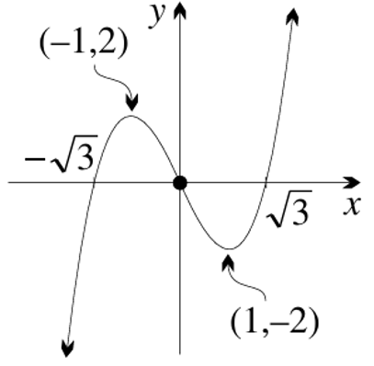
  - Sketch the graph of $f(x)$, indicating all important features.

  - If $y=x^{3}-3x^{2}-9x+11$, show that $y'=3(x-3)(x+1)$ and $y''=6\left(x-1\right).$
  - Find any stationary points and use the sign of y'' to determine their nature.
  - Find the coordinates of any points of inflection.
  - Sketch the graph of the function, indicating all important features.
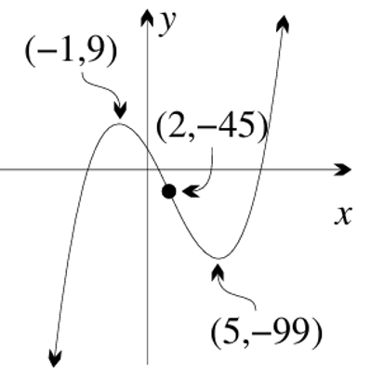

  - If $y=3+4x³-x⁴,$ show that $y'=4x²(3-x)$and $y''=12x(2-x)$.
  - Find any stationary points and use a table of test values of y' to determine their nature.
  - Find the coordinates of any points of inflection.
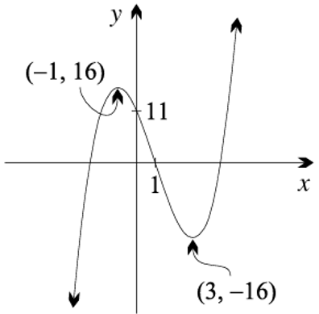
  - Sketch the graph of the function, indicating all important features.

  - Show that the derivative of $f\left(x\right)=\frac{1}{x^{2}- 4}$ is $f'(x) = -\frac{2x}{{\left(x^{2}- 4\right)}^{2}}.$
  - Show that $y = f(x)$ has a stationary point at $x = 0$.
Then determine its nature, using a table of values of $f'(x)$.
  - Show that the function is even. What symmetry does its graph exhibit?
  - State the domain of the function and the equations of any vertical asymptotes.
  - What value does $f(x)$ approach as $x → ∞$ and as $x → -∞?$
Hence write down the equation of the horizontal asymptote.
  - Sketch the graph of $y = f(x),$ showing all important features.
  - Use the graph to state the range of the function.
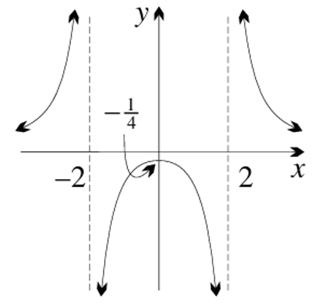
c) line symmetry across $y$ axis
d) domain $x∈R$, $x≠-2, 2$ where there are vertical asymptotes
e) $y=0$
$$g)\left(-∞,-\frac{1}{4}\right]∪ \left(0, ∞\right)$$

- The graphs of $f\left(x\right)$, $f^{'}\left(x\right)$ and $f^{''}\left(x\right)$ have been sketched below.
Describe your observations.
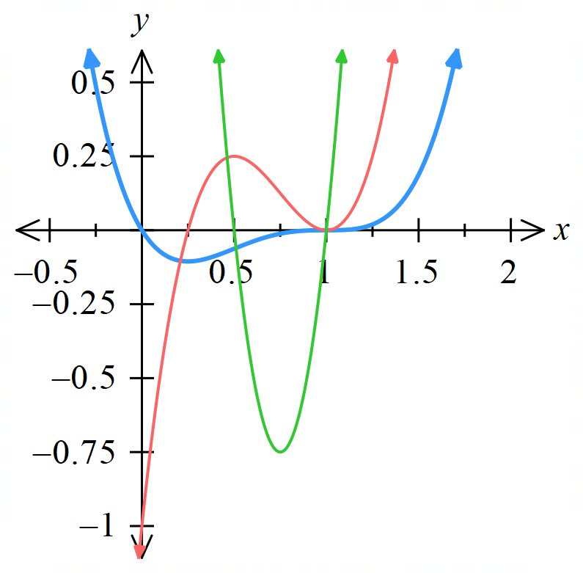

Where $f'(x)$ crosses the x-axis, $f$ has stationary points
Where$f''(x)$ crosses the $x$-axis, $f$ has points of inflection and$f'$ has turning points
The sign of $f'$ tells us where $f$ is increasing/decreasing
The sign of $f''$tells us where$f$ is concave up/down
At $x =\frac{1}{4}$ $f$has a minimum
At $x = 1$: $f$ has a stationary point of inflection (f'(x) = 0 and f''(x) = 0)

- By considering the sign of the graph, sketch $f^{'}\left(x\right)$ and then sketch $f^{''}\left(x\right)$  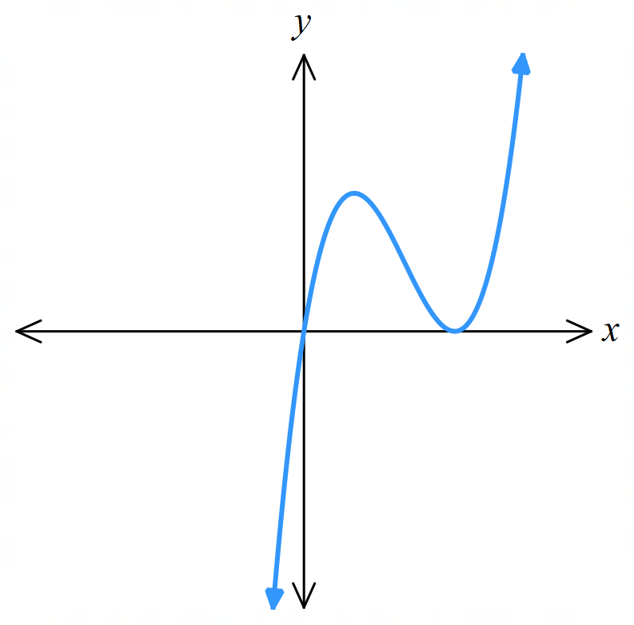  $f\left(x\right)$  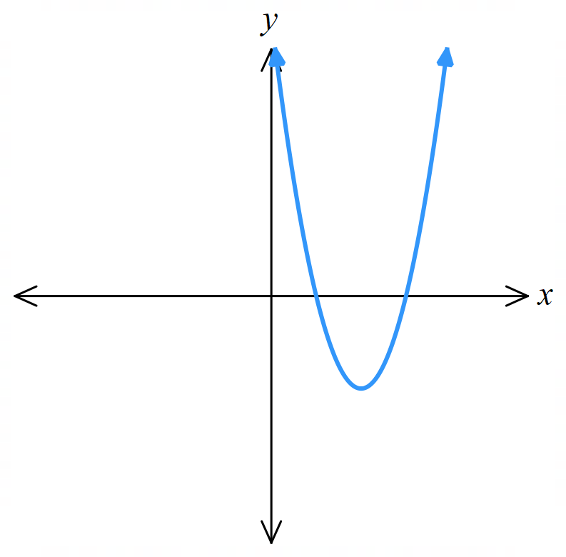  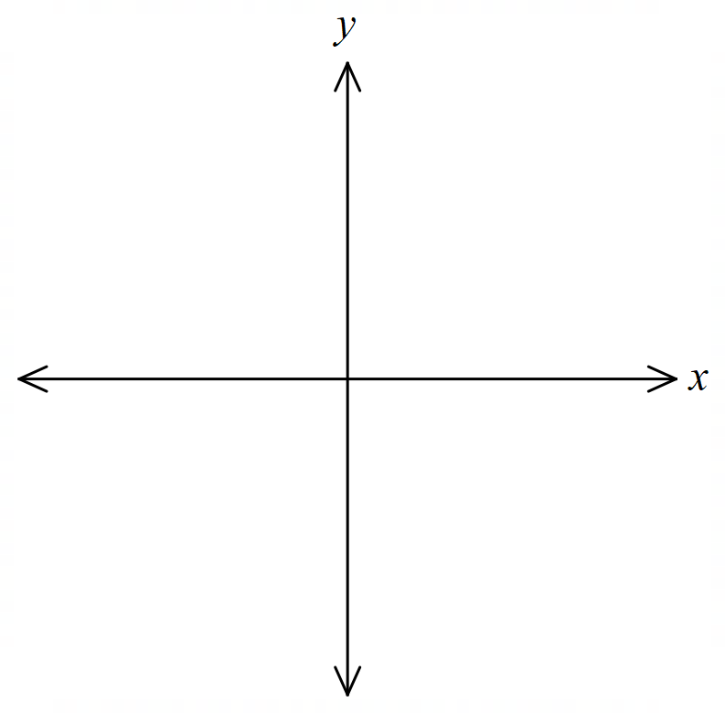  $f^{'}\left(x\right)$  $$f^{''}\left(x\right)$$  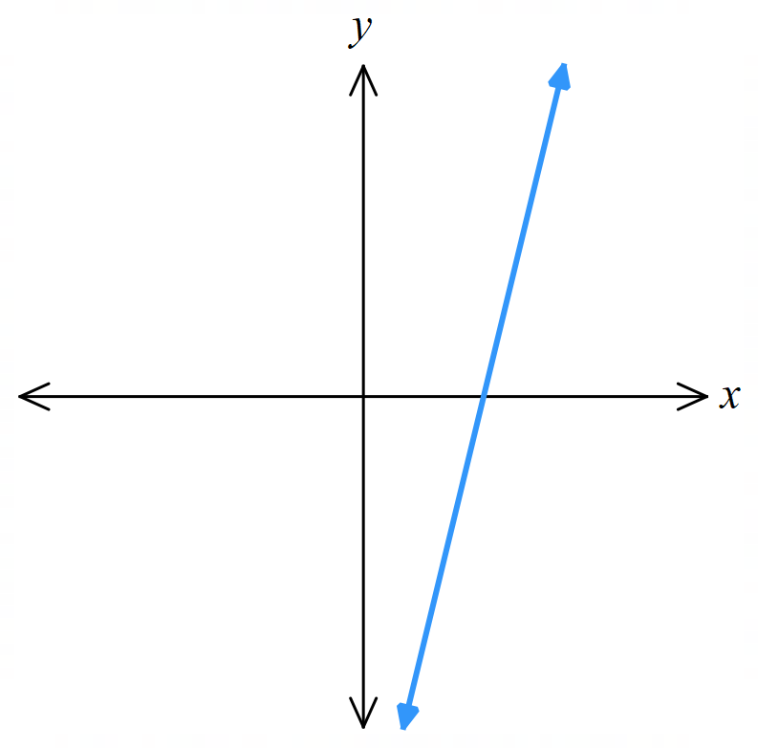 | 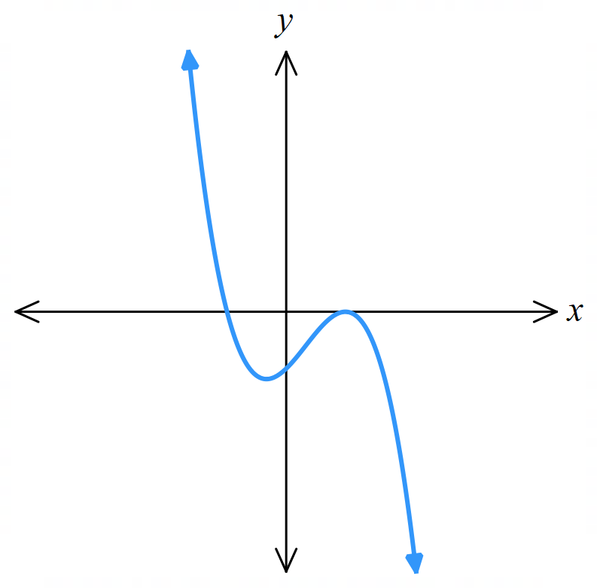  - By considering the sign of the graph,  sketch $f^{'}\left(x\right)$ and then sketch $f^{''}\left(x\right)$  $$f^{'}\left(x\right)$$  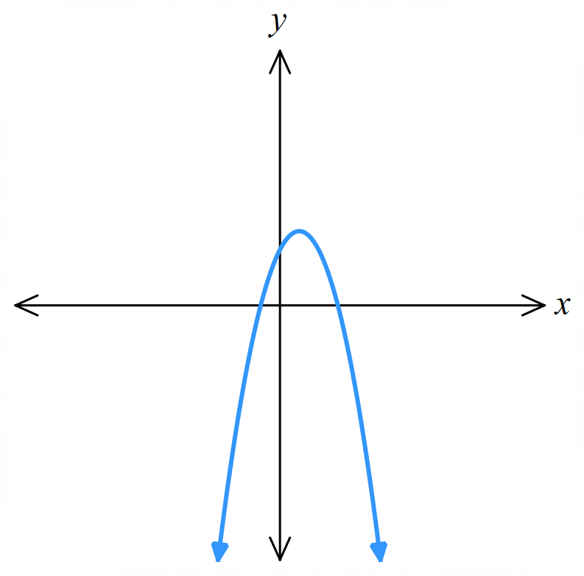  $$f^{''}\left(x\right)$$  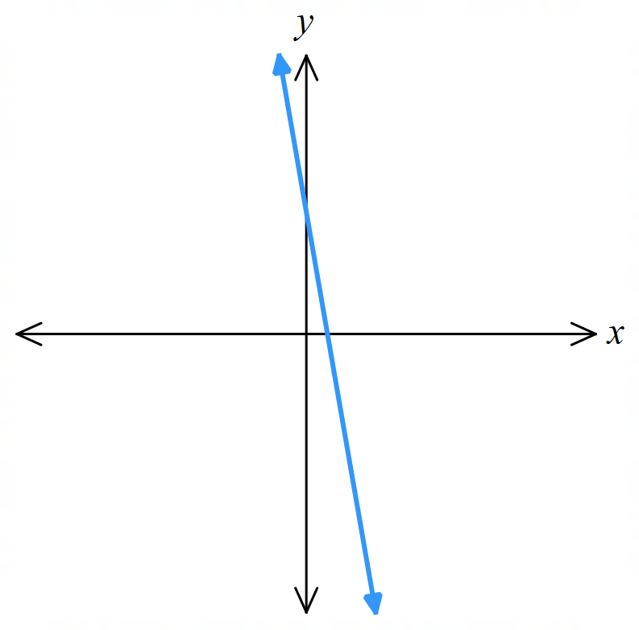

Mastery

  - Show that the derivative of $f\left(x\right)=\frac{x}{x^{2}- 4}$is $f'(x) = -\frac{x^{2}+ 4}{{\left(x^{2}- 4\right)}^{2}}.$
  - Explain why the curve $y = f(x)$ has no stationary points, and why the curve is always decreasing.
  - Given that $f^{''}\left(x\right)=\frac{2x^{3}+ 24x}{{\left(x^{2}- 4\right)}^{3}}$, show that (0, 0) is a point of inflection.
Then find the gradient of the tangent at this point.
  - State the domain of the function and the equations of any vertical asymptotes.
  - What value does $f(x)$ approach as $x$ becomes large?
Hence write down the equation of the horizontal asymptote.
  - Show that the function is odd. What symmetry does its graph have?
  - Analyse the behaviour of the function as it approaches the vertical asymptotes.
  - Sketch the graph of $y = f(x)$, showing all important features.
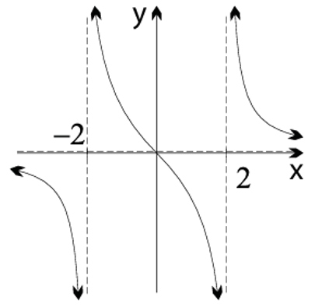
  - Use the graph to state the range of the function.

c) gradient = $-\frac{1}{4}$
d) domain $x∈R$, $x≠-2, 2$ where there are vertical asymptotes
e) $y=0$
f) 180 degree rotational symmetry about origin
i) all real $y$

  - If $f\left(x\right)=\frac{x^{2}}{1 + x^{2}},$ show that $f^{'}\left(x\right)=\frac{2x}{{\left(1 + x^{2}\right)}^{2}}$ and $f^{''}\left(x\right)=\frac{2 - 6x^{2}}{{\left(1 + x^{2}\right)}^{3}}.$
  - Hence find the coordinates of any stationary points and determine their nature.
  - Find the coordinates of any points of inflection.
  - State the equation of the horizontal asymptote.
  - Sketch the graph of the function, indicating all important features.
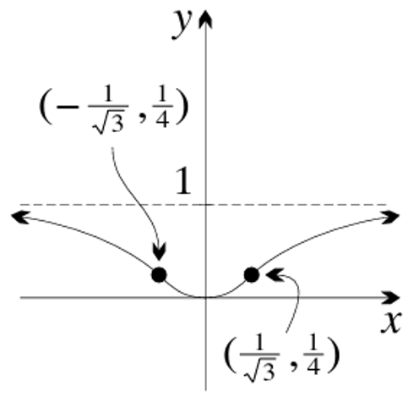

  - Show that if $y =\frac{x + 2}{x - 3}$, then $y^{''}=\frac{10}{{\left(x - 3\right)}^{3}}.$
  - By examining the sign of $(x - 3)³,$ determine when the curve is concave up, and when it is concave down.
  - Sketch the graph of $y =\frac{x + 2}{x - 3}.$
  - Confirm your answer by showing that $y=\frac{x+2}{x-3}$ can be written as $y=1+\frac{5}{x-3}$ and sketching using transformations.
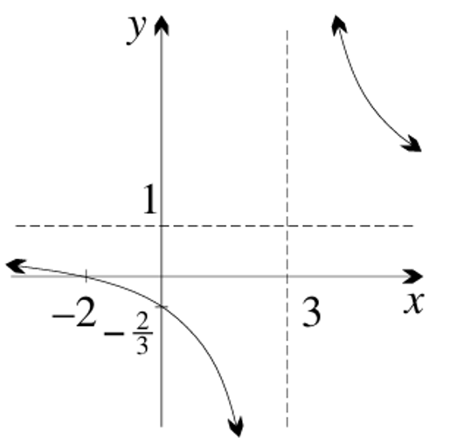
b) concave up when $x>3,$concave down when $x<3$
$$d) y=\frac{x+2}{x-3}=\frac{x-3+5}{x-3}=\frac{x-3}{x-3}+\frac{5}{x-3}$$
$$=1+\frac{5}{x-3}$$
This is indeed a hyperbola dilated by a factor of 5 and shifted right by 3, up by 1.

- Consider the curve $y = xeˣ$.
  - Where is the function zero, positive and negative? Is it even, odd or neither?
  - Show that $y' = (1 + x)eˣ$ and $y″ = (2 + x)eˣ$.
  - Show that there is one stationary point, and determine its nature.
  - Find the coordinates of the lone point of inflection.
  - What happens to $y$,$y'$and $y″$ as $x → ∞?$
  - Given that $y → 0$ as $x → -∞,$ sketch the curve, then write down its range.
  - Hence also sketch $y = -xe⁻ˣ$ by recognising the simple transformation.
a) $f\left(x\right)=0$ when $x=0$. It is negative for $x<0$ and positive for $x>0$
it is neither odd nor even
e) They all tend towards $∞$,
meaning the curve is increasing at an increasing rate above the $x$ axis.
f) $y≥-$ $\frac{1}{e}$
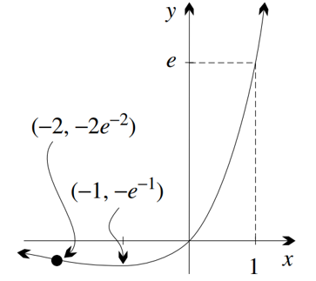
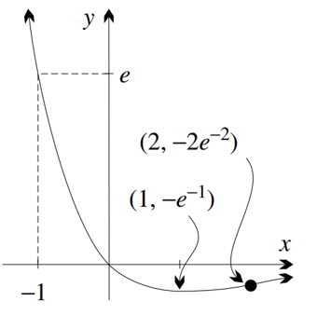

- Consider the function $y = (1 - x)eˣ$.
  - Find the zero.
  - Find $y'$ and $y″$.
  - Show that the curve has a maximum turning point at its y-intercept, and a point of inflection at $(-1, 2e⁻¹).$
  - What happens to $y, y'$ and $y″$ as $x → ∞$?
  - Given that $y → 0$ as $x → -∞$, sketch the graph and write down its range.
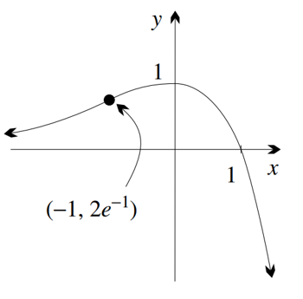
a) Zero at $x=1$
b) $y^{'}=-xe^{x}, y^{''}=-\left(x+1\right)e^{x}$
d) They all tend towards $-∞$,
meaning the curve is decreasing at an increasing rate below the $x$ axis.
e) $y≤1$

  - What is the natural domain of $y =\frac{eˣ}{x}$?
  - Show that the curve has a local minimum at $(1, e)$but no inflection points.
  - Sketch the curve and state its range.
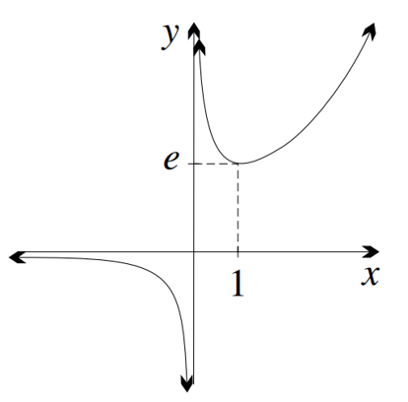
a) $x∈R, x≠0$
c) $y<0, y≥e$

  - Write down the domain of $y =\frac{1}{x}+ ln x$.
  - Show that the first and second derivatives may be expressed as single fractions as $y^{'}=\frac{x - 1}{x^{2}}$ and $y^{″}=\frac{2 - x}{x^{3}}$.
  - Show that the curve has a minimum at $(1, 1)$ and an inflection at $\left(2,\frac{1}{2}+ ln 2\right)$.
  - Sketch the graph and write down its range.
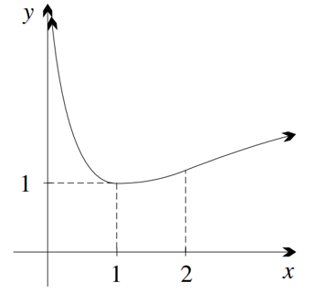
a) $x>0$
d) $y≥1$

- Consider the curve $y = x \log_{e} x - x$.
  - Write down the domain and $x$-intercept.
  - Show that $y' = \log_{e} x$ and find $y″$.
  - Hence show that there is one stationary point and determine its nature.
  - What does $y″$ tell you about the curve?
  - Given that$y → 0⁻$ as $x → 0⁺$, and that the tangent approaches vertical as$x → 0⁺$, sketch the curve and write down its range.
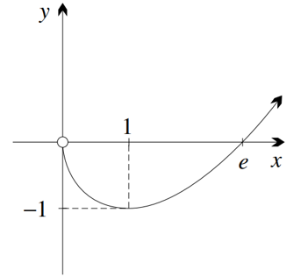

a) $x>0$, $\left(e,0\right)$
$$b) y^{''}=\frac{1}{x}$$
c) $\left(1,-1\right)$ is a minimum
d) $y^{''}>0$, so concave up throughout its domain
e) $y≥-1$

  - Write down the domain of $y = \log_{e}(1 + x²)$.
  - Is the curve, even, odd or neither?
  - Find where the function is zero, and explain what its sign is otherwise.
  - Show that $y^{'}=\frac{2x}{1 + x^{2}}$and $y^{″}=\frac{2\left(1 - x^{2}\right)}{{\left(1 + x^{2}\right)}^{2}}.$
  - Hence show that y$= \log_{e}(1 + x²)$has one stationary point, and determine its nature.
  - Find the coordinates of the two points of inflection.
  - Hence sketch the curve, and then write down its range.
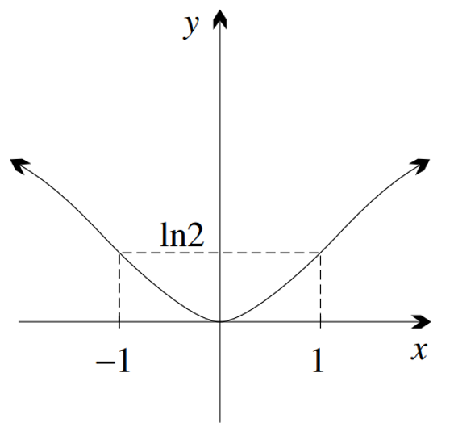
a) $x∈R$
b) even
c) zero at $x=0$, and positive everywhere else as $\log{}$of a number greater than 1 are positive
e) $\left(0,0\right)$ min
f) $\left(1,\ln{2}\right) (-1,\ln{2})$
g) $y≥0$

  - Find the domain of $y = (ln x)²$.
  - Find where the function is zero, and explain what its sign is otherwise.
  - Find $y'$ and show that$y^{″}=\frac{2\left(1 - ln x\right)}{x^{2}}$.
  - Hence show that the curve has an inflection at $x = e$.
  - Classify the stationary point at $x = 1$, sketch the curve, and write down the range.
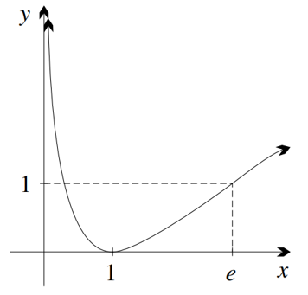
a) $x>0$

b) it is zero at $x=1$ and positive everywhere else as squares must be positive
$$c) y^{'}=\frac{2}{x}\ln{x}$$

d) let $y^{''}=0$
$$1-\ln{x}=0$$
$$∴x=e$$
$$y^{''}\left(2\right)=\frac{2-2\ln{2}}{4}=0.1534…$$
$$y^{''}\left(3\right)=\frac{2-2\ln{3}}{9}=-0.0219…$$
Since $f^{''}\left(e\right)=0$ and sign changes, it is an inflection point.

d) $stationary point (1,0), a minimum; range y≥0$

  - Find and classify the lone stationary point of $y =x^{2}\ln{x}$in its natural domain.
  - Show that there is an inflection at $x = e^{-\frac{3}{2}}$.
  - Examine the behaviour of $y$ and$y'$ as $x → 0⁺$.
  - Hence sketch the graph of this function, then write down its range.
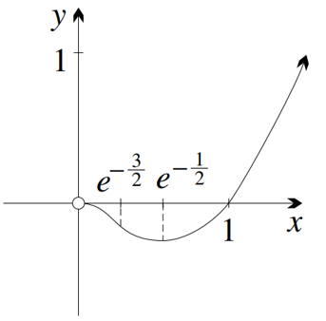
a) Natural domain is $x>0$. Minimum at $\left(\frac{1}{\sqrt{e}}, -\frac{1}{2e}\right)$
c) $y$ and $y^{'}→0^{-}$
Graph becomes horizontal approaching the origin
d) $y≥ -$ $\frac{1}{2e}$

  - What is the natural domain of $y = ln(ln x)?$
  - What is the $x$-intercept?
  - Find $y'$ and $y″$, and explain why there are no stationary points.
  - Explain why there is no inflection at $x = e⁻¹$.
  - Sketch the curve.
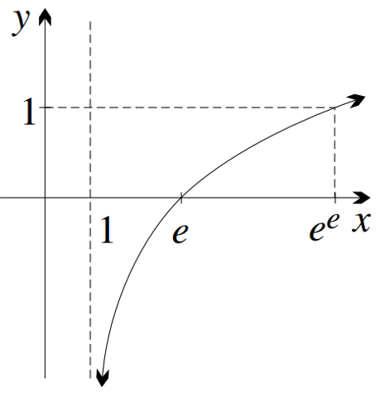
a) $\ln{x}>0, so x>1$
b) $x=e$
c) $y^{'}=$ $\frac{1}{x\ln{x}}$ which can never be zero or negative, so always increasing
$y^{''}=-$ $\frac{1+\ln{x}}{{\left(x\ln{x}\right)}^{2}}$
d) This is outside the domain

- Consider the curve $y = sin x + cos x$in the interval $0 ≤ x ≤ 2π$.
  - Find the values of the function at the endpoints of the domain.
  - Find the $x$-intercepts of the graph.
  - Find any stationary points and determine their nature.
  - Find any points of inflection and sketch the curve.
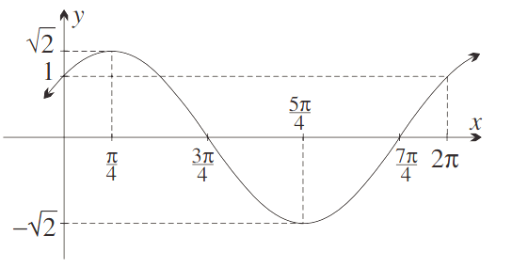
a) $f\left(0\right)=1$
$$f\left(2π\right)=1$$
$$b) x=\frac{3π}{4} or\frac{7π}{4}$$
$$c) \left(\frac{π}{4},\sqrt{2}\right) max, \left(\frac{5π}{4}, -\sqrt{2}\right) min$$
$d)$ The $x$-intercepts are also inflection points.

  - Find the first and second derivatives of $y=cos x+\sqrt{3} sin x$.
  - Find the stationary points in the domain $0 ≤ x ≤ 2π$, and use the second derivative to determine their nature.
  - Find the points of inflection.
  - Hence sketch the curve, for $0 ≤ x ≤ 2π$.
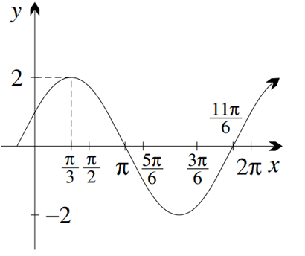
a) $y^{'}=-\sin{x}+\sqrt{3}\cos{x}$
$$y^{''}=-\cos{x}-\sqrt{3}\sin{x}$$
$$b)max⁡at \left(\frac{π}{3},2\right) min⁡at \left(\frac{4π}{3}, -2\right)$$
$$c) \left(\frac{5π}{6},0\right), \left(\frac{11π}{6},0\right)$$

  - Find the derivative of $y = x + sin x$, and show that $y″ = -sin x$.
  - Find the stationary points in the domain $-2π < x < 2π$, and determine their nature.
  - Find all the points of inflection.
  - Hence sketch the curve, for $-2π ≤ x ≤ 2π.$
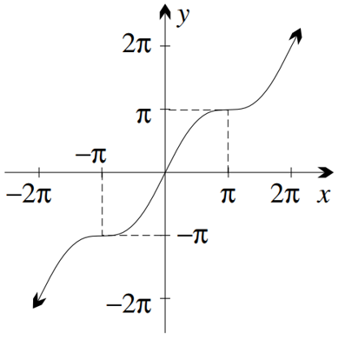
a) $y^{'}=1+\cos{x}$
Since $y^{'}≥0$ the function is always increasing or zero
$$y^{''}=-\sin{x}$$
Concavity changes between positive and negative
b) $\left(-π,-π\right)$ and $\left(π,π\right)$ are horizontal inflection points
c) (0,0), $\left(-π,-π\right)$ and $\left(π,π\right)$

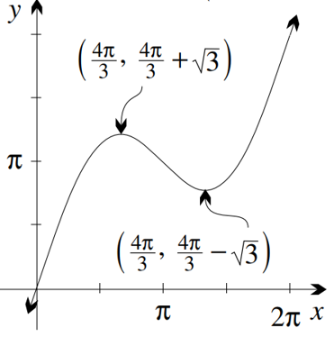
- Find any stationary points and inflections of the curve $y=2sin x+x$ in the interval $0≤x≤2π$, then sketch the curve.
$$Maximum at \left(\frac{2π}{3},\frac{2π}{3}+\sqrt{3}\right)$$
$$Minimum at \left(\frac{4π}{3},\frac{4π}{3}-\sqrt{3}\right)$$
Inflection at $\left(π,π\right)$

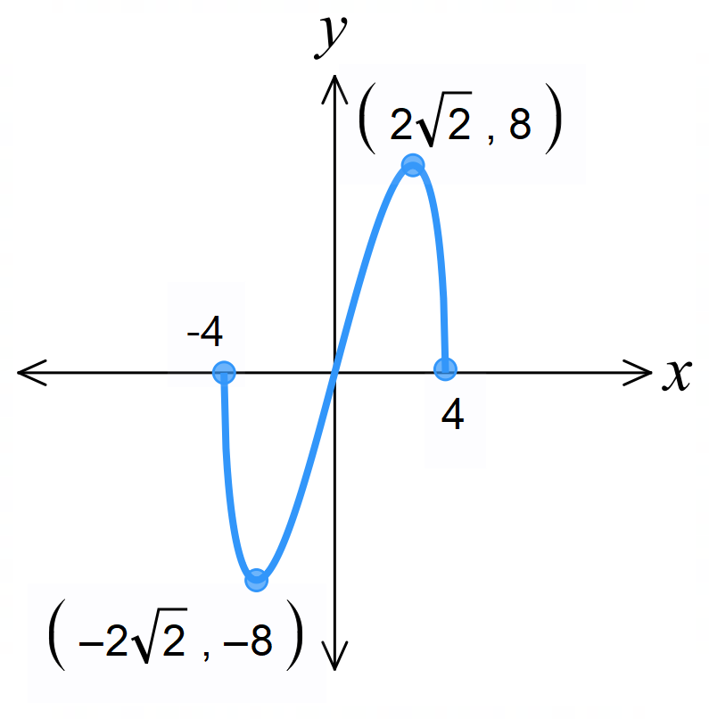
- Sketch $y=x\sqrt{16-x^{2}}$

- Sketch $y=x^{2}\ln{x}$
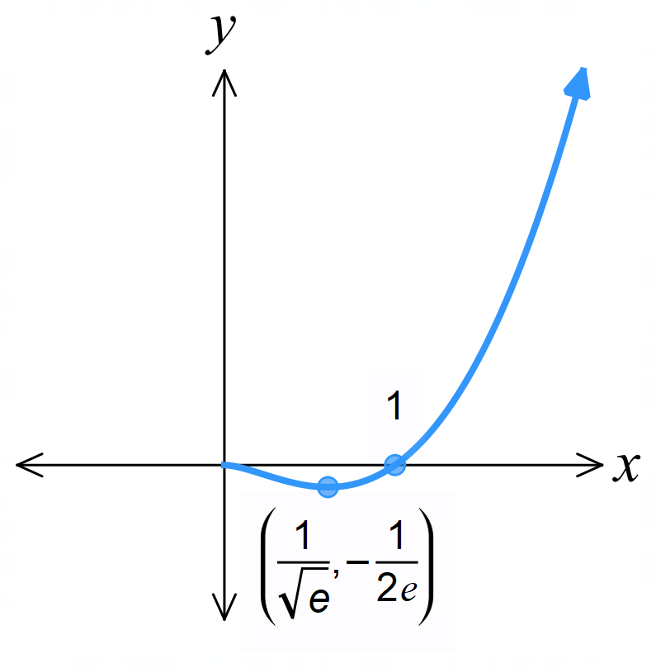

Inflection point (not shown) at $\left(\frac{1}{\sqrt{e^{3}}}, -\frac{3}{2e^{3}}\right)$
Also, there should be an open circle at $x=0$ as the function is undefined there (not shown on image)

- Sketch $y=$ $\frac{x}{e^{x}}$
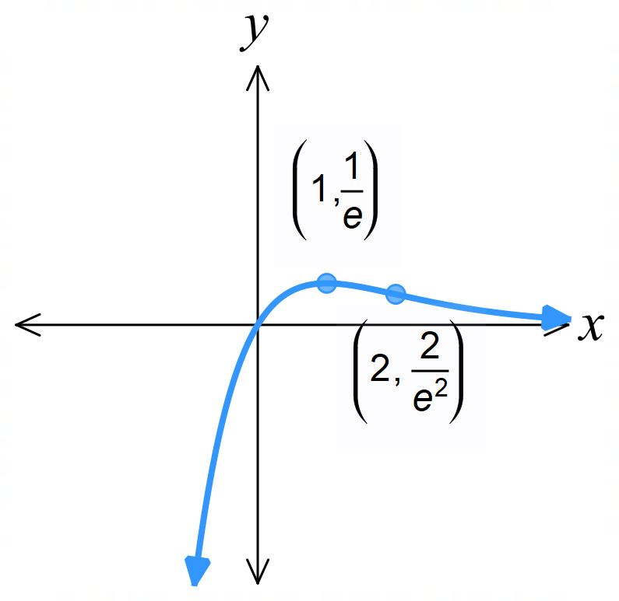

Exam Questions
- 2017 HSC Advanced Band 4
The function $f\left(x\right)$ is defined for $a≤x≤b$.
On this interval, $f^{'}\left(x\right)>0$ and $f^{''}\left(x\right)<0$
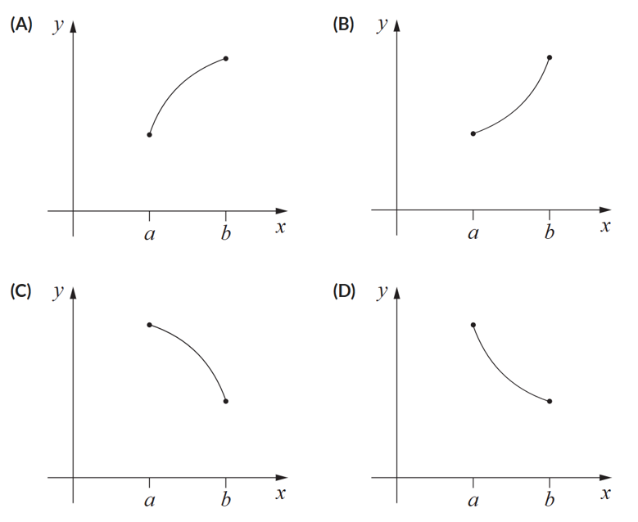
Which graph best represents $y=f\left(x\right)?$

Gradient always positive and concave down
A

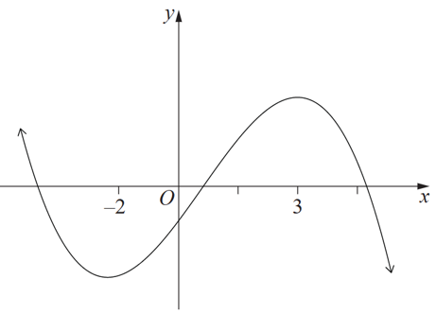
- 2021 HSC Advanced Band 4
The diagram shows part of $y=f\left(x\right)$ which has a local minimum at $x=-2$ and local maximum at $x=3$.

Which of the following shows the correct relationship between $f^{''}\left(-2\right),f\left(0\right),f^{'}\left(3\right)$?
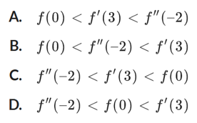
The graph is concave up at $x=-2,$so $f^{''}\left(-2\right)$ is positive
$f\left(0\right)$ is negative
$$f^{'}\left(3\right)=0$$
A

- 2023 HSC Advanced Band 4
The following table gives the signs of the first and second derivatives of a function $y=f\left(x\right)$ for different values of $x$.
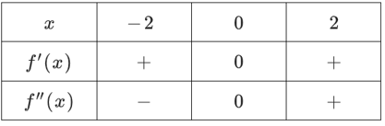

Which of the following is a possible sketch of $y=f\left(x\right)$?
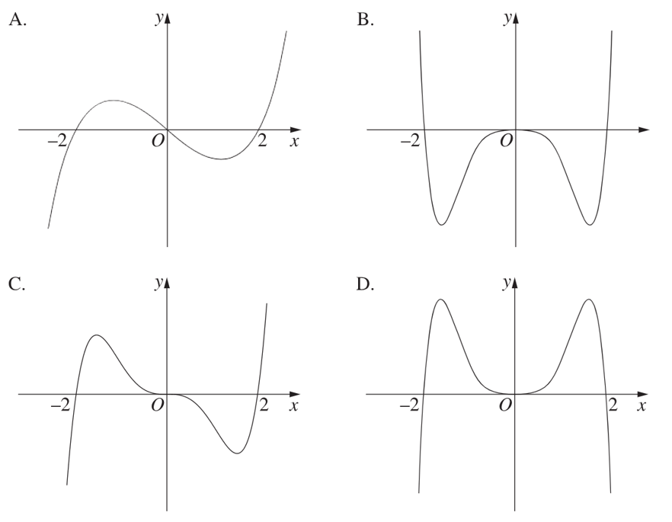

Gradient is positive at $x=-2$ and 2,
so eliminate B and D
SP and POI at $x=0$, so eliminate A
C is the answer

- 2014 HSC Advanced Band 4
Find the coordinates of the stationary point on $y=e^{x}-ex$ and determine its nature.
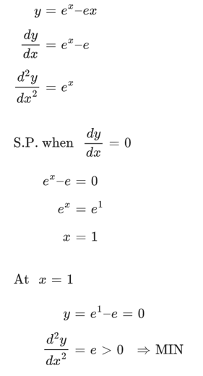

- 2022 HSC Advanced Band 4
Let $f(x) = xe⁻²ˣ$.
It is given that $f'(x) = e⁻²ˣ - 2xe⁻²ˣ.$
  - Show that $f''(x) = 4(x - 1)e⁻²ˣ$.
  - Find any stationary points of $f(x)$ and determine their nature.
  - Sketch the curve $y = xe⁻²ˣ$, showing any stationary points, points of inflection and intercepts with the axes.
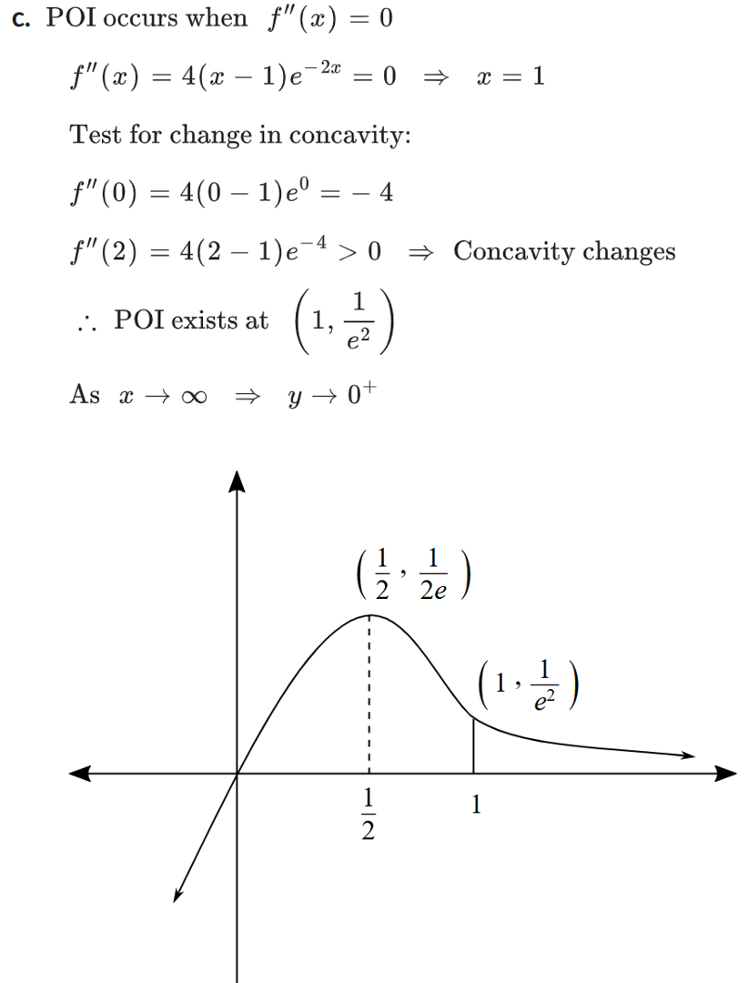
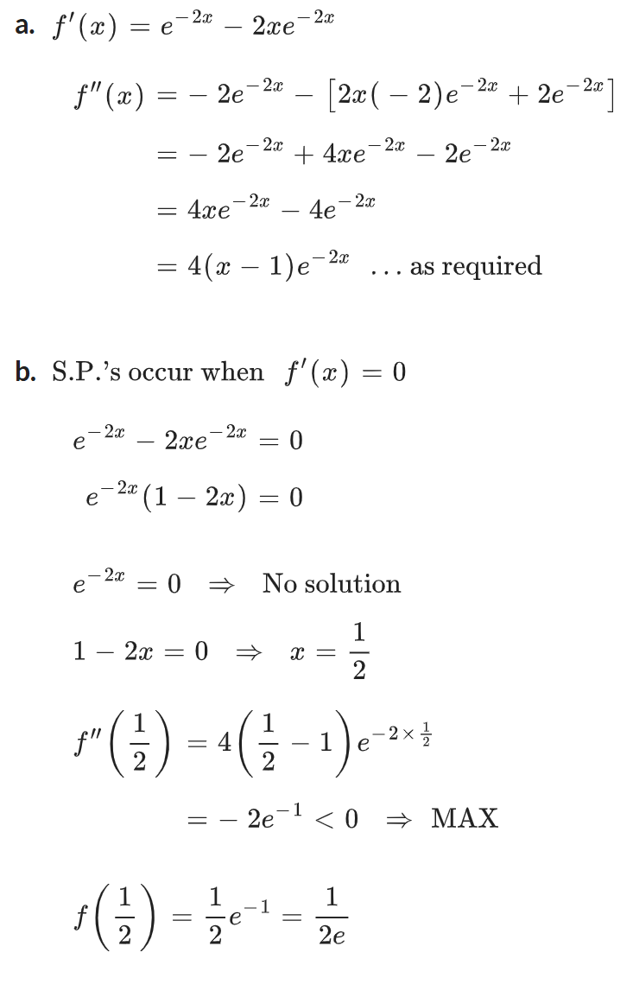

- 2018 HSC Advanced Band 5
The diagram shows the graph of $f^{'}\left(x\right)$.
For what value of $x$ does $f\left(x\right)$ have a point of inflection?
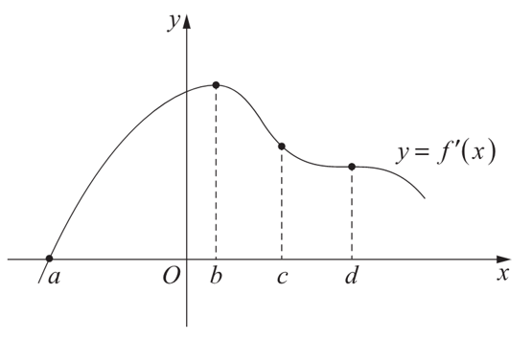

Stationary point of $f^{'}\left(x\right)$ is where $f^{''}\left(x\right)=0$
So, b or d
Point of inflection when $f^{''}\left(x\right)$ changes sign
Gradient of $f^{'}\left(x\right)$ changes sign at b only
$x=b$ is the answer

- 2024 HSC Advanced Band 4
Sketch the curve $y=x^{4}-2x^{3}+2$ by first finding all stationary points, checking their nature, and finding the points of inflection.
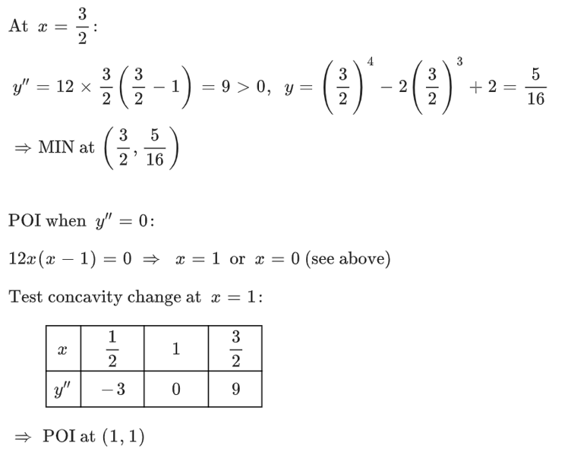
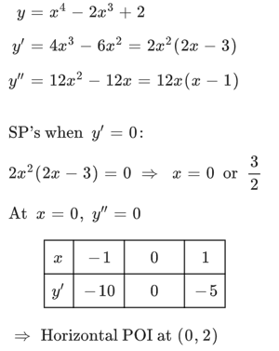

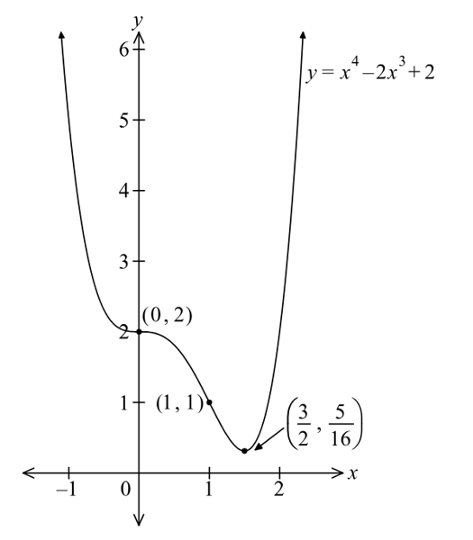

- 2014 HSC Advanced Band 4
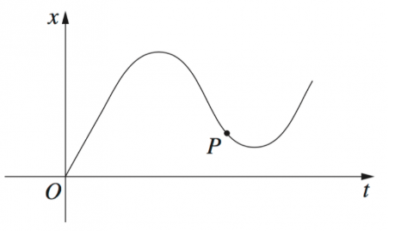
The graph shows the displacement $x$ of a particle moving along a straight line as a function of time $t$. Which statement describes the motion of the particle at the point $P$?

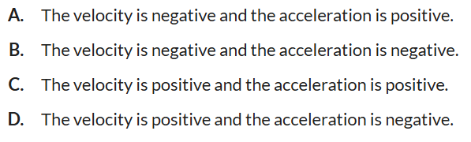

Gradient negative $f^{'}\left(t\right)<0$, so velocity negative
Concave up $f^{''}\left(t\right)>0$, so acceleration positive
A
- 2025 HSC Advanced Band 4
Consider $f\left(x\right)=$ $\frac{x^{2}}{e^{x}}$
Find the stationary points of the function and determine their nature.
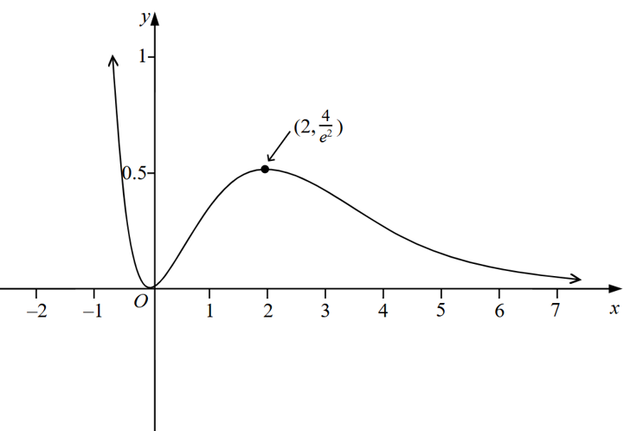
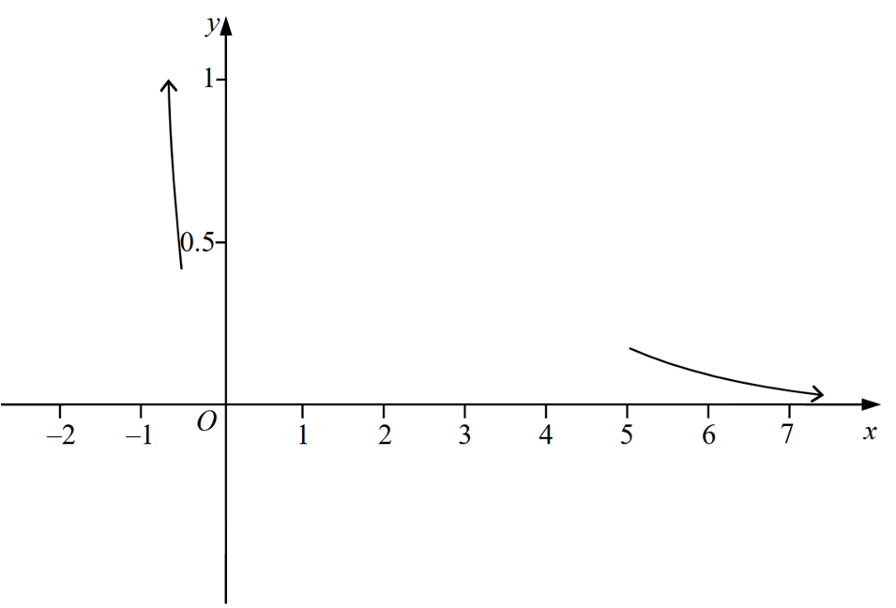
A partially completed graph of $f\left(x\right)$ is shown below. Use your answer to complete the graph.
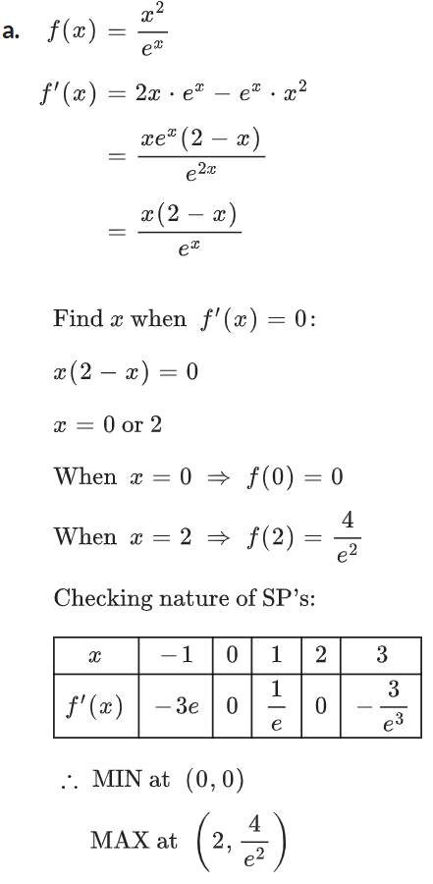

- 2013 HSC Advanced Band 5
The diagram shows points A, B, C, D on the graph $y=f\left(x\right)$.
At which point is $f^{'}\left(x\right)>0$ and $f^{''}\left(x\right)=0$?
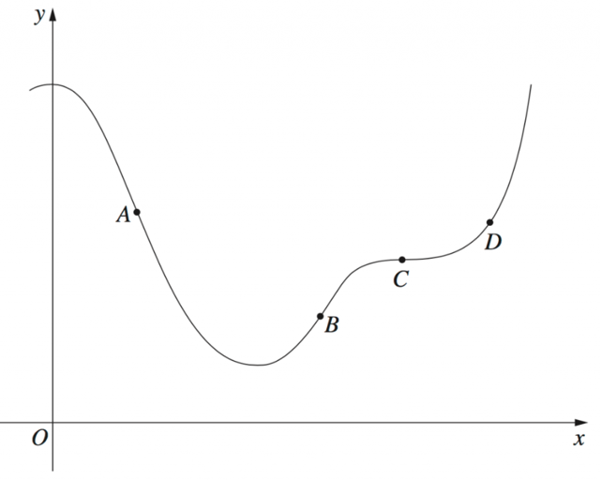

Positive gradient: B or D
D is concave up,
so B is the answer

- 2020 HSC Advanced Band 4
Sketch $y=-x^{3}+3x^{2}-1$, labelling stationary points and points of inflection.
Do not determine the $x$-intercepts.
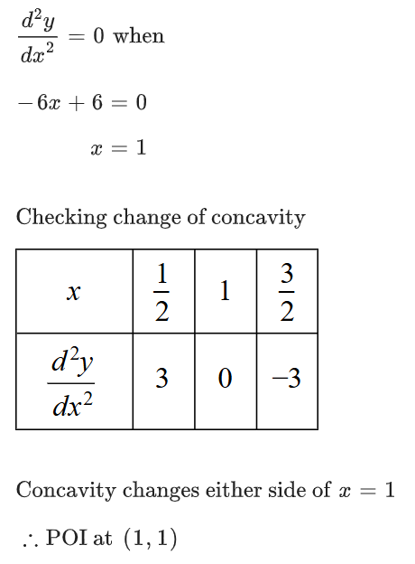
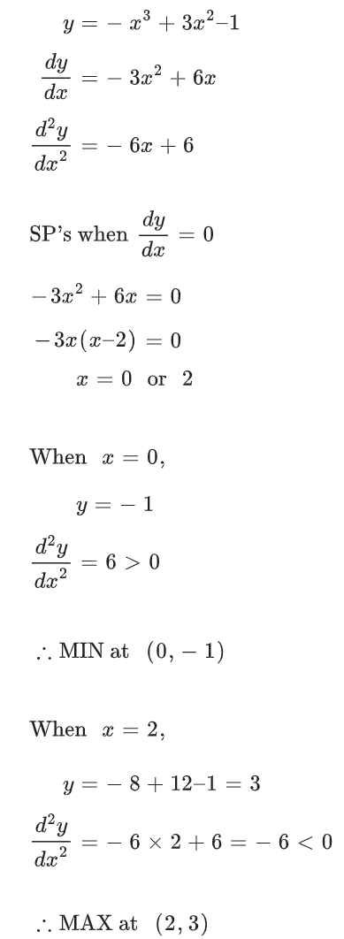

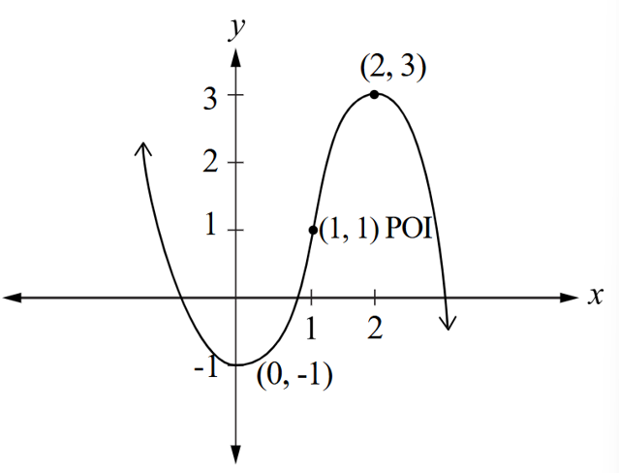

- 2024 VCE Methods Band 5
A function is defined as $f\left(x\right)=$ $\frac{x-h}{\left(x+1\right)\left(x-4\right)}$.
Determine the range of $h$ for which the graph of $f\left(x\right)$ has no turning points.

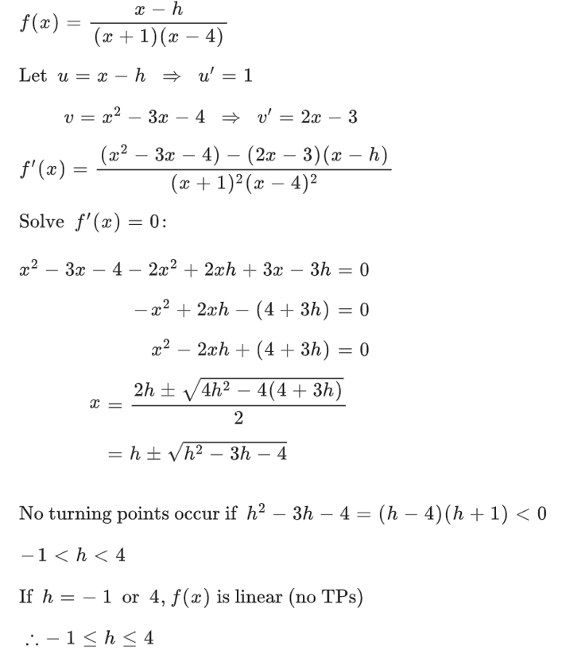

- 2023 HSC Advanced Band 5
$$f\left(x\right)=e^{-x}\sin{x}$$
  - Find the coordinates of the stationary points of $f\left(x\right)$ in $0≤x≤2π$.
You do not need to check the nature of the points.
  - Without further calculus, sketch the graph of $f\left(x\right)$ in the domain $0≤x≤2π$, showing stationary points and intercepts.
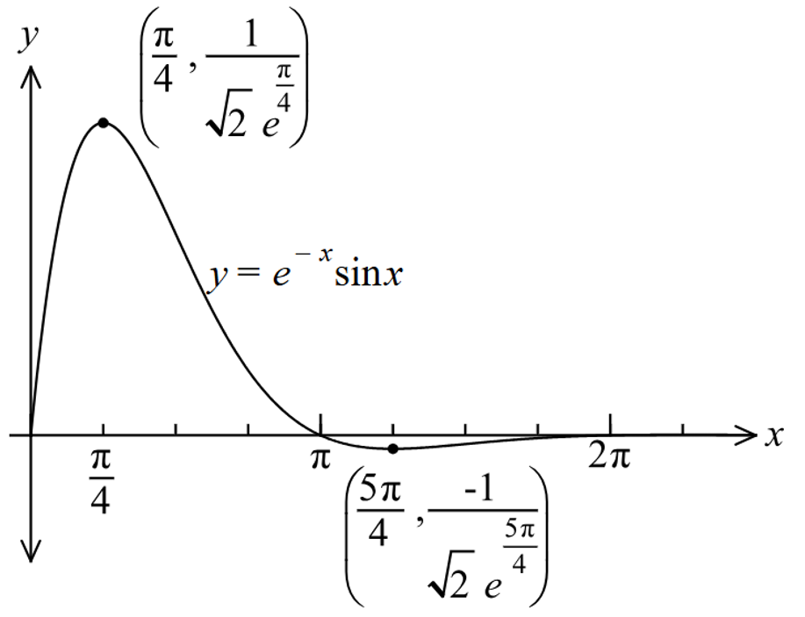
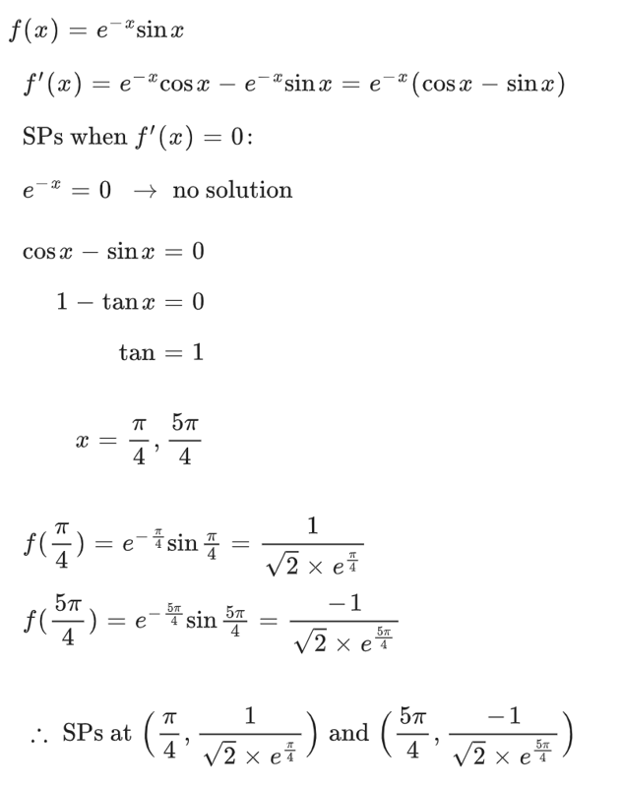
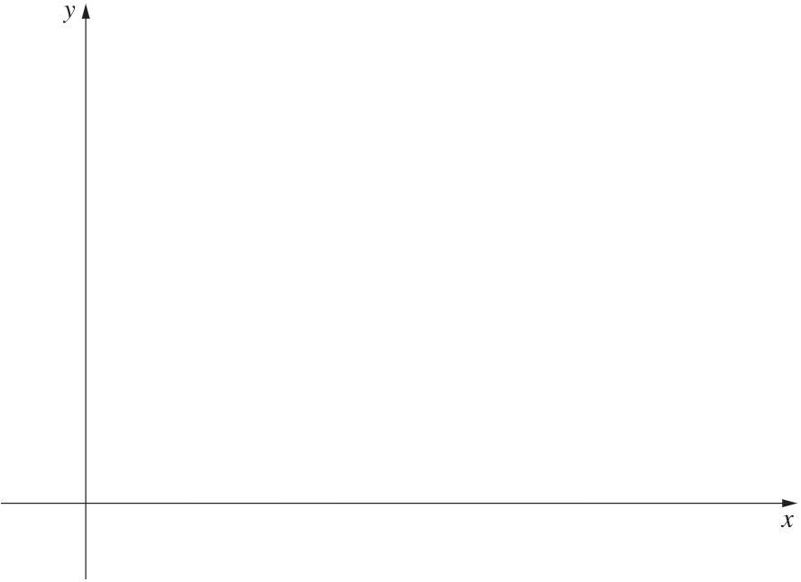

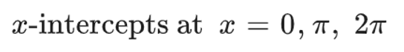

- 2009 HSC Advanced Band 6
The diagram illustrates the design for part of a roller-coaster track.
The section RO is a straight line with slope 1.2.
The section PQ is a straight line with slope $-1.8$.
The section OP is a parabola $y=ax^{2}+bx$.
The horizontal distance from $y$-axis to $P$ is 30 m.
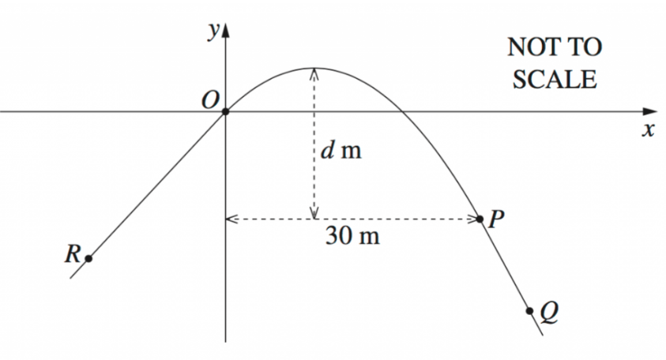

For a smooth ride, the straight-line sections must be tangent to the parabola at O and P.
  - Find the values of $a$ and $b$ so that the ride is smooth.

$$y^{'}=2ax+b$$
$$y^{'}\left(0\right)=b=1.2$$
$$y^{'}\left(30\right)=60a+b=-1.8$$
$$60a+1.2=-1.8$$
$$∴a=-0.05$$
  - Find the distance $d$ from the vertex to the horizontal line at $P$, as shown on the diagram.

Find vertex:
$$y=-0.05x^{2}+1.2x$$
$$y^{'}=-0.1x+1.2=0$$
$$x=12$$
At $x=12, y=7.2$
$$∴Vertex\left(12,7.2\right)$$
Point $P$ is $\left(30, -9\right)$
$$∴d=7.2+9=16.2 m$$

